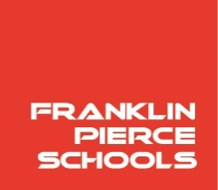

**Franklin Pierce Schools**

**Nutrition Services Department**

11807 24th Ave E., Tacoma, WA 98445

253-298-4618, Fax 253-298-4264

www.fpschools.org

August 25, 2023

Dear Parent/Guardian:

**We Need Your Help!**

Our school is participating in a federal program called the Community Eligibility Provision (CEP). This program allows all children in our school to eat at no charge. However, some education programs we provide are funded with state dollars.

We will no longer be collecting Free and Reduced-Price Applications every year, instead, we must collect the Family Income Survey. This form helps us collect household information for all students attending CEP schools. **Without this information, our schools** **could lose important state funding for educational programs that our students are entitled to.**

**Important note: the Income Survey may be filled out at any time during the school year. Families do not need to be US citizens to apply or be approved for free meals.**

**What You Can Do**

**If your family receives Basic food, tanf, Medicaid, or snap benefits and/or is qualified for McKinney Vento or foster benefits, you do not need to fill out this form.**

If none of the above programs apply to your household, please take a moment to complete the form and return it to your student’s school.The Family Income Survey captures information and ensures the district/school receives state funding for education programs.

We’re excited to offer no-cost meals to all students and appreciate your help. To continue to offer this program, we must collect this important data. If you have any questions, please contact Heather Waite at 253-298-4618.

Sincerely,

Karen Brown

Nutrition Services Director