StudentVUE Instructions:

*Revised 08/21/19*

Viewing Class Schedule

(Class Schedule can also be viewed on ParentVUE)

1. To access your StudentVue account, click on the StudentVUE-Login link on the District home page

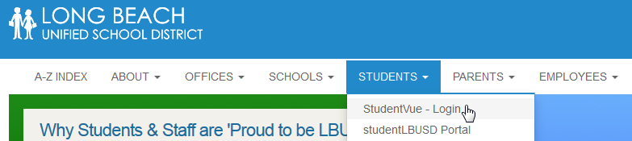

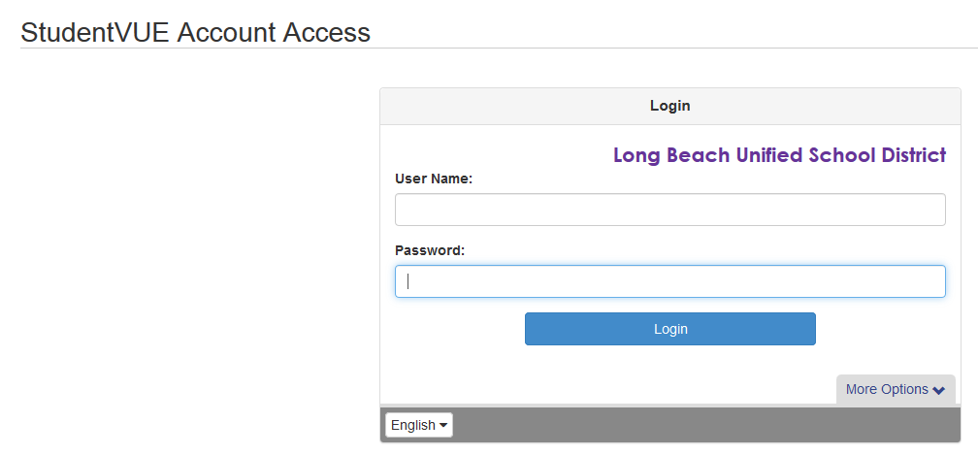

2005128693

042298

1. Enter your Username and Password, then click “Login”

Your Username is your 9 digit Student ID

Your Password is your birthdate in this format: MMDDYY

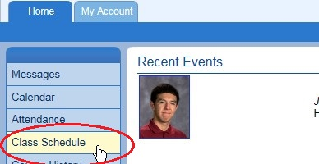

2. Click on “Class Schedule”

3. The main window will display your class schedule.

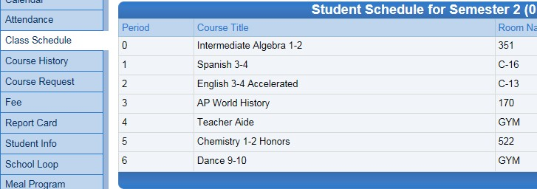



4. When you are finished, click “Logout” to end your session