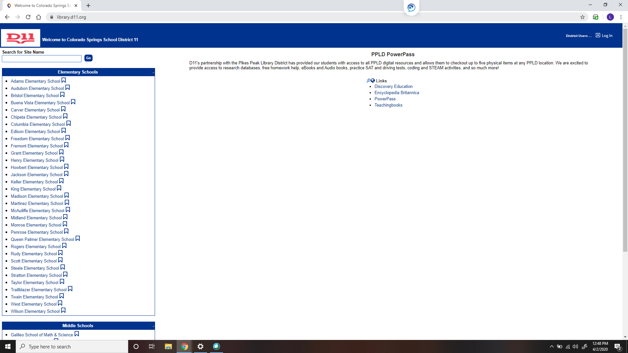

Type library.d11.org and click on Edison

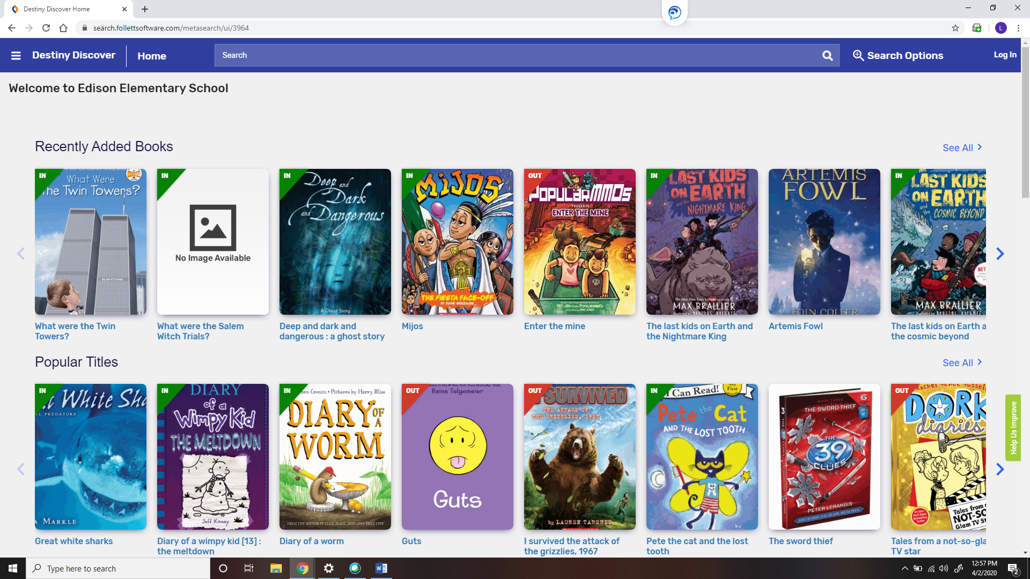

←

Students log in with their student log in. (First 5 of their last name,1st initial, middle initial and last 4 of their ID) Password is their network password

{

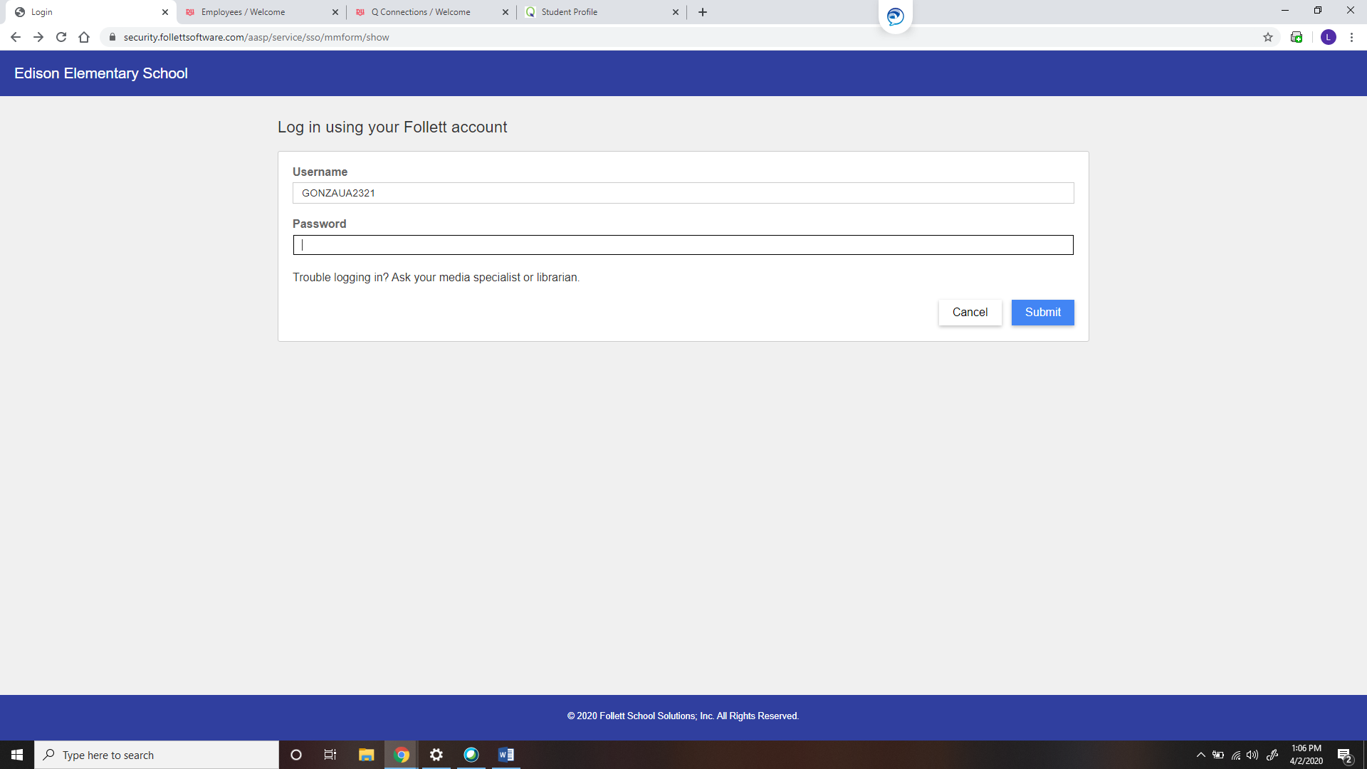

This is what they will see.

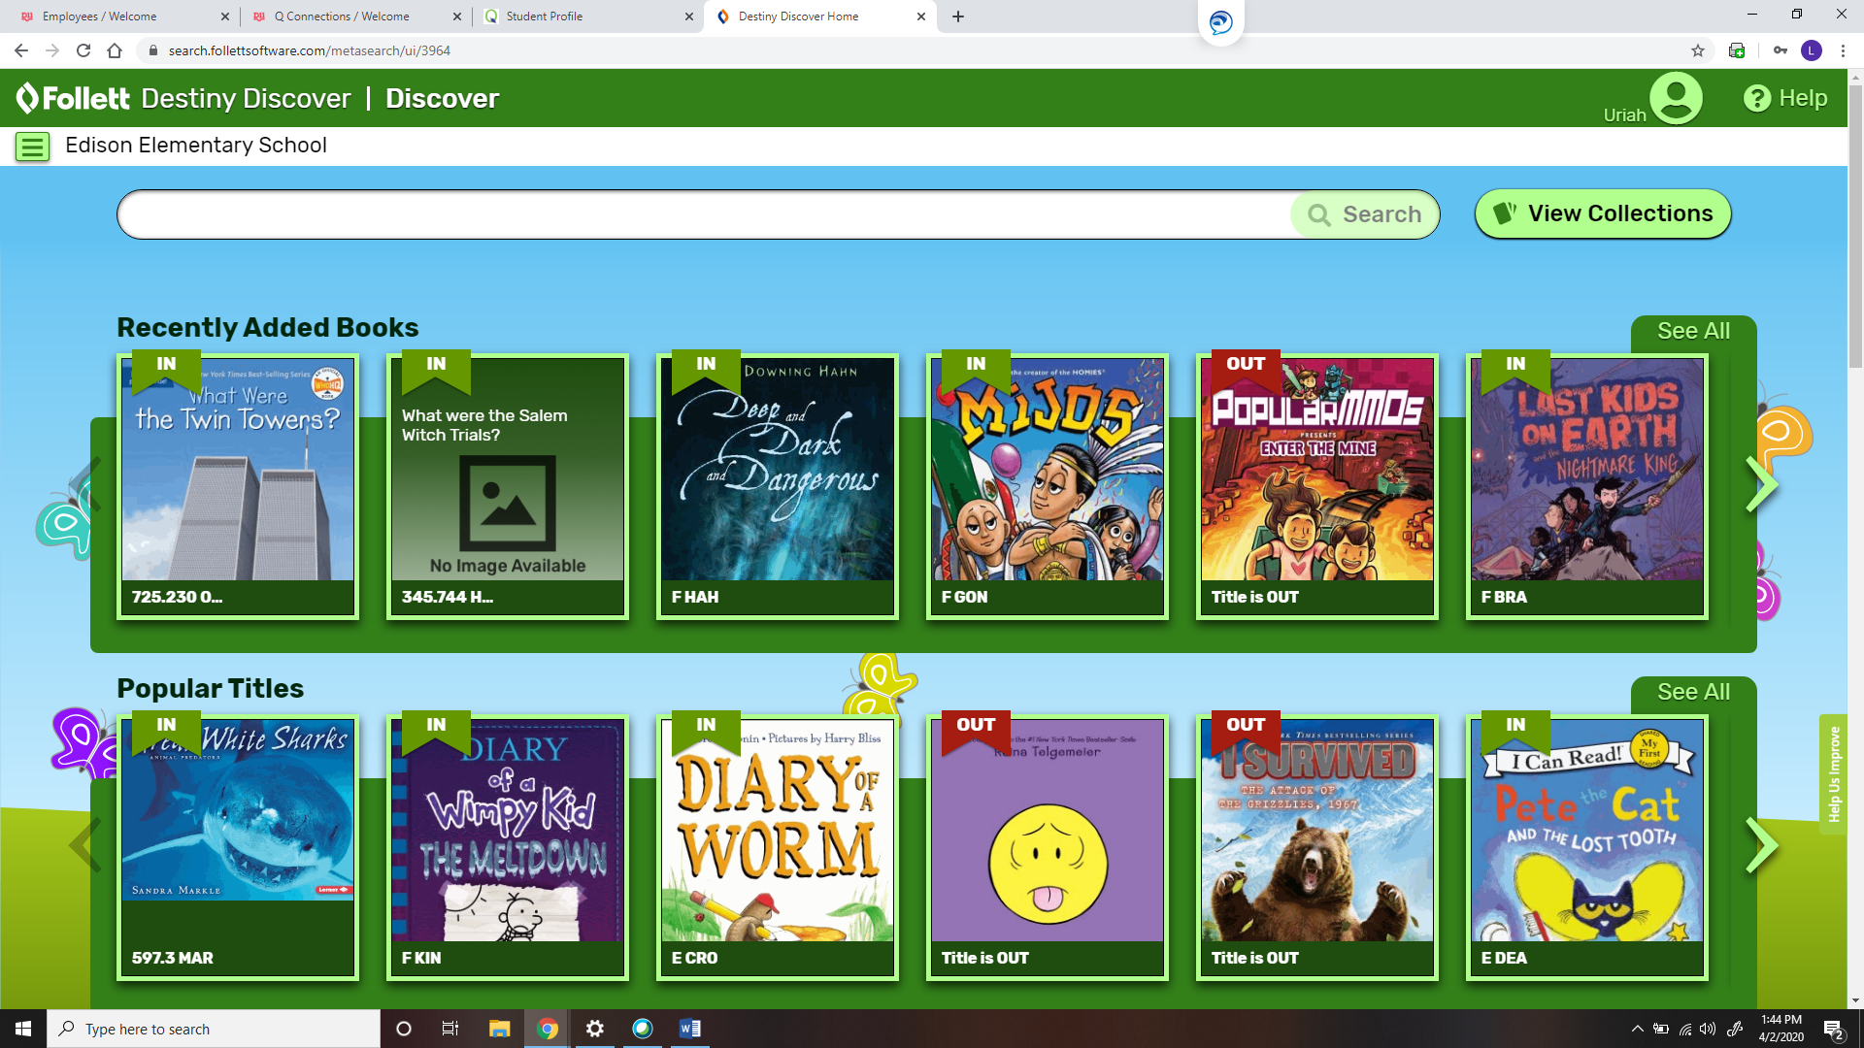

If they type Lightbox they will see these options

