
Course Number and Title: Principles of Algebra
Academic Credits: 1 credit
Course Delivery Format: In person (AIS)
Teacher: Mr. Matthew Mills

(Fulfills graduation requirement in ALL pathways)

Teacher Summary:
I have been teaching for 9 years spending my last 7 here at Susquehanna Township High School. I have my bachelor’s in mathematics and my master’s in education. I look forward to working with you and your family this year!

Teacher Room Number: 302
Teacher Phone: 717-657-5117 ext: 42302
Teacher Email: mmills@hannasd.org
Office Hours: By appointment only; please email to schedule an appointment.

Course Description:
Principles of Algebra introduces and explores elementary functions including linear, polynomial, exponential, rational, and radical. These functions wills be used to model real-world situations.

Prerequisites:
Middle School math.

Required Texts and Materials:
Writing utensils, laptops and chargers, folder

Recommended Texts and Materials:
Bring a calculator to class daily. TI-30XIS will be provided as a class set, but these cannot leave the classroom.

Course Outcomes:
The student will demonstrate through the mathematical process an understanding of:
- Structure and operations with expressions and quantities
- Creating equations that describe numbers or relationships
- Reasoning with equations and inequalities
- Interpreting and building functions
- Constructing and comparing linear functions

Units of Study/Pace of Course:

Unit | Major Topics | Standards Addressed | Approximate Length  of Unit | Assignments/  Assessments
Pre-Algebra Review | -Review all pre-algebra related topics | Please click here to see Pennsylvania’s Principle of Algebra Standards. | 30 days | Each Unit will have 1-3 assignments per major topic, 1-3 review days, and 1-4 assessments; all based on the judgement of the educator.
Real Numbers | -Basic operations  -Order of Operations  -Number comparisons  -Distributive Property |  | 15 days
Solving Equations | -Combining Like Terms  -One and Two steps  -Multistep  -Variables on both sides  -Absolute value  -Consecutive integers  -Perimeter problems  -Mixture problems  -Distance Rate Time |  | 20 days
Rational Numbers and Equations | -Add/subtract fractions  -LCM  -Clearing fractions in equations  -Solving proportions  -Application of proportions |  | 24 days
Linear Equations | -Rate of change  -Direct Variation  -Slope-int form  -Point-slope form  -Standard form  -Parallel & Perpendicular equations |  | 30 days
One variable Inequalities | -One and Multistep  -Compound  -Absolute value |  | 28 days
Systems of Linear Equations and linear inequalities | -Graphing  -Elimination method  -Substitution method  -Application |  | 25 days
Exponents  and Polynomials | -All exponent rules  -Operations with polynomials  -Factoring polynomials & GCFGCF |  | 25 days
Procedures for Late Assignment:
Assignments are expected to be completed by the next day.
Late work will be accepted up to the last day of the unit.

Procedures for Redo Work:
Work will need to be redone if students wish to retake an assessment.

Procedure for Extra Credit:
No extra credit will be offered.

Calculation of Final Grade:
CATEGORY | Percent of Quarter Grades | Percent of Overall Grade
Assessments | 60% | Q1 = 20%  Q2 = 20%
Demonstration of Knowledge | 30% | Q3 = 20%  Q4 = 20%
Learning Opportunities | 10% | Midterm = 10%  Final = 10%
Total: | 100% | 100%

Grading Scale:
- A - 90% - 100%
- B - 80% - 89%
- C - 70% - 79%
- D - 60% - 69%
- F - 0% - 59%

SOAR in the Classroom:
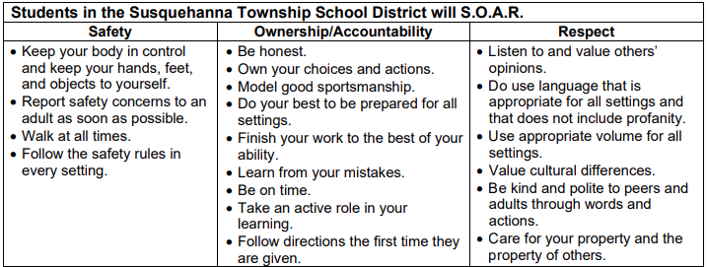

Class Attendance Policy:
Click HERE for the board approved attendance policy.

Cell Phone Policy:
Click HERE for the board approved electronic device policy.

Academic Integrity Policy:
Click HERE for the board approved academic integrity policy.

Pass Policy:
All students must use e-hall pass to sign out of class.

Academic Assistance Program (AAP):
Need additional assistance in the class? Come to AAP after school on Mondays, Tuesdays, and/or Thursdays from 2:37-4:30pm in the library. A certified teacher will be on staff to help with any work or questions you may have. Students may ride the 4:30pm late bus home from AAP.

