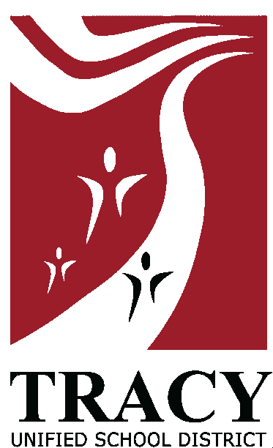**BOARD AGENDA REQUEST FORM**

TO: Dr. Rob Pecot, Superintendent

FROM: Julianna Stocking, Assoc Supt of Ed Services

DATE: May 19, 2023

RE: **Approve Agreement for Special Contract Services with**

**San Joaquin County Office of Education for the Artist-in-Residence Program at Central School, McKinley School, and Louis Bohn School for the 2023 - 2024 School Year**

**PROPOSED BOARD MEETING DATE**: June 13, 2023

TYPE OF ACTION REQUIRED: (a contract and MOU approval form is required for outside services of a consultant or organization.

Please check:

**Public Hearing**

**Recognition**

**Consent**

**Action**

**Information/Discussion/Report**

**Closed Session**

**Pending Fingerprint Approval**

**NOTE:** All Agenda items must be submitted to the appropriate Associate Superintendent **in accordance with the board meeting deadlines.**

|  |
| --- |
| ***Internal Use: ITEM #***  ***APPROVED BY:*** |

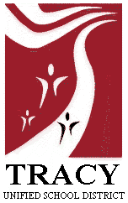

**EDUCATIONAL SERVICES**

**MEMORANDUM**

**TO:** Dr. Rob Pecot, Superintendent

**FROM:** Julianna Stocking, Associate Superintendent of Educational Services

**DATE:** May 19, 2023

# SUBJECT: Approve Agreement for Special Contract Services with San Joaquin County Office of Education for the Artist-in-Residence Program at Central School, McKinley School, and Louis Bohn School for the 2023 - 2024 School Year

**BACKGROUND:** The Artist-in-Residence Program is provided by the San Joaquin County Office of Education. The program will provide several artists who will work with students Kindergarten through eighth grade for four-to-eight-week sessions (depending on the school). Students will learn basic art concepts and carry out various art projects.

**RATIONALE:** In the past we have been fortunate enough to have the San Joaquin County office of Education, Artist-in-Residence Program provide our students with an opportunity to learn about art in a new way. This program was a wonderful success. Students and teachers were very pleased with not just the art but with the full lessons presented during the art classes. Many students do not get the opportunity to use art in their homes or to go to museums. Opening their eyes to art is vital and also increases their use of language in a meaningful context. The instruction builds on verbal skills and increases students’ vocabulary. The art process helps to promote skills such as paying attention to details, critical thinking, reasoning, and improving visual and spatial acuity. The art projects are used to enhance writing and reading project-based learning for the Common Core Standards. This supports Goal 1: Prepare all students to be well-rounded individuals with the knowledge and skills to pursue their college and/or careers.

**FUNDING**: These contracts are to be paid with Title 1 Funding. The Central School contract will not exceed $9,920.00 to be paid from Title 1 funds. McKinley School contract will not exceed $ 8,778.00 from Title 1 funds. Bohn School contract will not exceed $4,416.00 from Title 1 funds.

**RECOMMENDATION:** Approve Agreement for Special Contract Services with San Joaquin County Office of Education for the Artist-in-Residence Program at Central School, McKinley School, and Louis Bohn School for the 2023 - 2024 School Year.

**Prepared by:** Nancy Morgan Link, Principal, Central School.