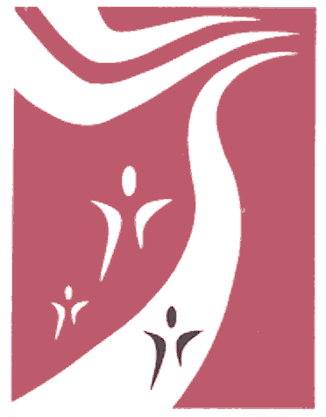
TRACY
UNIFIED SCHOOL DISTRICT

"The future belongs
to the educated"

Dr. James C. Franco
Superintendent
(209) 830-3201
(209) 830-3204 Fax

Dr. Casey J. Goodall
Associate Superintendent
of Business Services
(209) 830-3230
(209) 830-3234 Fax

Dr. Sheila Harrison
Assistant Superintendent
of Educational Services
(209) 830-3202
(209) 830-3209 Fax

James Mousalimas
Assistant Superintendent
of Human Resources
(209) 830-3260
(209) 830-3264 Fax

1875 W. Lowell Avenue
Tracy, CA 95376
www.tracy.k12.ca.us







Date

Dear Parent or Guardian:

To make sure your child is ready for school, the California law, Education Code Section 49452.8, now requires that your child have an oral health assessment (dental check-up) in either kindergarten or first grade, whichever is his or her first year in public school. Assessments that have happened within the 12 months before your child enters school also meet this requirement. The law specifies that the assessment must be done by a licensed dentist or other licensed or registered dental health professional.

Take the attached Oral Health Assessment/Waiver Request form to the dental office, as it will be needed for your child’s check-up. If you cannot take your child for the required assessment, please indicate the reason for this in Section 3 of the form. You can get more copies of the necessary form at your child’s school or online from the California Department of Education’s Web site at http://www.cde.ca.gov/ls/he/hn/. California law requires school to maintain the privacy of students’ health information. Your child’s identity will not be associated with any report produced as a result of this requirement.

The following resources will help you find a dentist and complete this requirement for your child:

- Medi-Cal/Denti-Cal’s toll-free number or Web site can help you to find a dentist who takes Denti-Cal: 1-800-322-6384; http;//www.denti-cal.ca.gov. for help enrolling your child in Medi-Cal/Denti-Cal, contact Healthy Connections at 209-833-2420.

- Healthy Families’ toll-free number or Web site can help you to find a dentist who takes Healthy Families insurance or to find out if your child can enroll in the program: 1-800-880-5305. or:
http://www.healthyfamilies.ca.gov/hfhome.asp.

For additional resources that may be helpful, contact the local public health department at 209-468-3481. St. Raphael’s Dental Clinic 209-467-0703,
San Joaquin County Public Health Clinics at 1-800-839-4949.

