**PARENT HEARING REFERRAL NOTICE**

To Parent (s)/Guardian (s) of: _________________________________________ Date:_________________

Grade:__________ School:___________________________________ Teacher:____________________

Student has failed a hearing screening* at school and should be examined by a physician. When the examinations is done, please ask your physician to fill out the bottom portion (***Physician Report of Examination***) of this form and return to us as soon as possible.

**Audiometric Evaluation/Audiogram**

**KEY:**

**Right AC unmasked O**

**Left AC unmasked X**

**Red Box: normal range**

**Right Ear** **Left Ear**

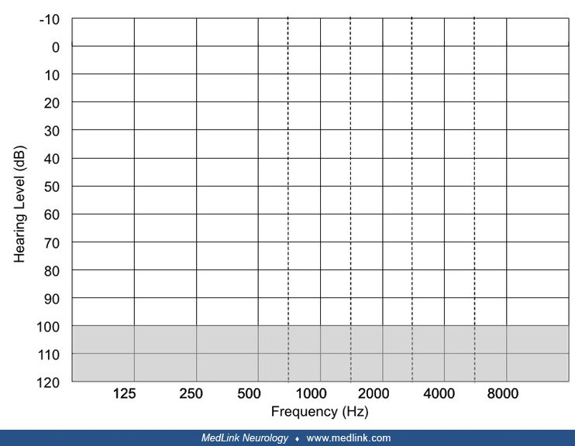

**\*NOTE: These are hearing screening test and failure indicates that a more complete examination should be done.**

***Physician Report of Examination (to be completed by physician):***

1. Diagnosis:______________________________________________________________________________
2. Recommendation for School:_______________________________________________________________
3. Physician Signature:___________________________________ Date:_____________
4. Please return to: TUSD Health Services

fax: (209)830-3242

*CONFIDENTIALITY NOTICE: This communication and any documents, files or previous e-mail messages attached to it constitute an electronic communication within the scope of the Electronic Communications Privacy Act, 18 USCA 2510. This communication may contain non-public, confidential or legally-privileged information intended for the sole use of the designated recipient(s). The unlawful interception, use or disclosure of such information is strictly prohibited under 18 USCA 2511 and any applicable laws.*