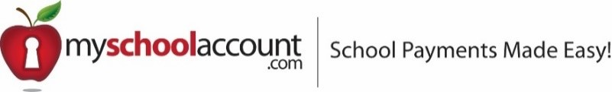

Dear Families,

West Campus continues to partner with Miami Prime Catering and MySchoolAccount.com for the management of our lunch service and payments. MySchoolAccount.com offers you the ability to make deposits directly into your student’s account online or via their Mobile App. You can track what your children have been eating for the past 30 days, transfer funds between students, and have an email reminder sent to you when an account balance gets low. Deposits and payments can be made in person at the School Cafeteria, through ACH (checking/savings) *or* Credit/Debit Card*. Each child’s account will be updated in real time, so account balance information will be current daily.

In order to take advantage of this service, you will need to create a parent account. This requires you to:

1. Go to **www.myschoolaccount.com**.
2. Click “Create Account” on the top menu bar.
3. Fill in the required information on the “Parent Account Sign-Up page.”
4. Select **FL** for the state.
5. Create a User ID and Password
6. Choose **Miami Prime Catering** from the “School District” drop down menu.
7. Click the “Accept” box, and then click “Signup.” An email will be sent to your email address that will contain a “verification code.”

After you receive the “verification code” you may begin to add your children’s information. To do this, you will need to:

1. Go to **www.myschoolaccount.com** and login using your previously created user ID and password.
2. Enter the “verification code” to verify your account and email address.
3. Begin adding your children’s information according to the guidelines provided. You will need each of your children’s students’ ID numbers to add to each student. Please add FCin front of the student ID. Please contact the student’s school for ID number.
4. After the students are added you will be able to make payments to the student account(s) and view transaction history.

**Note: A parent account can be linked to many children, but a child can only be linked to one parent.**

We urge you to take full advantage of this system by funding your student’s account in advance online for use as a declining balance in line.

*Note: There will be a per transaction convenience fee of $2.00 at check out for Checking/Savings and 4.75% for credit/debit. These convenience fees are only associated with financial deposits and not necessarily purchases.

Any money that is not spent by the end of the school year will be available the following school year. If you have any questions, please contact us, Miami Prime Catering, at **305-907-700**5 or at info@miamiprimecatering.com.

Warmest Regards,

**MIAMI PRIME CATERING & FOOD SERVICES, LLC**

**Any questions regarding the website service myschoolaccount.com should be directed to support@myschoolaccount.com.