PREKINDERGARTEN

PARENT HANDBOOK AND
SCHOOL YEAR CALENDAR

2023-2024

Wakulla Educational Center
87 Andrew J Hargrett Sr. Road Crawfordville, Florida 32327
850-926-8111 -- http:// https://www.wakullaschooldistrict.org/

TABLE OF CONTENTS
- Purpose and Direction 1
- Parent Involvement 2
Parent-School Responsibility Agreement 2-3
Volunteer Program 3
Discipline Guidelines and Plan 4-5
- General Information 6
Open House 6
Registration 7
Big Day Curriculum 6
Visitors 7
Withdrawal 7
Attendance 8
School Hours 8
Voluntary Pre-K 9
Special Events and Field Trips 9
Appropriate Dress 9
Items From Home 10
Parent Drop Off/Pick Up 10
Parent Information 11
Parent Involvement Education 11
Patriotism 12
Classroom Transfer 12
Transportation Information 13-14
Nutrition 15
- Medical Information 16
Illness 16
Head Lice 15
Administration of Prescription Medicine 16-17
Administration of Non-Prescription Medicine 17
Immunization Guidelines 17
- Involvement 18
It Looks Like Play 19
School Advisory Council 19
Parental Participation 19
Wakulla School District Calendar 20
Wakulla PreK Calendar of Events 21
2019-2020 School Financial Report Statement 22
Non-Discrimination Statement 23

I PURPOSE/DIRECTION
PURPOSE

The Wakulla prekindergarten program recognizes that the development of the whole child is essential for learning to take place and that human development can be stimulated and encouraged, but not forced. We recognize movement as a natural characteristic of the preschool child and is the mode through which learning takes place. We believe in the provision of timely learning experiences that promote growth and development of children while accommodating each child’s unique needs, interests, and abilities. Our purpose is to provide a safe and healthy learning environment through play which stimulates and encourages positive self-esteem.

DIRECTION
Wakulla Pre-Kindergarten program strives to provide a learning environment that is enriched through the developmentally appropriate practices and daily classroom activities that stimulate the whole child (physical, mental, social, emotional, and cognitive) and prepares them for future academic challenges with the support of parental involvement.

II. PARENTAL INVOLVEMENT

Parent-School Responsibility Agreement

This first break from home offers opportunities for establishing common understanding between school and home that will carry over all through the school year. The Parent-School Responsibility Agreement is completed during registration/screening of your child.

School Responsibilities

Wakulla Prekindergarten will:

- provide a safe, warm, nurturing, stress-free environment for children.

- provide developmentally appropriate activities to meet the individual needs of each child.

- develop a positive relationship with parents/guardians and maintain constant contact with them.

- provide opportunities for parents/guardians to participate in school/classroom activities throughout the year.

Parent Responsibilities 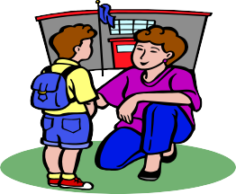

Parents/Guardians will:

- see that the child attends school regularly unless the child is sick.

- designate an adult to take the child to the designated bus stop ON TIME in the morning or bring the child to the drop off location at school.

2

- designate an adult on the approved pick up list to meet the child ON TIME at the bus stop or at the school
pick-up in the afternoon - half day students are released (12:30-1:00) and those that stay all day pick-up is (2:30-3:00pm)
- sign the child out in the front Office when picking a child up early.
- Sign the child in at the front Office if you arrive at 9:00am or later.
- notify the school immediately of any changes in address or phone numbers.
- attend regularly scheduled parent meetings.
- send a complete change of clothing to the school to use in case of accidents (underwear, socks, pants, shirt).

Volunteer Program

Parents are their child’s first teacher. Because you are so important in the educational process, we want to promote a home-school relationship by requesting your assistance as a school volunteer. It has been our experience that parents who are interested in spending time with their children and support the educational efforts of the school, have a positive influence on children’s attitudes and their achievement. Be a part of our volunteer group and find out how you can help the children, the teachers, and yourself. For further information please contact Principal, Mr. Louis Hernandez; Assistant Principal, Mrs. Deeann Peeples or our Volunteer Coordinator, Rebecca Fairchild for details. YOU ARE WANTED AND NEEDED AT OUR SCHOOL!
3

EAGLET DISCIPLINE GUIDELINES AND PLAN
Social-Emotional Learning
Second Step is a program rooted in social-emotional learning (SEL) that helps transform schools into supportive, successful learning environments uniquely equipped to encourage children to thrive. Second Step is more than just a classroom curriculum, Second Step’s holistic approach helps create a positive school climate and empathetic society by providing education professionals, families, and the community with tools to enable them to take an active role in the social-emotional growth and safety of today’s children.
Second Step will be used by the Wakulla County Pre-K to guide students on how to thrive in a school and life setting. Students will learn the appropriate way to; listen, pay attention, manage their behaviors and get along with others. These self-regulating and social-emotional skills set students up for success in kindergarten and beyond.
When inappropriate behavior occurs, the following steps are taken:
1. Minor misbehaviors are ignored if there is no danger to the child or others.
2. The adult will use non-verbal communication through eye contact, a gentle touch, or closer proximity in order to encourage on-task behavior.
3. The adult intervenes by placing him/herself between the child and the source of the problem, thereby distracting the child.
4. The child is encouraged to go to another center or area, thereby removing him/herself from the disruptive situation.
5. The child is given "time-out," separated from the other children (1 minute per age of the child), thereby giving the child a time to "cool down" or think about the problem. An adult always takes time to discuss the problem and possible solutions before the child rejoins the group or activity.
4
6. If inappropriate behavior continues or is severe, contact will be made and maintained with the parents/guardians until the behavior improves. An individualized positive behavior plan will be created to improve the behavior.
7. If a child severely disrupts a class (tantrum, hurting him/herself or others), the child will be immediately removed from the classroom or setting by an adult. The child will be taken to the Principal or Assistant Principal until she/he has calmed down and can discuss the problem and possible solutions. The child will be returned to class and the parents/guardians will be notified. Each parent will receive a copy of the school discipline plan in the Parent Handbook as well as the classroom behavior management system at Open House or during the first week of school. This plan will be fully explained and questions answered at that time.
8. Depending on the severity and frequency of the problem, parents may be called to take the student home.
Discipline is not punishment; discipline is guidance, learning, and a training process that takes time and patience. Rules are a positive way to guide children and help them learn acceptable behavior. Rules give children limits and encourage them to develop self-control. Rules should be kept simple, few in number, clear, truly necessary, reasonable for the age of the child, and stated in a positive way. Consistent and fair rules help children control their own behavior. They set limits that children can learn and depend on. Some adults have only one basic rule: You may not hurt yourself, others, or things. Hurt can be explained as either physical or emotional.

OUR EAGLET RULES

- We use walking feet.
- We use helping hands.
- We use listening ears and looking eyes.
- We use thoughtful and kind words.

5

III GENERAL INFORMATION

Open House

OPEN HOUSE WILL BE LIMITED TO THOSE STUDENTS NEW TO OUR SCHOOL

Registration

Application for Prekindergarten is done during the summer at Wakulla Educational Center. All applications for the Voluntary Prekindergarten (VPK) must be made on-line at www.elcbigbend.org through the Early Learning Coalition. The child must be 4 on or before September 1.
Application for the Prekindergarten Exceptional Student Education Program must follow the designated procedure required by the District. Please call the Office to inquire about the process or to schedule an appointment for a developmental evaluation.

Registration for any preschool program requires the following documents:

- Birth Certificate or proof of birth
- Immunization Records (DCF Form)
- Proof of health examination (DCF)
- Two proofs of residency

It is crucial that you keep the school informed of current telephone numbers and addresses, especially emergency contact numbers. If your address or home/work phone number changes, please be sure to notify the school as soon as you know your new address or phone number.

6

Big Day Curriculum
Wakulla County Pre-K will use the Big Day curriculum for all students. Big Day curriculum has been approved by the Florida Office of Early Learning. Every teacher, in every class (with the exception of the students needing MELD curriculum), will use the same curriculum to move through the year and cover all standards required by the Florida Department of Education. Based on years of research that demonstrate the importance of teacher-student interactions, immediate and regular access to the best literature available, and the need for social-emotional development instruction, Big Day for PreK offers teachers a thematic and integrated approach to guiding our youngest learners. Organized around eight themes that grow in scope as children become more aware of their surroundings, the program introduces children to math, literacy, science, and the arts in a way that feels like play and inspires joyful engagement.
Teachers using Big Day Curriculum help students build a base of knowledge and an understanding that will help them be more successful in their future education.

VISITORS

ALL visitors on campus MUST use the main Office entrance and check in at the front desk upon arrival. You will receive a Visitor’s Pass to wear while on campus. Parents are not allowed to walk their child to class. Students will be escorted to class by staff members. Student safety is our top priority!

Withdrawal

Call the school Office as soon as possible if your child will be moving to another school district.

7

Attendance

Regular attendance and participation in classroom activities are keys to success in school. Once enrolled, regular attendance is required! Non-attendance will result in your child being dropped from the program after 10 consecutive absences and no parental contact.

If your child is tardy, sign in at the Office. Every effort will be made to maintain classroom instruction. Students arriving to school late may wait in the front Office until the classroom teacher is available to pick them up from the Office.

If your child will be absent, call the Office before 9:00 a.m. This is especially helpful if the child is out for several days. A written excuse signed by a parent must accompany a child when the child returns to school.

School Hours

The school day for students begins at 9:00 a.m. and ends at 3:00 p.m. Students should not arrive prior to 8:30 a.m., as there is no supervision. Children should be picked up no later than 3:00 p.m..

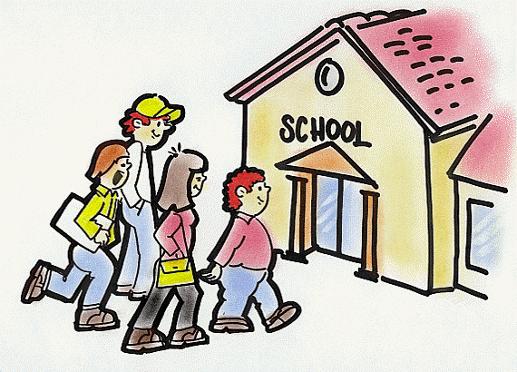

8

Voluntary Pre-K (VPK)

Students who attend the VPK program must be five by September 1,2023. Parents may contact the Early Learning Coalition in Crawfordville at 617-4586 for assistance in obtaining on-line Summer VPK certificate.

Special Events and Field Trips

You will be notified of all special classroom events and scheduled field trips. Parents must fill out and return the Field Trip Authorization Form in order to have their child attend a trip away from school grounds.

In addition to this, an individual permission slip for field trips must be signed and returned. This form assures the classroom teachers that you are aware that your child will be off campus on a particular day. Please sign and return these forms as soon as you get them.

Remember, field trips are for prekindergarten students only. Other family members may not accompany classes on the school bus. All fieldtrip chaperones must be on the approved volunteer list. All students participating in a field trip must use the school provided transportation both ways. Exception to this rule may be made only if the student is to ride with his/her legal guardians/parents AND this exception has been arranged, in writing, with the Principal. –SB 4.43

Appropriate Dress

The prekindergarten program is an active and fun place to learn. Children paint, glue, play in sand and water, and play outdoors almost every day. Therefore, sturdy, comfortable clothes that you do not mind getting dirty are necessary so that children can really be involved in all activities without worrying about their clothes. Make sure your child's clothes are easy to pull up and down for bathroom needs. Tennis shoes or close- toed shoes are best for the safety of your child. Flip flops ARE NOT allowed. Please dress your child appropriately according to the weather. WRITE NAMES ON ALL CLOTHES THAT YOUR CHILD CAN TAKE OFF WHILE AT SCHOOL (sweaters, jackets, raincoats, caps, etc.). Lost and Found is located in the cafeteria on a mobile coat/storage rack.

9

Items From Home

Please send a change of clothes for the appropriate season, including underwear and socks. Make sure your child's name is on each clothing item. All clothes will be returned at the end of the school year. If your child uses the spare clothes at school, remember to send replacements. In addition, a backpack (without wheels) with your child’s name written on it is needed to carry snacks, papers, etc. to and from school daily.

Your child will need a one-inch-thick mat for rest time. Label it with your child's name. Your child will also need a daily nutritious snack.

Please do not send toys or other valuable items from home. Be sure to regularly check your child’s backpack each day.

Morning and Afternoon Drop-Off/Pick Up

No vehicles are allowed in the bus loading area daily from 8:30-9:30 a.m. and 2:30-3:30 p.m. Parking for student drop off and pick up is located in the Office parking lot. Please do not leave vehicles running and unattended or park in reserved/ handicapped spaces without proper tags/decals. Never leave your child unattended in the school parking lot. If another adult will pick up your child, please send a written note AND CALL THE OFFICE and provide the adult with a pick-up pass. Please allow sufficient time to notify the teacher and bus driver of any changes. Parents please understand, for the safety of your child, no bus changes will be accepted after 1:45pm. Between 2:00-2:15pm teachers and students are transitioning to bus rooms or the pick-up room. ALL STUDENTS MUST BE PICKED UP THROUGH THE CAR PICK-UP LINE OR RIDE THE BUS. Parents will ONLY be

permitted to walk/pick up their child to/from class ON THE FIRST 2 DAYS OF SCHOOL. On the 3rd day, students must either ride the bus or go through the drop off and pick-in line. Please call ahead (prior to 2:00) if you wish to pick up your child early from the front Office.
10

PARENT INVOLVEMENT EDUCATION:

Purpose

Education is a co-operative affair between home and school for the good of the child. Parents are encouraged to visit classrooms for the purpose of gaining an insight into operation, content of programs, and for the purposes of gaining an insight as to means of helping their own child. Parents are not expected to evaluate teacher effectiveness, nor may they have access to data on students other than their own child.

Guidelines

To avoid misunderstanding between parties concerned, the following guidelines for visits to the classroom must be followed:

- An appointment will be made with the school administrator in charge of the elementary, middle, or secondary program, the teacher of the class to be observed and the parent a minimum of one week prior to the visit. This appointment will take place on time not considered instructional time of the teacher.
- The parent/guardian will be briefed as to the lesson, its objectives and process of instruction to be used. This should avoid any misunderstanding.

- The length of the visit will be prearranged, not to exceed 20 minutes.
- No more than one (1) person at a time will be permitted to visit the room.
- Parents/guardians visiting classrooms will be spectators, not participants.

Delegation of Responsibility

It is understood that the school administration reserves the right to refuse visitation to persons who are not parents, guardians, or to persons it considers disruptive to the education process.

11

Parent Information

Your child's teacher will send home weekly notes telling about the class activities and giving some ideas for at-home activities. Monthly newsletter with important events, breakfast and lunch menus will be sent home within the first few days of each new month. Other notices will be sent home with your child as needed. Please check your child’s backpack DAILY each day for any notices.

Classroom Transfers

FS 1003.3101: If a parent or guardian wishes to request his or her child be transferred to another classroom teacher, they will need to contact the principal or the principal’s designee. This does not give a parent the right to choose a specific classroom teacher. Schools will approve or deny the transfer within 2 weeks after receiving a request. If a request for transfer is denied, the school must notify the parent and specify the reason for the denial.

Patriotism

1003.44 Patriotic programs; rules.—
(1) Each district school board may adopt rules to require, in all of the schools of the district, programs of a patriotic nature to encourage greater respect for the government of the United States and its national anthem and flag, subject always to other existing pertinent laws of the United States or of the state. When the national anthem is played, students and all civilians shall stand at attention, men removing the headdress, except when such headdress is worn for religious purposes. The pledge of allegiance to the flag, “I pledge allegiance to the flag of the United States of America and to the republic for which it stands, one nation under God, indivisible, with liberty and justice for all,” shall be rendered by students standing with the right hand over the heart. The pledge of allegiance to the flag shall be recited at the beginning of the day in each public elementary, middle, and high school in the state. Each student shall be informed by a written notice published in the student handbook or a similar publication pursuant to s. 1006.07(2) that the student has the right not to participate in reciting the pledge. Upon written request by his or her parent, the student must be excused from reciting the pledge, including standing and placing the right hand over his or her heart. When the pledge is given, unexcused students must show full respect to the flag by standing at attention, men removing the headdress, except when such headdress is worn for religious purposes, as provided by Pub. L. ch. 77-435, s. 7, approved June 22, 1942, 56 Stat. 377, as amended by Pub. L. ch. 77- 806, 56 Stat. 1074, approved December 22, 1942.

12

TRANSPORTATION

Parents must fill out a transportation form located in the registration packet. Any changes to this form must be sent immediately to the front Office. It is essential for the school to have current telephone numbers of parent/guardians in the event of an emergency.

Parents/guardians (or designated adults) need to be with their child prior to pick up in the morning and meet the child at the bus stop ON TIME (10-15 minutes prior to arrival time) each afternoon. Children will not be let off the bus unless an adult on the approved pick up list is present. Parents may not pick up or drop off children in the elementary school bus loading areas. If a child should miss the bus in the morning at the regular neighborhood bus stop, parents may call the bus garage (926-7550) or bring the child to school.

If there are changes in transportation arrangements, please send a note in the morning AND call the Office to allow us time to make sure all parties involved are aware of the change and make any necessary arrangements. Please include your child’s name, teacher’s name, your name, date for change and needed changes in the note. The school must be notified prior to 1:45pm. Calling after 1:45pm does not allow enough time to let the child, teacher, administrator, and, if needed, the bus driver know of the necessary change in plans for your child’s safe arrival. If a parent or authorized adult wishes to pick up a child at school rather than have him/her transported by the bus in the afternoon, you must notify the Office of this change AND YOU MUST ARRIVE AND SIGN YOUR CHILD OUT IN THE FRONT OFFICE PRIOR TO 2:00 PM.

13

Riding the bus is a privilege and students are to conduct themselves appropriately at all times while waiting for the bus and while aboard the bus. Students who do not follow the rules while riding the bus may lose this privilege.

Students must use inside voices.
- Students must wear their seatbelt and stay seated in the assigned seat given to them by the bus driver.
- Students must board, depart, and cross the roadway following instructions from the bus driver.
- Eating and drinking is not permitted on the bus.

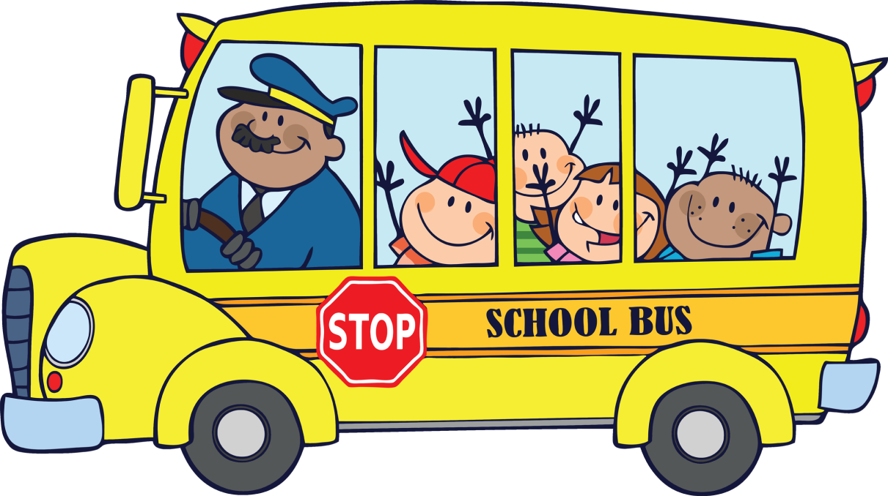

14

Nutrition

The cafeteria is a vital part of the school's health and nutrition program. Breakfast and lunch are available for each Prekindergarten child in the program. Menus meet the recommended nutritional allowances for children ages 1 to 5. Monthly menus are included in the Pre-K Parent Newsletter (Bird’s Eye View) for your information. Monthly menus are also available on-line at www.wakulla.schooldistrict.org

Breakfast and lunch are a part of the daily routine at Pre-K. Every student will eat in the cafeteria with his/her teachers and classmates. Parents may choose to pack breakfast and lunch items for their child. Milk can be purchased for .35

During the 2033-2024 school year, all Pre-K students will receive BOTH breakfast and lunch at no cost.

Parents should report any food allergy or special diet to school staff at enrollment, or as soon as possible. This notification must be followed up with a doctor’s statement of the specific food allergy. Please send all information from the doctor as soon as possible. Your child's classroom teacher can provide you with the breakfast and lunch times for the class. If your child arrives too late in the morning or returns from a medical appointment late in the day, the food line may be closed.

15

IV. MEDICAL INFORMATION

ILLNESS

Children MUST stay at home whenever they have any of the following symptoms: Fever, vomiting, diarrhea, green/yellow nasal discharge, pink eye, Impetigo (running sores), or rash. If contacted by the school due to the illness of your child, you must make arrangements to have your child picked up as soon as possible for the safety of your child and others. Students must be symptom free for 24 hours ( =1 whole school day) before returning to class.

Diarrhea in Prekindergarten Students, (as described by the Wakulla County Health Department)
Exclude from group setting if:
  - Stool is not contained in the diaper of a diapered child.
  - Diarrhea is causing “accidents” for toilet-trained children.
  - Stool frequency exceeds 2 or more stools above normal for that child.
  - Blood or mucus in stool
  - Stool that is all black or very pale

Students may not come to school with communicable health problems like: head lice and/or nits, scabies, German Measles, Rubella, Impetigo, ring worm, mumps, Chicken Pox, or pink eye. These communicable health conditions require medical attention. You may be asked to bring a doctor's statement in these cases before your child comes back to school. We require that your child be symptom- free for 24 hours ( =1 whole school day) before returning to class.

Head Lice
All Wakulla County Schools have a no nit/lice procedure. Head checks are conducted periodically as requested by the teachers. Students sent home with head lice must be brought back to school by an adult and be cleared in the clinic before returning to the classroom or riding the school bus.

All prescription medications will be hand delivered to the clinic by the parent/guardian with the following information on the label:

- Student's name
- Name of medication 16
- Date of prescription and pharmacy
- Specific instructions on the administration of the medication
- Approximate duration of medication

a, A medical permission form or letter signed by the student's parent(s) or legal guardian shall be required. The medical permission form or letter shall be updated every school year. A two (2) day grace period will be extended to parents for renewal of authorization of medication. The medical permission form can be obtained from the clinic or from the Pre-K Office. You may also obtain the form by going on-line at www.wakullaschooldistrict.org.
- Prescription medication which is kept at school shall be counted and shall be stored in its original container, in a secure location under lock and key as designated by the school Principal. Only staff that has been designated by the Principal and has received training shall have access to the medication.

- A record shall be maintained on each student who receives prescription medication during school hours, including the date and time each dose of the prescription medication that was administered. These records shall be made available at all times to the Principal and authorized staff.

Administration of Non-prescription Medication

All non-prescription medication will be hand delivered to the clinic by the parent/guardian in the original sealed container with the manufacture’s recommended dosage. The dosage must be appropriate for the child’s age and weight. Upon receipt in the clinic, the medication will be labeled with the student’s name. The medication may be stored in the Clinic until the end of the school year at which time it must be picked up by the parent/guardian or destroyed. S.B. Policy 5.62 in its entirety @www.wakullaschooldistrict.org.

Immunization Guidelines

Children entering, attending or transferring to preschool in Florida are required to have a current immunization form and documentation of a health examination within the 12-month period prior to their initial entrance.

17

INVOLVEMENT

IT LOOKS LIKE PLAY BUT WE ARE LEARNING
. . . to work and play together.
. . . to respect the rights of others.
. . . to listen as well as speak.
. . . to express ourselves creatively.
. . . to grow in self-control.
. . . to grow from dependence to independence.
. . . to listen to directions and follow them.
. . . to develop good working habits.
. . . to finish what we start.
. . . to clean up after work time.
. . . to participate in group activities.
. . . to enjoy using a variety of materials.
. . . to share toys, equipment and experiences.
. . . to develop an interest in books.
. . . to dramatize stories and experiences.
. . . to develop an interest in the world around us.
. . . to improve muscular coordination.
. . . to stay with plans for an increasingly longer period of time.
. . . to develop new interests and extend old ones.
. . . to understand new words and be able to use them.
. . . to be HAPPY! 18

SCHOOL ADVISORY COUNCIL

Wakulla Pre-K School Advisory Council is composed of staff members, parents, administrators, teachers, and community leaders who work together on an annual committee. The School Advisory Council solicits information to better help our program at Wakulla Education Center. The information is used to generate goals and plan activities. Progress towards these goals is assessed and reported. Meetings are open to all teachers, parents, and community members. Copies of the School Board approved plan are available upon request at the beginning of each school year. If you are interested in serving, please contact Ms. Dawn Chunn at 926-8111.

PARENTAL PARTICIPATION
Wakulla Pre-K’s parents are a vital part of our school’s success. Teachers appreciate parent volunteers and look forward to the enrichment they bring to the classroom. School wide activities to involve parents will be planned throughout the school year. Parents will be invited and encouraged to attend. Our school needs your help. If you are interested in being a part of the Family Fun Day Committee, please notify your child’s teacher.

19

20

NON DISCRIMINATION STATEMENT

The following policy applies to students, applicants for admission, employees, and applicants for employment:

The School Board of Wakulla County, Florida does not discriminate in admission or access to, or treatment or employment in, its programs and activities on the basis of race, color, religion, age, sex, national origin, marital status, disability, genetic information for applicants and employees, or any other reason prohibited by Federal and State law regarding non-discrimination. See 34 C.F.R. 100.6(d); 34 C.F.R. 106.9; 34 C.F.R. 110.25.

In addition, the School Board provides equal access to the Boy Scouts of America or any other youth group listed in Title 36 of the United States Code (as a patriotic society). This holds true for all students who are interested in participating in educational programs and/or extracurricular school activities. See 34 C.F.R. 108.9.

Disabled individuals needing reasonable accommodations to participate in and enjoy the benefits of services, programs, and activities of the School Board are required to notify the administrator at the school/center at which the event or service is offered to request reasonable accommodation in advance.

The designated Equity Coordinator, Title IX and Section 504 Compliance Coordinator as required by 34 C.F.R. 100.6(d) is Lori Sandgren
69 Arran Road, Crawfordville, Florida 32327; (850)926.0065; lori.sandgren@wcsb.us.

23

-
-

