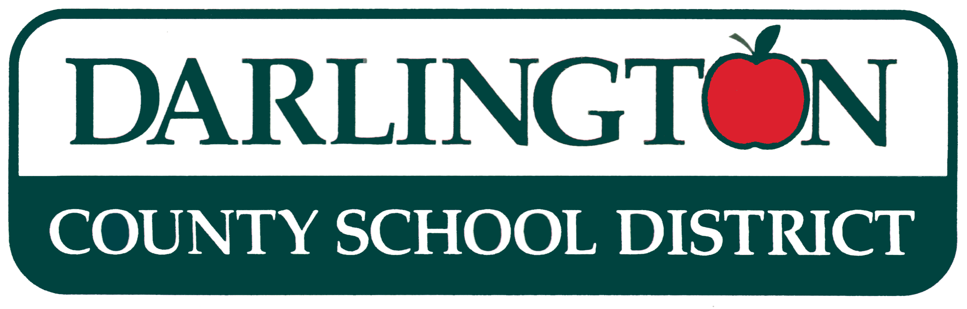
JUSTIFICATION FOR
SOLE SOURCE PROCUREMENT

SOLE SOURCE CHECKLIST

YES NO Is the compatibility of equipment, accessories, or replacement parts the paramount consideration?
YES NO Is the sole supplier's item needed for trial use or testing.
YES NO Is the item one of a kind; a patented item with no other source of supply or acceptable alternate; or does the item possesses characteristics required by the District that no other source can provide.
YES NO Is the sole supplier's item is to be procured for resale.
YES NO Has the manufacturer designated exclusive distributors in specified areas with territorial rights such that competition among the available distributors cannot be obtained.

Based upon the following determination, the proposed procurement action described below is being procured pursuant to the authority of SC Code § 11-35-1560; SC Reg. § 19-445-2105 and according to DCSD Procurement Code § 1560 .

Darlington County School District proposes to procure
as a sole source procurement from
Explain any answer noted as YES on the checklist and provide additional information, either below or with an
attachment, on the proposed sole source procurement (REQUIRED).

School/Dept. Cost $

Fund Manager Approval: ___________________________________ Date _______________________

Procurement Approval: _____________________________________ Date _______________________

The effective date of the contract/order must be after the effective date of the proposed justification and the justification must be approved by a person with delegated procurement authority.

