**Student Handout**

**Obtaining Information**

Read the following paragraph and fill in the chart below:

Living things are similar to and different from each other. When we look at a fish, a human, and a plant, we will learn that certain organs and systems are similar, and other organs and systems are not. The external structures (outside body parts) and the internal structures (inside body parts) of organisms can also tell us a lot about a species--where it lives, how it finds food, how it reproduces, and how it protects itself from predators. Even though humans and fish do not look the same, we share similar organs and body parts. Read the chart below to see a few of the differences.

|  |  |  |
| --- | --- | --- |
|  | Humans | Fish |
| Breathing | Lungs | Gills |
| Outside Layer | Scales | Slime Layer |
| Movement | Arms | Pectoral Fins |
| Movement | Legs | Pectoral Fins |

Fill in your own chart below.

|  |  |  |
| --- | --- | --- |
|  | Aquatic Animals | Land Animals |
| Name of Organism: |  |  |
| External Structure #1: |  |  |
| External Structure #2: |  |  |
| How do those structures support the following:  a. Survival  b. Growth  c. Behavior |  |  |

**Label the Pictures Below**Explain how the parts you labeled help with the following: Survival, Growth or Behavior.

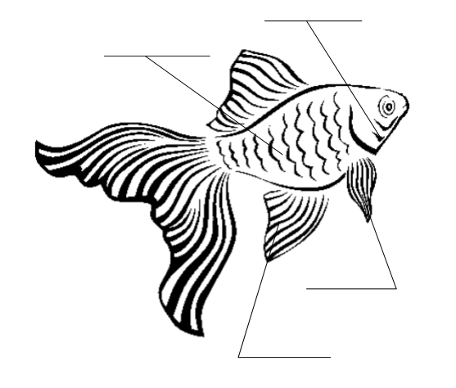[1]

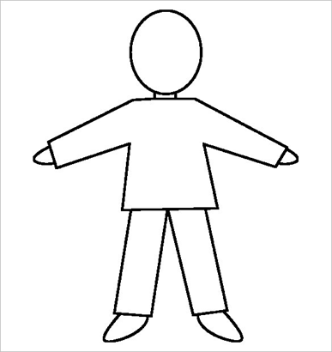[2]

**Evaluate Information**

* For each animal, we are about to see, I would like you to consider the following questions:
  + Where does this animal live?
  + Do you think it could live in somewhere different? Why or why not?
  + Do you think something else also could live in this animal's environment?
  + Why or why not? If an animal could, which animal would it be?

**Communicate Information**

* Your group will be given a short article about an animal. Your job is to gather as much information about that animal as possible to share with the class. Your job is to focus on the special internal and external features of your animal. You will complete a small poster to present your information to the class.
* Things to consider while you are reading:

1. What makes my animal unique?
2. What are some special adaptations that allow my animal to survive?
3. What are some interesting facts that I could share with the class?
4. How could I compare my animal to another animal that we have discussed earlier in class?

* After you have read the article and taken some notes, fill in the chart below.
* A completed chart is a tool for you to collect evidence so that you can complete your poster presentation.

**Internal and External Structures of Animals**

**Animal: ________________________________________**

|  |  |
| --- | --- |
| External Structures: Explain how they work |  |
| How does the animal support survival? |  |
| How does the animal support growth? |  |
| How does the animal support behavior? |  |
| How does the animal support reproduction? |  |
| Any additional information |  |

* Allow your teacher to check over your chart before you begin your poster. Please make sure that you are adding accurate information.
* When you have finished your poster, practice who will say what during the whole-class presentation. Your poster presentation should be three minutes or less.

**Poster Presentation Rubric**

|  |  |
| --- | --- |
| **Poster Requirements** |  |
| **Content** | * Description of the animal’s habitat (1-2 sentences) * Explanation of three different ways your animal is physically adapted to its environment * Explanation of two different ways your animal is behaviorally adapted to its environment * Interesting fact about your animal |
| **Creative and clear graphic (drawing and/or pictures)** | * At least one picture or diagram showing your animal |
| **Organization** | * Titles/Labels * Flow of Information |

**Presentation Rubric**

|  |  |  |
| --- | --- | --- |
| **Presentation Component** | **Possible Score** | **Your Score** |
| Volume/eye contact/clear speech | 25 |  |
| Quality Content: Complete sentences and effective word choice | 25 |  |
| Enthusiasm/preparedness | 25 |  |
| Explanations of the content and graphic(s) of the poster | 25 |  |

1. Picture from<https://www.etsu.edu/coe/cuai/documents/3ls12internalandexternal.pdf>
2. Picture from <https://images.template.net/wp-content/uploads/2015/08/Blank-Human-Body-Outline-Template-For-Kids.jpg>