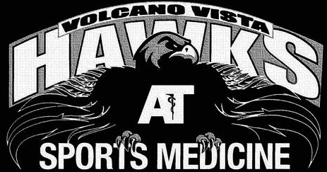

8100 Rainbow Blvd NW, Albuquerque, NM 87114

Athletic Trainer: Enrique Ochoa ATC LAT CES

License Number 669

Contact Ph: 505-890-0343 Ext: 37085

Athlete Name:____________________________

Sport:_______________________

Date of Injury__________________

Injured area/body part_____________________

Diagnosis:

Treatment:

Status:

______Full participation, no restrictions

______Participation with the following restrictions:____________________________________

______Out of Participation

Date of visit:__________

Provider signature and Credentials:______________________ Print name:________________

Phone number or email of provider:_____________________