
Lab: Solubility
Student Guide

Pre-Lab Information
Purpose Explore the relationship between temperature and solubility using a laboratory procedure.
Time Approximately 45 minutes
Question What is the effect of temperature on the solubility of a solid in a liquid?
Hypothesis If the temperature of the liquid is increased, then more sugar will dissolve because warm solutions hold more solute than cold solutions.
Variables Independent Variable: temperature of water
Dependent Variable: amount of sugar that can be dissolved
Summary You will measure the amount of sugar you can dissolve at four (or more) different temperatures of water and analyze the resulting data.

Safety
- Always wear a lab gown and safety goggles while performing an experiment.
- Behavior in the lab needs to be purposeful. Use caution while working around the hot plate.
- Check glassware, such as your beaker, for cracks and chips prior to use.
- Remember to always use the tongs while handling the hot beaker.
- Report all accidents—no matter how big or small—to your teacher.

Lab Procedure

Step 1: Gather Materials
  - 100 mL beaker
  - beaker tongs
  - spoon
  - stirring rod

- thermometer
- hot plate
- hot pad
- balance

  - 300 g sugar
  - ice
  - water
  - weigh paper

Step 2: Measure the Mass of One Spoonful of Sugar
Use a weighing paper to measure the number of grams of sugar that are in one spoonful of sugar. Be sure to use a level spoonful, not a heaping spoonful, to help ensure that each time you add sugar, it is approximately the same amount. Record that value above the data table.

Step 3: Measure Solubility in Cold Water
- Place ice in a 100 mL beaker. Fill the beaker with water until the ice and water total 50 mL. Stir until just a small amount of ice remains. Let the temperature of the chilled water stabilize to obtain a temperature ≈ 5°C (between 0°C and 10°C).
- Record the temperature in °C.

- Add a spoonful of sugar (again, a level spoonful, not a heaping spoonful). Stir using the stirring rod. Continue adding spoonfuls of sugar until the solution becomes saturated, stirring after each spoonful is added.
- After the solution reaches saturation, record the amount of sugar (in spoonfuls) dissolved before the saturation point. Do not discard the solution; continue to use it throughout the rest of the procedure.

Step 4: Measure Solubility in Room Temperature Water
- Place the beaker on the hot plate (setting on medium). Check the water temperature periodically until the water reaches ≈ 25°C (between 20°C and 30°C). Use the tongs to remove the beaker from the hot plate.
- Record the temperature in °C.
- Add a spoonful of sugar, and stir using the stirring rod. Continue adding spoonfuls of sugar until the solution becomes saturated, stirring after each spoonful is added.
- After the solution reaches saturation, record the amount of sugar (in spoonfuls) dissolved before the saturation point. Remember to include the number of spoonfuls added in Step 2.

Step 5: Measure Solubility in Hot Water
- Place the beaker on the hot plate (setting on medium). Check the water temperature periodically until the water reaches ≈ 50°C (between 45°C and 55°C). Use the tongs to remove the beaker from the hot plate.
- Record the temperature in °C.
- Add a spoonful of sugar, and stir using the stirring rod. Continue adding spoonfuls of sugar until the solution becomes saturated, stirring after each spoonful is added.
- After the solution reaches saturation, record the amount of sugar (in spoonfuls) dissolved before the saturation point. Remember to include the number of spoonfuls added in Steps 2 and 3.

Step 6: Measure Solubility in Boiling Water
- Place the beaker on the hot plate (setting on high) until you observe the water boiling (≈ 100°C). Use the tongs to remove the beaker from the hot plate.
- Record the temperature in °C.
- Add a spoonful of sugar, and stir using the stirring rod. Continue adding spoonfuls of sugar until the solution becomes saturated, stirring after each spoonful is added.
- After the solution reaches saturation, record the amount of sugar (in spoonfuls) dissolved before the saturation point. Remember to include the number of spoonfuls added in Steps 2, 3, and 4.
(Optional): Collect additional data at a variety of different temperatures.

Step 7: Dispose of Waste
Let the solution cool before disposing. Dispose of all materials as instructed by your teacher. Clean and dry the glassware before putting it away.

Data
Record your data either in the space below or in your lab notebook.

Approximate grams per spoonful: g

Temperature (°C) | Sugar dissolved (spoonfuls) | Sugar dissolved (grams)*
Additional Data Points
- To fill in the last column, multiply the number of spoonfuls by the number of grams in one spoonful. For example, if your spoon holds approximately 10 grams of sugar, multiply the number of spoonfuls by 10 to obtain the number of grams of sugar. The value will be an approximation, but will be precise enough for the purposes of this lab.

Graph
Graph a scatterplot using x = temperature (°C) and y = sugar dissolved (g). Each row will give one point for the graph. Analyze and interpret the scatterplot.

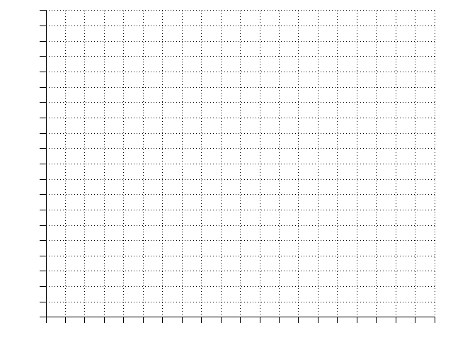

Analysis
When students write their lab reports, they should provide a written explanation of their results that describes how the dependent variable was affected by the independent variable.

Conclusion
When students write their lab reports, they should restate the hypothesis and explain whether it was supported or refuted by the data. They may also revise the hypothesis and state what experiment they would perform next. They should also identify any additional questions that arose from conducting the experiment.

