ATRISCO HERITAGE ACADEMY HIGH SCHOOL

Instructional Council Meeting Agenda

Date of Meeting | 26 January 2023
Chair | Caitlin Hein
Place: AHA Library | Time: 2:40- 4:00 pm

Norms/Rules/Expectations
- Meetings run w/ openness: everyone encouraged to participate
- Timely start, productive meetings, please limit cell/electronics use, stay on topic
- Discussions should be focused and solutions based. Reps are encouraged to workout any issues before the meeting within their groups.

- Introduction – Caitlin Hein
- Time Keeper – Caitlin Hein
- Meeting Minutes – Elizabeth Hill
Walter Scott Trujillo
Valerie Sisneros
Jennifer Hoover
Jessica Chavarria
Jocelyn Carillo Gurrola
Saria Maldonado Cardoza
Cathy Duran
Jessica Babcock (student rep)
Cameron Marquez (student rep)

Time | Topics
10 | Updates:  Registration 2023  BIG CHANGE!!  February 6th we will not release from 4th period and use passing period & Advisory time to do our 1st live lesson surrounding Course Request for the 2023-2024 School Year. Teachers will simply need to login to the Google Meet Link which will be shared via the Advisory Lesson Plan Document. (Please do not share link with students.) Teachers who do not have 4th period class (ie. Prep or collab) will be assigned a partner teacher to help during this time or to hallway duty to send students to class.  -No passing period after 4th (bell schedule below)  -We will still be using physical cards for registration  -We want to capture all students (Students tend to ditch Advisory)  -We want all students to get an equitable experience  *Students with IEPs will get to meet with their sponsor teacher during lesson 2  -Seniors will have a separate activity through our activities department (plan forthcoming). Combo classes: teachers release seniors to attend activity.  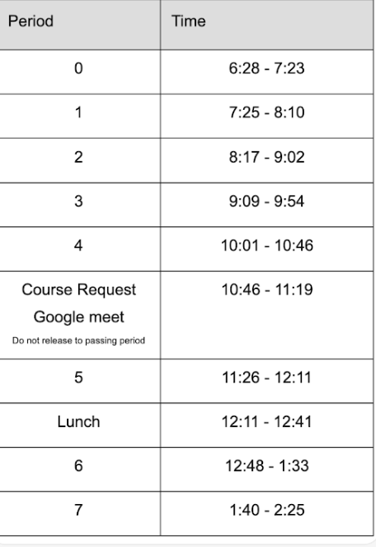  Bell schedules Spring 2023
50 | Hallway duty data review  Write action items for 2/2 meeting  IC Discussion: What’s working and what’s not? What do we need from admin? What are specific action items we can ask departments for feedback on?  Common document created to share ideas, feedback  Feb. 9 meeting we will decide on next steps before sharing out to departments.

