ATRISCO HERITAGE ACADEMY HIGH SCHOOL

Instructional Council Meeting Agenda

Date of Meeting | 11 August 2022
Chair | Caitlin Hein
Place: AHA Library | Time: 2:40- 4:00

Norms/Rules/Expectations
- Meetings run w/ openness: everyone encouraged to participate
- Timely start, productive meetings, please limit cell/electronics use, stay on topic
- Please keep side conversations to a minimum as it is hard to focus in our meeting space.

- Introduction – Caitlin Hein
- Time Keeper – Caitlin Hein
- Meeting Minutes – Elizabeth Hill
Time | Topics
10 | - Bell schedules- Fall 2022 Semester  - proposed change:  - 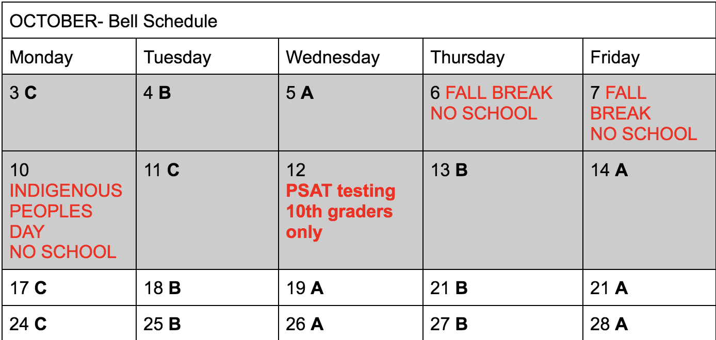
30 | Discipline as it affects instruction  Cell phones: Red, yellow, green system adopted for schoolwide use  Tardies: Attendance- admin is sending out calls every class period to students who are marked absent- if they miss more than 50% of class mark as absent, document in synergy if they are marked absent due to missing more than 50% of the class, after 5 tardies fill out referral form, Teacher policies that work: take cell phone when late, take away bathroom privileges if late (within reason), mini lessons by students with chronic tardies (students teach a mini lesson to the class for every tardy), calls home  Ditching: No more attendance referrals- admin using data to track, teachers PLEASE take attendance  IDs: Checks, order new ones through advisory  Attendance Reminders
20 | Open house:  Format, community activities
20 | Input on the Expectations Assemblies  Ic rep action item: Seek dept input on what needs to be covered.  Be clear on the WHY- why do we have these systems, putting it in context with life skill
 | Questions, next steps

