ATRISCO HERITAGE ACADEMY HIGH SCHOOL

Instructional Council Meeting Agenda

Date of Meeting | 11 August 2022
Chair | Caitlin Hein
Place: AHA Library | Time: 2:40- 4:00

Norms/Rules/Expectations
- Meetings run w/ openness: everyone encouraged to participate
- Timely start, productive meetings, please limit cell/electronics use, stay on topic
- Please keep side conversations to a minimum as it is hard to focus in our meeting space.

- Introduction – Caitlin Hein
- Time Keeper – Caitlin Hein
- Meeting Minutes – Elizabeth Hill

Jessica Chavarria
Jennifer English
Jessica Cano
Valerie Sisneros
Jessica Brooks
Robert Jones
Augustine Garcia
Ashley Nkbengeshe
Joe Montoya
Cathy Duran
Cameron Marquez
Jocelyn MCNL
Jessica Krichels
Katy Hammel
Jessica Malherbe Corcoran
Kaycie Robinson

Time | Topics
10 | - Bell schedules- Fall 2022 Semester  - proposed change:  - 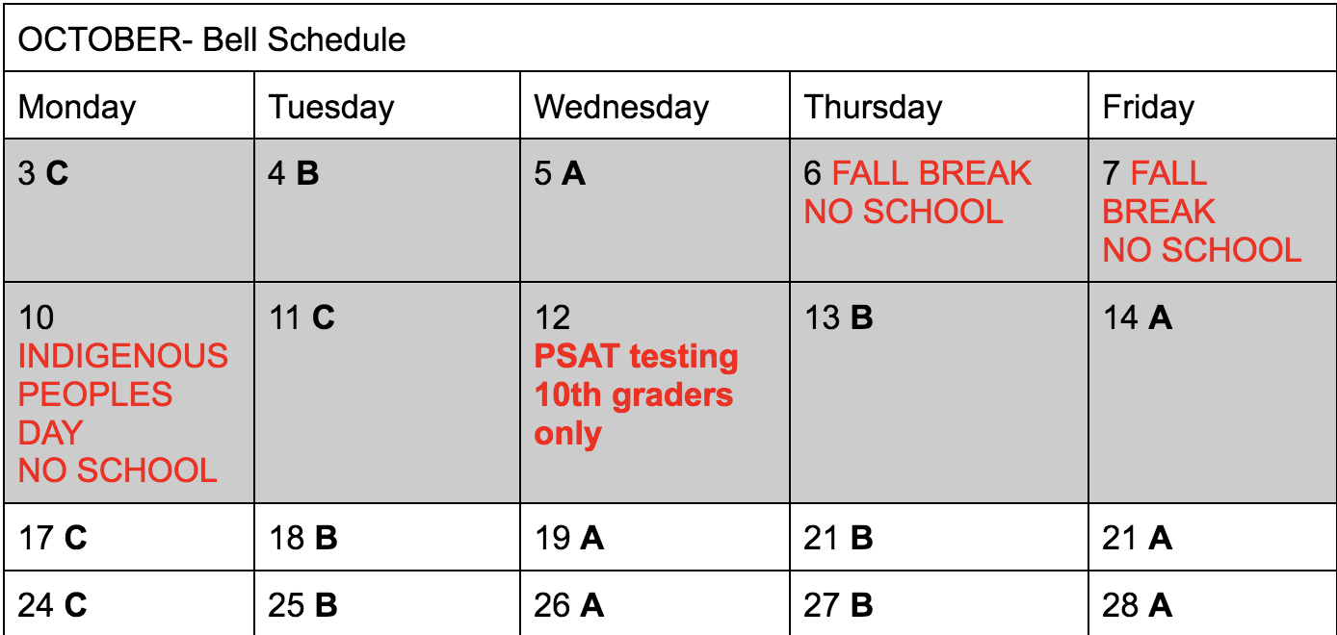  - Tues 10/11 changed to C day, Wed 10/12 pSAT, Ths 10/13 B, Fri 10/14 A  - IC Decision: approved
30 | Discipline as it affects instruction  Cell phones:  - Majority of departments want to move forward with Red Yellow Green policy. Teachers who are against the RYG system do not have to implement.  - RYG signage will be redone (mistake in printing). Will be reprinted and redistributed with magnets ASAP.  - Suggestions for use (up to teacher discretion):  - RED: phones/earbuds cannot be used  - YELLOW: Phones/earbuds can be used for instruction/classwork or for nonacademic uses with teacher permission.  - GREEN: Phones/earbuds allowed.  Tardies:  Important New policies:  - Take attendance in first 10 minutes of class.  - If students miss more than 50% of class, mark them absent and document in Synergy noting the time student came in.  - Admin is calling home every period of absence.  - No one is allowed to leave campus and come back (even seniors, even for lunch).  - If arriving late, students should go through front office for passes. HOWEVER, do not send kids who arrive to class without a pass to go get passes.  - Admin will begin temporarily revoking driving privileges from students who are chronically driving in late.  - After 5 tardies, write incident referral (bottom of JagWU). We are no longer doing attendance referrals; Ms. Nkbengeshe is running absence reports and the attendance office will deal with this.  - tardy referral consequences: lunch detention and parent conference  - Successful policies in use right now for consideration:  - Take cell phone when late  - Restorative justice: kids who are violating cell policy must give back what they took away by delivering lessons on certain topics (bell ringers, discussion, etc)  - Lose hall pass privileges for the day  Ditching: Attendance VP Ms. Nkbengeshe will be taking charge of attendance - teachers no longer need to submit attendance referrals. For 5 or more tardies, use the incident referral doc in the JagWU  IDs:  - Checks, order new ones through advisory  - IDs are a security issue and must be worn at all times. We had several security incidents last year with students/people on campus who should not have been.  - Students who need new IDs can fill out the replacement form and get new IDs before school or at lunch.  - ID wearing can be tied into participation grade (teacher discretion).  Advisory checklist/schedule document:  - Majority of departments want to adopt and continue to use.  - Activity/lesson ideas: teacher appreciation, pSAT testing strategies, conflict resolution, grade checks.  - Monday’s Advisory 8/15: send students with Chromebooks to front office to return.
20 | Open house:  Format, community activities  - Aug 31, 5-8 pm (goal: teachers leave at 7:30)  - Teachers do not need sign-in sheets; sign-in will be at front when they come in  - Families will get passport when they sign in for teachers to fill out as they visit classes. Turn in for chance to win prize.  - First 100 families get coupon for free pizza  - Open House Schedule document  - 5-5:45 - Title I meeting and Taste of AHA w/ vendors and performances  - 5:45-6:45 - Various meetings (AP parent, AVID parent, Senior parent, Bilingual parent, parent/studentvue tutorials)  - 6:45-7:30 - Meet and greet w/ teachers  - New Format→ content areas and grades set up together  - Freshman teachers: F bldg  - Sophomore teachers: E bldg  - Junior teachers: D bldg  - Senior teachers: C bldg commons  - Electives: Main caf  - District programs: B bldg courtyard  - IC Action item: Ask teachers to work together in collab to discuss what they want to share at Meet & Greet. Suggestions: syllabus, contact info, program highlights
20 | Input on the Expectations Assemblies  Held Aug 22 for 9th and 10-12th grades- no advisory, assembly schedule  Action Item: seek dept. input on what should be covered.
5 | Chromebooks - for counselors and Mr. Owen Brown ONLY:  Students who need CBs for eCad work (no technology at home) can get them if they talk to Mr. Brown or a counselor.
 | Questions, next steps

