
August 15, 2019

My Fellow Golden Eagle(s),

Welcome you to Annie R. Mitchell Elementary School. For those of you returning please introduce yourself to new students and staff. Our namesake, Annie R. Mitchell was a humanitarian, a historian, and above all else, an educator. Her beliefs support the S.O.A.R. campaign.

In this packet, I have included important information about our campus and the experience in which you and your family are about to embark. Thank you in advance for taking the time to read the information. We are continuing with the No Charge breakfast and lunch program, as well as our Literacy Based Homework Policy. School information is on our website, PTA Facebook, and sent by email and phone messages. Please call with any questions you have. Enclosed is a calendar of events for the year, however, we will also send out monthly calendars that I hope you find useful as you make your family plans.

Most Sincerely,

Mrs. Loretta Bryant, Principal
2019-20 Annie R. Mitchell Elementary School Literacy Based Homework

Dear Golden Eagle Parents,

After much research and success, Annie R. Mitchell will continue with Literacy Based Homework. All homework for the year will be focused on Literacy. The expectation from all staff is that your child will read each night. Kindergarteners will have a book bag to read aloud to you. We will continue to use Accelerated Reader as one assessment. Be sure to download the app to get up-to-the-minute information on your child’s progress.

Teachers will continue to send home a weekly report to keep you informed of progress and classwork samples. On the back, you will find examples of the math work learned that week. Should you desire additional work for your child to do at home, please see our website for a link to our curriculum and extension activities. Studying is a big component of reading, so your student should be able to explain concepts and draw conclusions. There may also be times your student has a long-term project to complete at home. Please check the weekly report.

Research shows that homework really is more beneficial for older students after 7th grade as they are able to stay focused longer and communicate understanding. Our younger students need time outside of the structured school day to play. As we change our way of teaching in class, students need more time to decompress and spend time with their families. Use your evenings to make memories and allow children to play and discover. Ask them to show you what they are learning each day. Teach them how to read recipes, change the oil on your car, play an instrument, and explore outside. If you are concerned about building homework stamina, create an evening routine that includes lessons from our website or the CAASPP practice test.

Please provide a quiet place for your children to read books, then check for understanding by listening to them read aloud and explain what they read. You can celebrate their progress by using the Accelerated Reader application “Home Connect” and support us in this literacy adventure. This policy should also provide you with time to enjoy family activities. We look forward to a great year working with your children, and preparing them for the future.

On the next page are an excerpt from Forbes Magazine and LinkedIn on the qualities that employers currently desire. Having homework for practice does not seem to align with these needed skills.

Mrs. Bryant, and the Golden Eagle Staff

The Skills Companies Need Most in 2019 – And How to Learn Them
Paul Petrone- January 1, 2019 LinkedIn Learning
https://learning.linkedin.com/blog/top-skills/the-skills-companies-need-most-in-2019--and-how-to-learn-them

Soft Skills- Creativity; Persuasion; Collaboration; Adaptability; Time Management
Hard Skills- Cloud Computing; Artificial Intelligence; Analytical Reasoning; People Management; User Experience Design

The Skills You Need To Succeed In 2020
Avil Beckford- August 6, 2018; Forbes Magazine
https://www.forbes.com/sites/ellevate/2018/08/06/the-skills-you-need-to-succeed-in-2020/#7f3bc569288a

Complex Problem Solving; Critical Thinking; Creativity; People Management; Coordination with Others; Emotional Intelligence; Judgment and Decision making; Service Orientation; Negotiation; Cognitive Flexibility

In addition: Learning how to learn; Speed reading and reading intelligently; Note-taking; Analyzing information; Spotting pattern and trends; Communicating; Understanding and leveraging technology; Cultural awareness and sensitivity;

Golden Eagle Pledge
As part of the Annie R. Mitchell Golden Eagle Family, I pledge to SOAR by using self-control, being on time and on task, acting responsibly, and respecting everyone.
I will show self-control by keeping my hands, feet, and objects to myself.
I will be on task by being prepared and ready to learn at all times.
I will act responsibly by following all campus expectations.
I will respect everyone by using kind words and actions.
I will SOAR

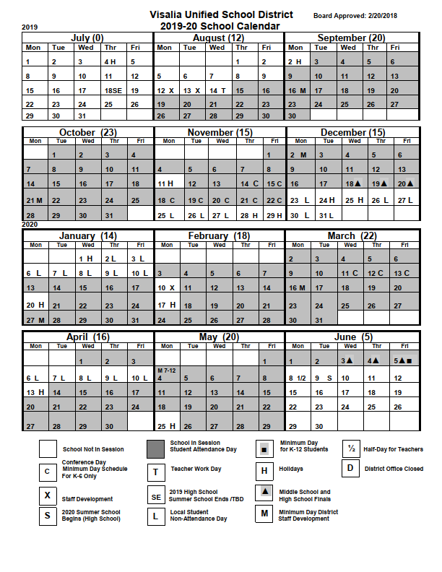

Annie R. Mitchell Elementary School

Tentative Calendar 2019 – 2020

*Most up to date calendar to be sent at beginning of each month.
August
- PTA sign-ups.
- PTA fund raiser starts

September
- PTA Meeting 6:00 pm
- 2nd No school in observance of Labor Day
- 5th 5:30-6:00 Title 1 Meeting, 6:00 – 7:00 pm Back to School Night
- 16th Staff Development/Minimum day 12:30 dismissal (K– 6th)

October
- PTA meeting 6:00 pm
- Movie Night
- Red Ribbon Week
- 11th Fall Picture Day
- 21st Staff Development/Minimum day 12:30 dismissal (K– 6th )

November
- End of Trimester 1
- PTA meeting
- 11th No school in observance of Veteran’s Day
- 14th-22th Parent Teacher Conf. Early dismissal 12:30 grades (K– 6th )/
Book Fair
- 25th-29th No school in observance of Thanksgiving holiday
December
- PTA meeting
- Winter Craft Night
- Dec 23rd- Jan 10th Winter Break

January
- 13th School Resumes
- 20th No School in observance of Martin Luther King Jr. Day
- 27th Staff Development/Minimum day 12:30 dismissal (K – 6th )

February
- PTA Meeting
- Mom’s & Muffins
- A&W Family Night
- 10th Staff Development-No School
- 17th No school in observance of President’s Day

March
- PTA meeting
- End of Trimester 2
- Dad’s & Donuts
- 11th-13th Parent Teacher Conferences early dismissal 12:30 grades K – 6th
- 16th Staff Development/Minimum day 12:30 dismissal (K – 6th )

April
- PTA meeting
- Science Olympiad
- 6th-13th Spring Vacation
- 14th School Resumes
May
- PTA Meeting
- Music Festival
- 25th No school in observance of Memorial Day
June
- 5th Last day of School, Minimum Day 12:30 dismissal (K-6th)

Annie R. Mitchell Daily Schedule
2019-2020
7:45 | Campus Opens
8:15 | Class instruction begins K-6
9:30-9:45 | 1st/2nd Recess
9:45-10:00 | 3rd/4th Recess
10:00-10:15 | 5th/6th Recess and Kindergarten Recess – Pursifull/Galicia/Farmer
10:15-10:30 | Kindergarten Recess - Solorio/Martin
11:00 | 1st Grade lunch begins
11:15 | 2nd Grade Lunch begins
11:15 | 1st Grade lunch goes to recess
11:30 | 2nd Grade Lunch goes to recess
11:30 | 3rd Grade Lunch begins
11:40 | 4th Grade Lunch begins
11:45 | 3rd Grade Lunch goes to recess
11:40 | 5th Grade Lunch begins
11:55 | 4th Grade Lunch goes to recess
12:20 | 6th Grade Lunch begins
11:55 | 5th Grade Lunch goes to recess
11:55 | Kindergarten Lunch
12:35 | 6th Grade Lunch goes to recess
12:10 | Kindergarten lunch goes to recess
2:05 | Primary Grade dismissal (K-3)  4th, 5th, 6th Wednesday only
2:55 | Secondary Grade dismissal (4-6)

Programs and Parent Committees

Educating a child is a partnership between a child’s family, the school, and the community. The staff at Annie R. Mitchell are committed to offering a challenging learning environment that is greatly enhanced by parent and community support.

Parents work collaboratively with staff to set priorities, help write the school achievement plan, and serve as elected members of the School Site Council and English Learner Advisory Committee. These meetings are open to all and occur throughout the school year.

A morning and afternoon Preschool are located on our campus. In addition we have two special education classes located on our campus for students who are severely disabled.

The HEART After School Program will be able to offer parents a grant funded program with attendance requirements that runs each day from 2:05 – 6:00pm. This program provides enrichment, reading time, and recreational activities.

The Annie R. Mitchell PTA is a very active part of the Golden Eagle Family here on campus. All families are encouraged to become members and stay involved in the lives of their children. Meetings are held monthly from 6:00pm to 7:00pm on campus in the school cafeteria.…..please plan on joining us and finding out how you might take part in this fantastic school partnership.

Attendance…children need to be in school and on time each day.
Successful students have to have good school attendance. Research shows the greatest indicator of a child’s academic success is regular school attendance. Annie R. Mitchell follows all state and local laws concerning student attendance.

Students who are late to school shall report directly to the school office to obtain a tardy pass. Parents will accompany their students and state the cause of the delay. If your child is late due to a doctor’s appointment, please submit a doctor’s note indicating the appointment time.

When your child is absent we want to make sure they are safe and well. Please call the office on the day of the absence to inform our staff. You will receive automated calls and a personal call from our office assistant, after these attempts your child’s absence will be marked as unexcused.

Before and After School
The campus opens to students at 7:45am. Students are not allowed on campus until this time as there is no supervision. When students are dismissed from school they are to go directly home or to their place for after school care (HEART, bus zone, etc...)

Traffic Safety. Dropping off and picking up students is a regular part of the school day, but one that may pose great danger. Please exercise extreme caution while in our parking lot or near our school:
- Pull into a parking space….do not stop in the driveway.
- Do not park in the loading zone areas or fire lane. (red)
- Always drive slowly when on or near campus. 10 mph in parking lot and 25 mph on street.

Student Life
Medication. Parents must register all medication with school nurse. All medication/s must be kept in the school office. A doctor’s note must accompany each medication before we may dispense the medication.

Lost and Found. A lost and found garment rack is maintained outside the southern cafeteria door. Lost and found items (not clothing) are kept in the school office. Please check with the office staff if you are missing something. Periodically notices will be sent advising of our intent to donate any remaining articles.

Parties in the classroom. In keeping with our ongoing efforts to protect instruction time as well as the safety of our students, parties (including food items) will be limited to the three pre-determined “Potential Party days”. All donated items must be pre-packaged foods.
- Day before winter break
- Valentine’s Day
- Last Day of School

Snacks at school. Snacks are permitted on campus, but must be consumed only in the designated break areas, and at recess. Please ensure the items sent are nutritious (no sodas, or energy-type drinks), and for safety reasons snacks may not be shared with other students. Glass containers are not allowed.

Annie R. Mitchell School Campus Rules

1 Students may not be dropped off at school before 7:45 a.m.
2 Students shall walk on sidewalks or on blacktop play areas except when running is required as part of an organized game (e.g. basketball, dodge ball, four square).
3 Students must have a pass whenever out of class during instructional time (exception: band/orchestra instrument = hall pass).
4 Students shall avoid physical contact with the exception of reasonable contact that occurs in some organized games (e.g. football, basketball)
5 Students should be ready to begin instruction in the classroom within three minutes of ending recess, and must walk to their designated classroom line.
- Plastic bats are to be used under adult supervision only and only in front of back-stops. All students waiting to bat must be behind a backstop. No other games shall be played in the area in which a softball game in being played.
- No activities involving the throwing/kicking of balls/objects shall be played near classroom buildings or on blacktop. These games must be played on the field.
- Toys are not appropriate at school. For this reason toys (including electronic equipment) may not be brought to school.
- A bike rack is provided for storage. Skates and skateboards of any kind shall not be ridden on campus at any time and may be stored in class.
- Upon arrival, students shall remain on campus until dismissal time.
- Students shall use restrooms designated for their grade level
- Lunch is to be eaten only in the cafeteria unless otherwise directed. Snacks at recess are to be eaten only in designated area.
- At dismissal all, students are expected to go directly home or to their afterschool program/s.
Annie R. Mitchell Elementary School

Dress Code
(2019 - 2020)

All students should wear clothing to school that fits well, reflects pride in oneself, is conducive to the learning process and demonstrates respect for school. The following guidelines are provided in conjunction with the Visalia Unified School District Student Conduct Code – Grades K-6.

As per Ed Code, any personal distraction on an individual shall not be allowed if it contributes negatively to the learning environment in the classroom. Teachers are expected to ensure the compliance of the dress code, and will contact the principal with questions about particular issues. Parents will be notified and/or asked to provide a change of dress.

- Shoes that are appropriate for school activities must be worn at all times. Shoes with cleats or high heels (including wedges) are not allowed. Shoes must have a heel strap.
- Caps and headgear shall not be worn at any time in buildings. Head covering may be permitted with written medical reason from a parent/guardian or religious belief. Headgear may be permitted during special event days as designated by the school site principal.
- Sunglasses shall not be worn unless a written medical reason is provided.
- Shirts and tops must cover the mid section at all times. Students shall not wear tube or halter tops, backless garments, see-through tops, shirts with spaghetti straps, fishnet, or half-tops. Shirt straps must be 1” or wider.
- Skirts and dresses should be longer than palms (finger joint) when arms are resting by sides.
- Pants and shorts must fit at the waist, hips, crotch and thighs. “No bagging or sagging.” Shorts should be longer than palms (finger joint) when arms are resting by sides.
- Underwear shall be worn and covered at all times.
- Clothing artwork and decoration shall not advocate, advertise, crude or vulgar printing, promote drugs or alcohol, violence, or gang activity or affiliation.
- Make Up is not allowed at the elementary grades.
- Studded Earrings are the only ear accessories permitted due to safety reasons.
- The Principal has the discretion to prohibit any other attire that does not meet the criteria listed above and has the discretion to make reasonable exceptions to the above for special days or events. Further, any distraction caused by a student’s dress and/or appearance that negatively impacts the educational environment on campus will be referred to the Principal.

