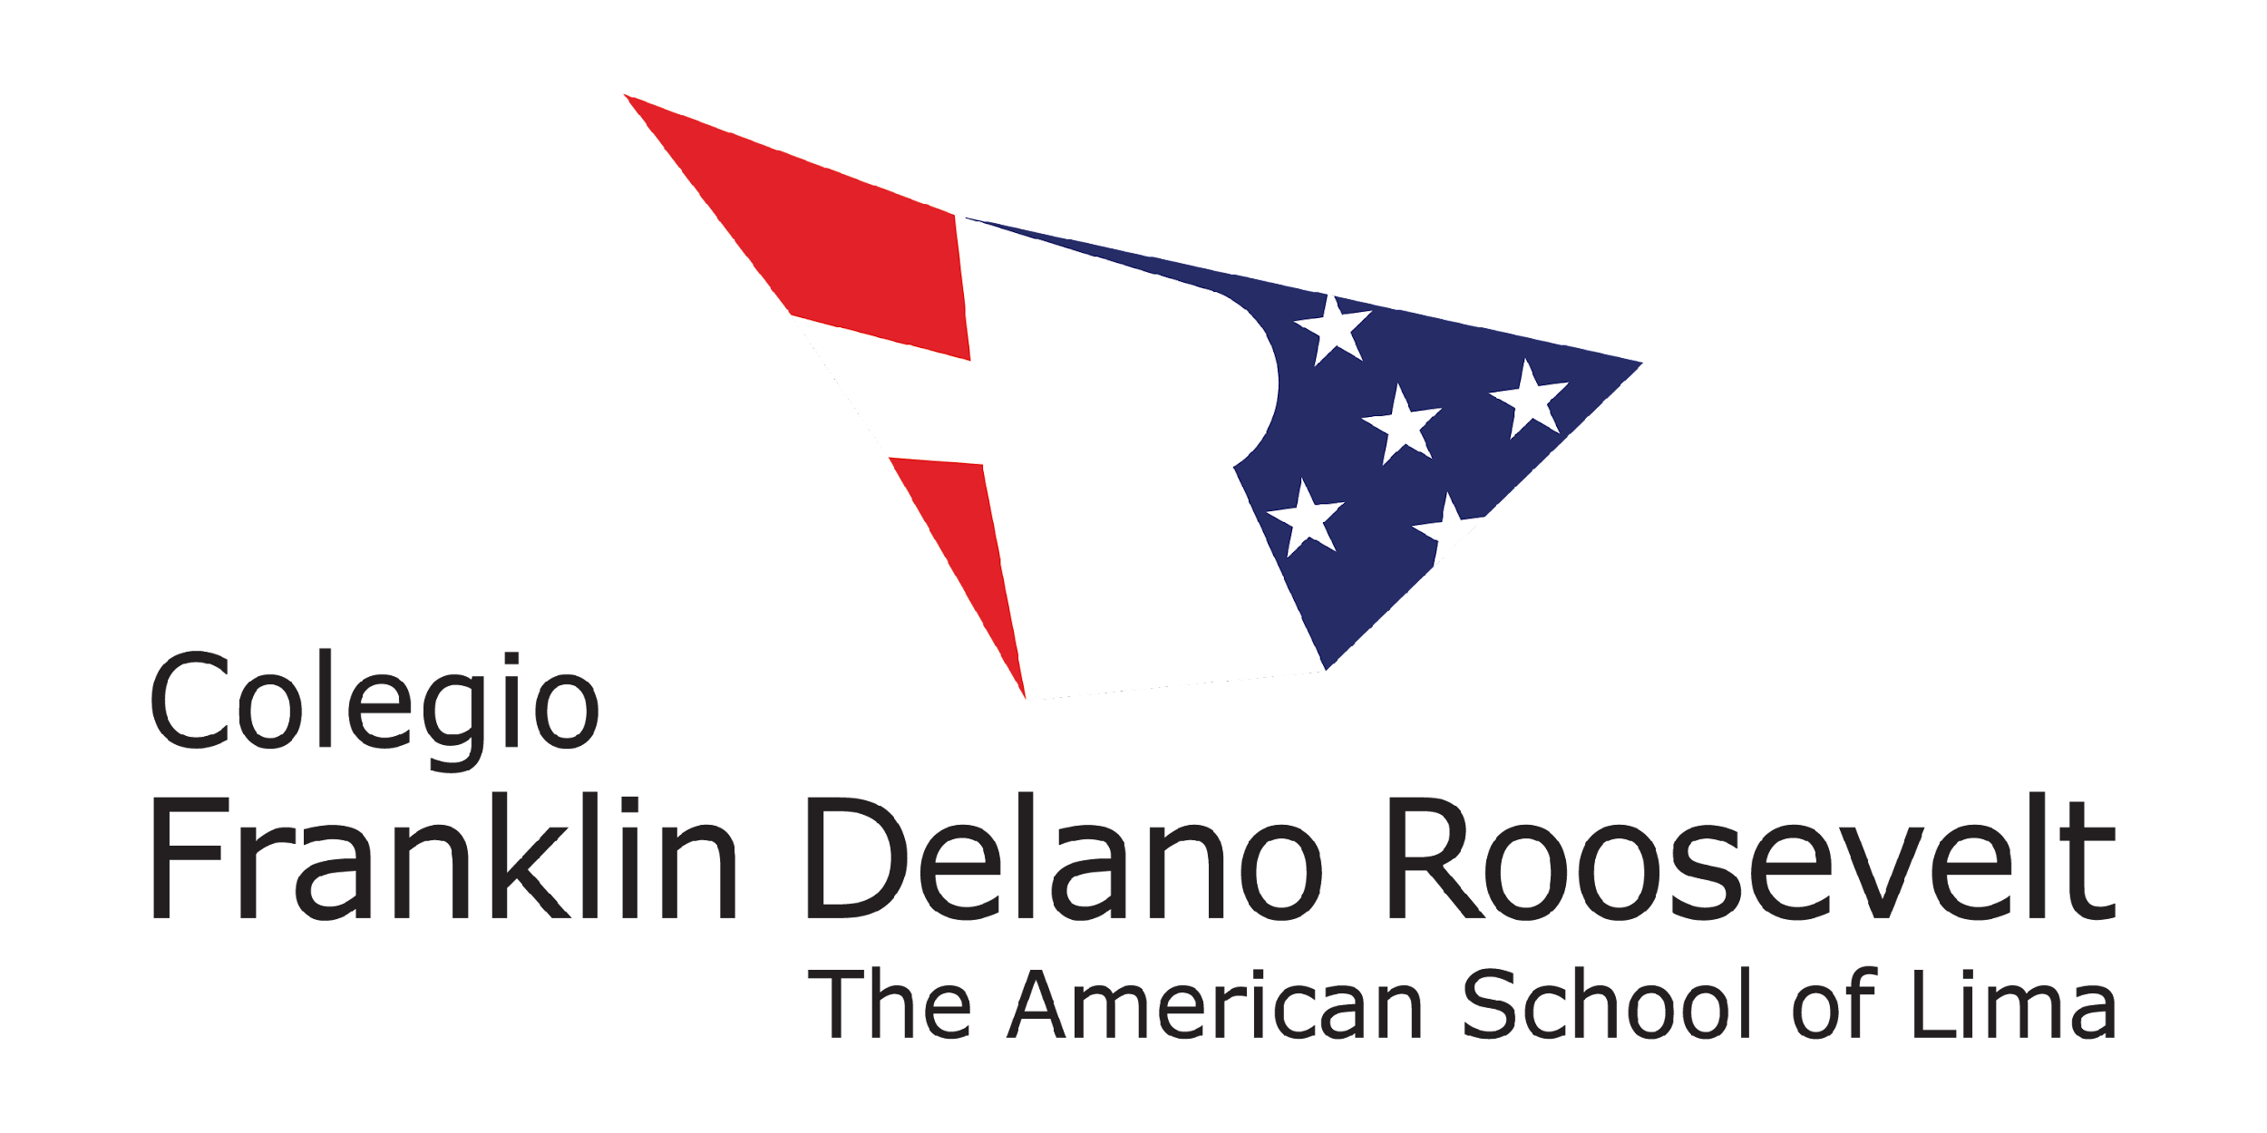

EDUCATIONAL SERVICES ENROLLMENT CONTRACT 2023 - 2024 ACADEMIC YEAR

In accordance with Peruvian Government’s Law 27665, regarding “Protection of the Family’s Economy Law regarding payment of tuition to Private Educational Institutions,” and as established with Law 29571, Protection's Code and Consumer Defense, all parents must be informed of the following notwithstanding the additional terms included.

Teaching Method: Parents and/or guardians declare that the provision of educational services offered by Colegio Roosevelt will be carried out under the educational teaching method which is established sporadically by the Ministry of Education in the exercise of its guiding functions (e.g. face-to-face, remote or an alternation or combination thereof or similar) and according to the best practices implemented by Colegio Roosevelt. The change of method and any relevant aspects related to the educational services provided by Colegio Roosevelt will be promptly communicated to parents and/or guardians.

Cost of the service: Parents and/or guardians declare to know and agree with the information related to the cost of educational service described below and the other conditions informed upon the student’s acceptance to Colegio Roosevelt, as well as the legal and philosophical framework observed by Colegio Roosevelt and the School's Internal Bylaws. Parents and/or guardians understand that Colegio Roosevelt’s Board of Directors has the right to review tuition fees annually. Parents and/or guardians declare to know and agree to the monthly tuition fee indicated in the table in this section, respectively;

Tuition School Year 2023-2024

 | EARLY CHILDHOOD  EC3 - EC4 | ELEMENTARY  KINDERGARTEN – 5th | SECONDARY  6th – 12th
Annual Tuition | $15,830 | $17,110 | $17,940*
Monthly Tuition | $1,583 | $1,711 | $1,794*
Annual Transportation Round Trip (optional) | $1,890 | $1,890 | $1,890
Annual Transportation One Way (optional) | $1,278 | $1,278 | $1,278

- Tuition Fees: The annual school fees include tuition and can be paid in ten (10) monthly installments: July (enrollment), August to December (Semester I) and March to June (Semester II). The dues for the payment of the monthly tuitions will be the last day of each month as indicated in the table below.

- The annual tuition for 12th graders will be divided into 9 monthly installments: July (matriculation), August to December and from March to May ($1,993 per month)

FIRST SEMESTER |  |  | SECOND SEMESTER
Month | Due Dates |  | Month | Due Dates
July (matriculation) | July 31 |  | March | March 31
August | August 31 |  | April | April 30
September | September 30 |  | May | May 31
October | October 31 |  | June | June 30
November | November 30
December | December 31

Recognition: The parents and/or guardians acknowledge that the school tuition for the provision of the contracted educational service has been established considering those inherent costs under any modality that is provided. Consequently, the parents and/or guardians declare that, if for any reason that is not attributable to them, Colegio Roosevelt is forced to nominally exclude such costs from the concept of school tuition, these will continue to be recognized by the parents and/or guardians as part of the school tuition, without prejudice to the modality of educational service that corresponds to apply. This is because they are essential resources for the fulfillment of the purpose contracted through this document and that Colegio Roosevelt is a non-profit entity, which must maintain a balanced budget.

Financial Assistance Program: This program provides to families who require assistance and upon compliance with the procedure and evaluation described in the documentation that will be provided to those who request it to the email address financialaid@amersol.edu.pe, under the deferred payment of monthly tuition and reduction of monthly tuition.

Matriculation Fee: The matriculation fee is equivalent to the July tuition and is due on the 31st of that month. New students accepted to Colegio Roosevelt after the academic year has started, must pay a matriculation fee equivalent to one-month tuition.

It is important to mention that, even if the parents and/or guardians have complied with the Registration Online process on the school's web portal (ROL), registration will not proceed and the student may not complete the following academic year in the event that the economic obligations agreed in this contract against Colegio Roosevelt have been breached, except in cases that have been the subject of a deferred payment agreement. The above is applicable without prejudice to the provisions of section 10. If this assumption is filed, Colegio Roosevelt will report 30 calendar days before the end of the academic year on non-continuity of educational services as a result of the above-indicated breaches.

Annual Transportation Fee: School transportation is optional. Users of this service may pay it in nine installments of $210 each (round trip) or $142 each (one way), from August to December and from March to June and need to be paid the last day of each month.

Penalty Interests: Penalty interests will be charged on monthly payments made after the due date referred to in section 3 above, respectively, which will be accrued automatically. The default interest rate shall be equivalent to the maximum rate set by the Central Reserve Bank of Peru – BCR which is applicable, as published on the official portal of the BCR.

Sports and other Extracurricular Activities: Most sports and extracurricular activities have no additional cost to the applicable monthly tuition. However, there are some activities that require additional payments, such as: Swimming Academy, Classes Without Walls, Out-of-School Adventure Education among others. Non-attendance to these activities will not impact the student’s educational record or any other concept regarding its educational service. The cost of activities at an additional cost will be timely informed to users, as appropriate. In any event, these extracurricular activities shall be carried out and adapted to the health protocols established by the competent authorities for this purpose.

Participation in extracurricular activities where FDR will be represented: If after a voluntary participation the student is selected to represent FDR by performing a certain activity in an international competition, this will be timely communicated to the parents including information regarding its cost, as appropriate. Students are not obligated to participate in such activities and their non-attendance will not impact the student’s educational record or any other concept regarding its educational service.

School Policies: Parents and/or guardians commit themselves to support the policies and procedures of Colegio Roosevelt outlined in the Parent Handbook located in THIS LINK which we declare we have reviewed and accepted.

School Certificates: According to applicable law, Colegio Roosevelt has the right to withhold the school certificates corresponding to the periods of unpaid tuition fees.

Medical Information: Parents and/or guardians attest that the medical information provided is accurate and complete.

Technology Digital Citizenship Agreement: Parents and/or guardians declare that they have reviewed, understand and agree with the statements listed in the Digital Citizenship Agreement that their minor child/children under my guardianship will sign during the first month.
EC-K: EC3 - K G1-G3: G1 - G3 G4-G5: G4 - G5 G6-G12: MS - HS

Internal Regulations: Parents and/or guardians declare that they have read the School’s Internal Bylaws published in the following link:

https://www.amersol.edu.pe/learning/official-peruvian-program/reglamento-interno and that they agree and commit to comply with the information stipulated in this document. Likewise, they declare that the information included in the Internal Bylaws may be modified, which will be timely informed, and may be reviewed. If parents have any questions, please contact the following email: csturner@amersol.edu.pe

- Verification information process: Colegio Roosevelt reserves the right to verify, in any case and as its convenience, the truthfulness of the information provided or shared by the parents and/or guardians through any of the means available of public access information (e.g. social network platforms). For such purposes, Colegio Roosevelt will observe any applicable regulation, including the one related to data privacy protection.

- Evaluation of Compliance: As part of the enrollment process, Colegio Roosevelt reserves the right to require parents or guardians to submit proof of non-debt for education fees or similar, or documentation that complies with the same purpose, issued by the educational institution or nursery of origin of the applicant student.

- Parent Participation: Colegio Roosevelt is an international school subject to a special and independent regimen that offers educational preparation in English language under high quality standards for students from age 3 through grade 12.

Colegio Roosevelt expects parents and guardians to commit themselves to support Colegio Roosevelt’s Mission, Core Values and Strategic Objectives listed below:

MISSION STATEMENT - Our mission is to empower our students to pursue their passion for learning, lead lives of integrity and create socially responsible solutions.

CORE VALUES

We believe that:
- embracing diversity sustains and enriches life.
- service develops the individual and builds community.
- experience is the most profound source of learning.
- each person has the potential to contribute.
- individual integrity is fundamental to a healthy community.
- choice empowers.
- survival of humanity depends on the health of the environment.

STRATEGIC OBJECTIVES

All students will:
- consistently engage in exploring and sharing diverse learning experiences in the pursuit of educational excellence.
- consistently align their words and actions, take responsibility for the consequences of their choices and treat themselves and others with respect.
- choose to act as socially responsible change agents for sustainable solutions to challenges in their community.

I declare that I agree with the terms and conditions applicable to the provision of educational service provided by Colegio Roosevelt and that it may be provided in different methods, as described herein. I also declare that I have read what is expected of me as a parent and/or guardian and am committed to supporting Colegio Roosevelt to ensure that my child (or minor under my guardianship) has a successful educational experience. I agree that non-compliance with the School Policies, Internal Regulations and Digital Technology Conduct Agreement, which I have reviewed and agree with, could result in the suspension or cessation of my child's (or minor under my guardianship) studies and that tuition for the next school year is not guaranteed. I also declare that I have been informed that, in case there are unpaid economic obligations to Colegio Roosevelt for the 2022-2023 academic year, except in the case of a deferred payment agreement under the Financial Assistance Program, my child (or minor under my guardianship) will not be enrolled for the following academic year and, in the case of unpaid tuitions, it will be possible to retain the corresponding certificate of study. Finally, I assume the commitment to comply on time with the payment of school tuition as set out in this document. This contract regulates the provision of educational services exclusively during the year 2023-2024 and will be terminated without any subsequent act at the end of that school year, except for the benefits provided by Colegio Roosevelt or parents or guardians, as the case may be, that must be implemented subsequently as agreed between them, as well as the policies of Colegio Roosevelt and the provisions of the educational authority.

Father’s or Guardian’s name _______________________________ Father’s or Guardian’s signature ________________________________

Mother’s or Guardian’s name _______________________________ Mother’s or Guardian’s signature _______________________________

Date _____________________________________________

ANNEX OF THE EDUCATIONAL SERVICES ENROLLMENT CONTRACT 2023 - 2024 ACADEMIC YEAR

In addition to the information contained in sections 2 and 5 of the Educational Services Enrollment Contract 2023 - 2024 Academic Year regarding the cost of the educational service, parents and / or guardians of new applicants are informed of the following applicable payments:

Application Fee (non refundable, non transferable): $500 per student. This fee will be charged only once. If the applicant is accepted, it will not be deducted from the Monthly Tuition nor from the Entrance Fee.

One-time Entrance Fee (non transferable): $19,500 per student. A $1,000 must be paid in advance. This payment is refundable if the student is not accepted. Once the student is accepted, parents must pay the balance of the entrance fee (minus the $1,000 paid as a deposit).

A note regarding reimbursement of entrance fees:

Students who attend Colegio Roosevelt are fortunate to experience a school with world-class facilities already in place and several additional capital projects just ahead. For example, the Roosevelt Elementary School, the Early Childhood Center, the Commons, the Condors Plaza, the safe internal pick up / drop off and the parking facilities, the athletic track and the playfields, each has been funded through the entrance fees associated with many students of the past. These facilities would not be possible without the funding that our entrance fees have provided.

In addition, a percentage of our entrance fees is committed to the Roosevelt Scholarship Program. All of these funds go directly to support the inclusion of top-notch students from the broader Lima community who would not be able to afford this education without this financial support from FDR. This program is at the heart of the school’s mission. Again, this would not be possible without the past, present and future contributions from the entrance fees.

So, the entire entrance fee paid upon admission to Colegio Roosevelt is immediately committed to provide for the capital projects and for the scholarship program that guarantee a “Roosevelt” first-rate educational experience for all. While entrance fees have become partially and technically reimbursable upon the exit of a student, it is respectfully asked that all paying entities consider that requesting the reimbursement of the entrance fee could deprive current and future students of full access to Colegio Roosevelt.

We Are Colegio Roosevelt. We Are Stronger Together.

I declare that I agree with the terms and conditions applicable to the provision of educational service provided by Colegio Roosevelt regarding the economic aspects described in this Annex, which is an integral part of the Educational Services Enrollment Contract 2023 - 2024 Academic Year. Likewise, I hereby declare to know that the information described in this Annex must be read and reviewed taking into account the information provided in the Educational Services Enrollment Contract 2023 - 2024 Academic Year.

Father’s or Guardian’s name _________________________________ Father’s or Guardian’s signature ________________________________

Mother’s or Guardian’s name __________________________________ Mother’s or Guardian’s signature _______________________________

Date ________________________________________________

May 2023

