## Extracurricular Offerings/Family Events

Cleveland Middle School excels in offering opportunities for every student to be involved. Research has shown that the more students are involved, the more successful they are academically. These are some of the activities that we offer:

**Academic Support**

* Before/After/Lunch School Activities:
  + Archery
  + Basketball/Volleyball/Track/ Soccer/ Flag Football/Cross Country/Tennis
  + Cheerleading
  + Golf
  + Esports
  + Honor Society
  + Open gym before school
  + Math Quiz bowl
  + Student Council/Community Service/Student Leadership
* 1+2 Clubs
* Spelling Bee
* 8th Grade Parent Night
* Homework Diner
* Spanish-Speaking Families Meetings
* Community School Council
* Adult Ed Computer Class
* 5th Grade Night

# 

# 

# Contact Us:

**Phone us at 505-881-9227 and enter the extension, or send us an email.**

**Marisol Fraga**- Principal, ext. 43501; [fraga@aps.edu](mailto:fraga@aps.edu)

**Amanda St. John**- Assistant Principal, ext. 43503; [amanda.stjohn@aps.edu](mailto:amanda.stjohn@aps.edu)

**Erica Pacheco**- Director of Special Programs ext. 43514; [Pacheco_er@aps.edu](mailto:Pacheco_er@aps.edu)

**Anne Portman, Deborah Maldonado**- Counselors ext. 43512 ; [anne.portman@aps.edu](mailto:anne.portman@aps.edu); [deborah.maldonado@aps.edu](mailto:deborah.maldonado@aps.edu)

**Johnnie Thompson, RN**- Health Office ext. 43511; [johnnie.thompson@aps.edu](mailto:johnnie.thompson@aps.edu)

**JoAnne O’Connell**-Community School Coordinator ext.43532;[joanne.oconnell@aps.edu](mailto:joanne.oconnell@aps.edu)

**Attendance Line**- ext. 43500

**Title I at CMS**

Cleveland Middle School has been a Title I school since 2010-11. What does this mean for your family? Families are invited to review and revise our **School-Family Engagement Policy and School-Family Compact** each year to help **promote the academic success of our students. We welcome your input.** Families are invited to attend our annual Open House when our Title I program plan and budget are presented. For questions about Title I please contact our school coordinator at (505)881-9227 or visit our website: <http://cleveland.aps.edu>, select ‘**Family Engagement.’**

**Revised March 2022**

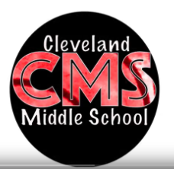

**Family Engagement**

**2022-2023**

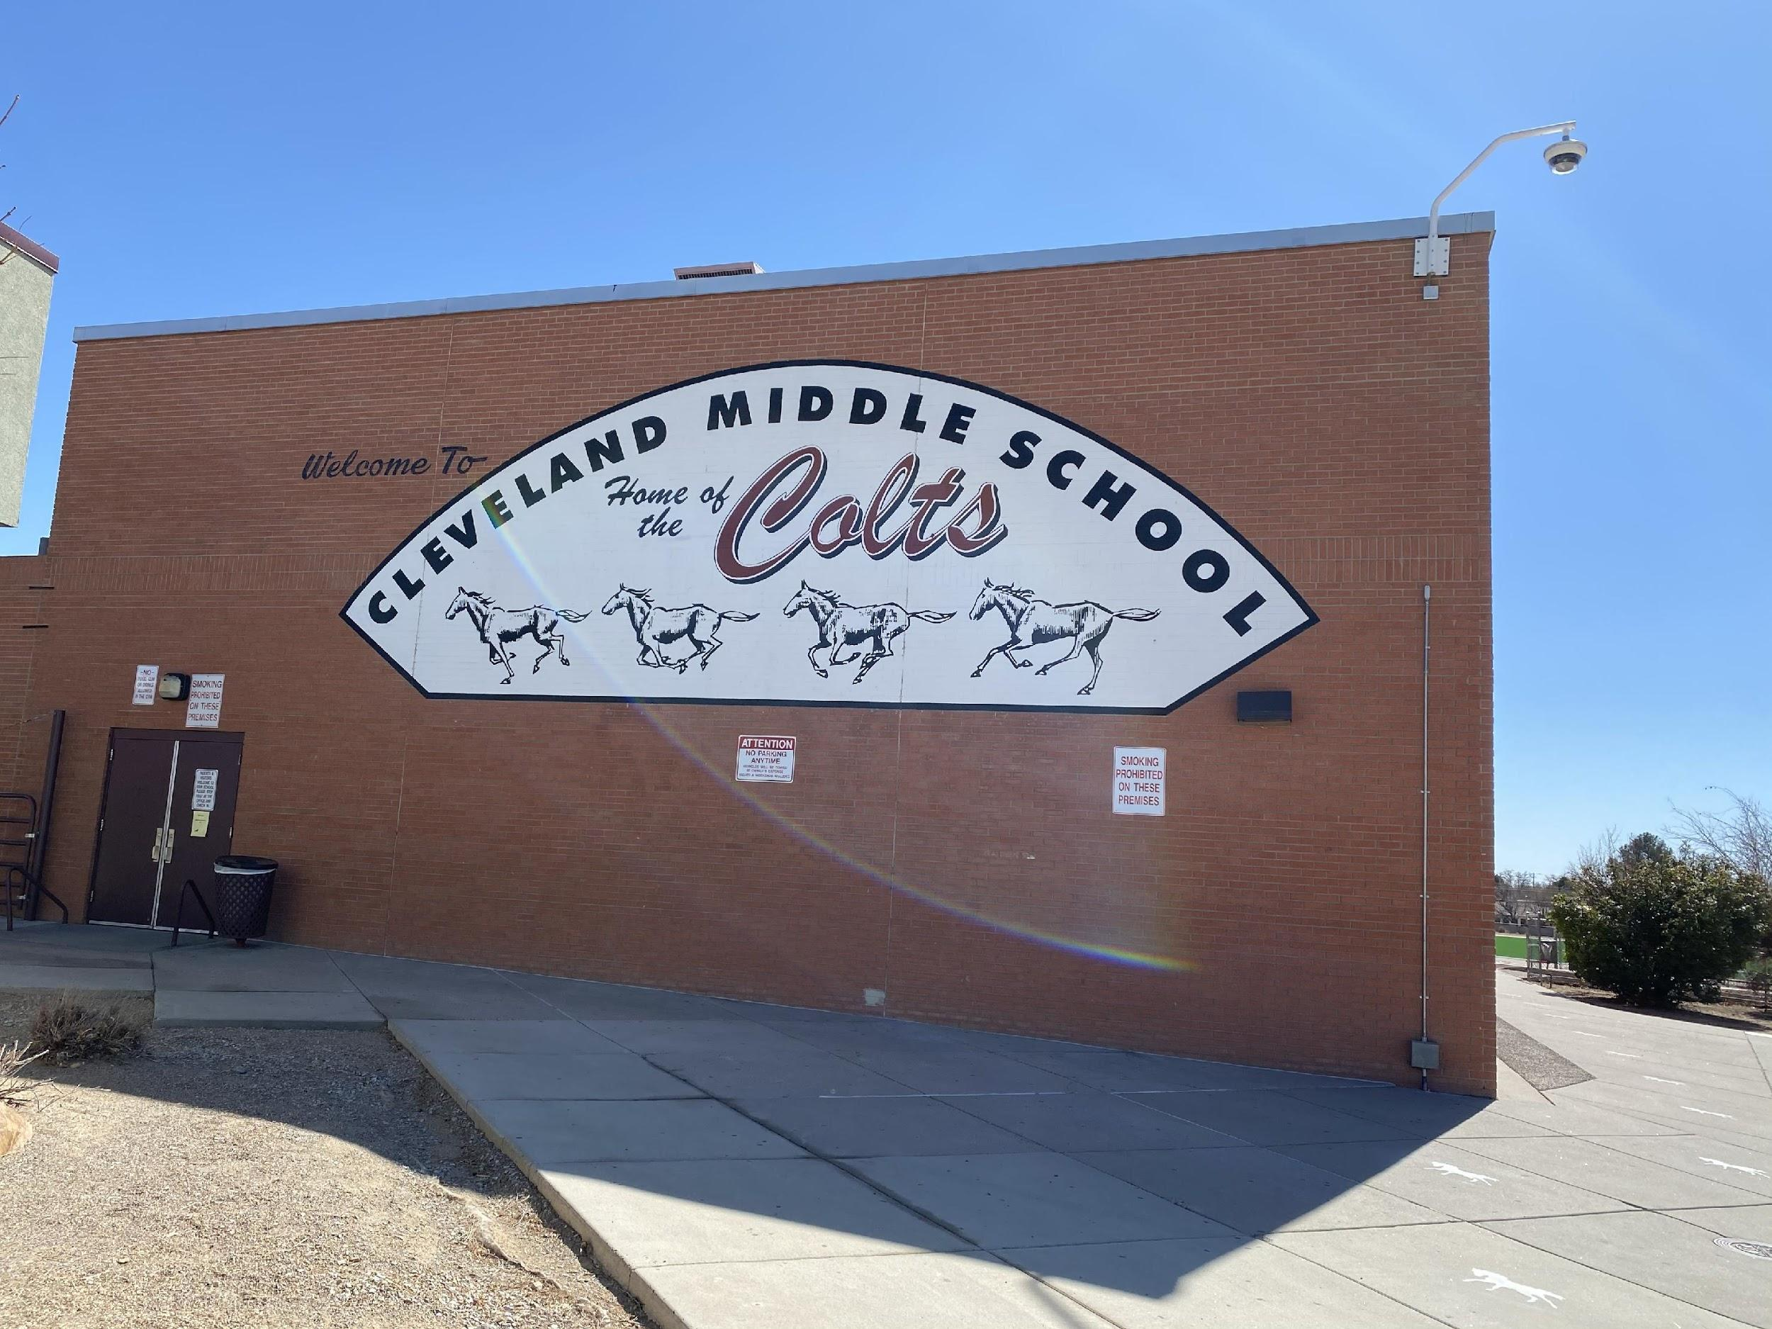

|  |
| --- |
| **Marisol Fraga, Principal**  6910 Natalie NE  Albuquerque, New Mexico, 87110  (505) 881-9227  Cleveland.aps.edu |

# Mission Statement

**Cleveland’s Mission is to provide quality learning and create opportunities for each student to succeed.**

# Curriculum Offerings

Cleveland offers an engaging and challenging middle school curriculum that is aligned with Common Core State Standards (CCSS)

* SpringBoard- CMS is a national demonstration school for this Pre-Advanced Placement curriculum in Math and English Language Arts
* Gifted curriculum in: Social Studies, Language Arts, and Seminar
* Enriched Math at each grade level, Algebra I for qualifying students
* Teacher with Teams- students are grouped with a team of teachers to build community
* Intervention- daily class for all students that address skill proficiency
* AVID- Advancement via Individual Determination, visit [www.AVID.org](http://www.avid.org) for more information
* Band, Orchestra, Chorus, Family & Consumer Sciences, Art, Technology, Health, PE, Yearbook, Leadership, Leadership (ROTC), Navajo, Media Literacy, Video Education

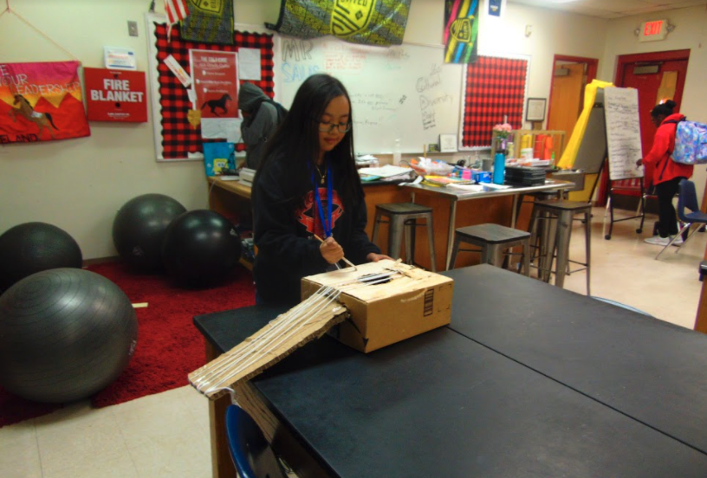

## Cleveland Middle School Family Engagement Policy

**Safety**

* All students provided with picture IDs
* Two full time counselors
* Full time registered nurse

**Support**

* Safety Plans school wide
* All students provided with agendas with weekly grade checks, annual calendar of events and School-Family Compact
* Parent Vue online system for families to check grades, assignments, attendance
* Free Before/After School Academic Support
* Free shot and dental clinics
* An active PTA
* PTA Sponsored student recognition initiative: Class of Cleveland
* Quarterly Rewards & Recognition Assemblies
* Social Worker to support/address school attendance
* **Cleveland is now a Community School and offers more support through community partners**

**Communication**

* School website with translation feature
* School Marquee
* Automated calls and emails
* Email addresses and links for all staff
* Student Led Conferences in the fall and spring
* Open House and S.T.E.A.M. Night
* Family Engagement opportunities
* Volunteer orientation/training provided
* Instructional Council Meetings held bi-weekly
* School-Family Compact in place
* School Newsletters
* Family Engagement web page with links to useful sites
* Remind/text messages from teachers

## Family Engagement

**Do you know what increases student achievement?**

**Do you know what builds more effective schools? YOU DO!**

Research supports the vital role that families play in academic success. When families are engaged:

* Students earn higher grades and test scores
* Adapt well and attend school regularly
* Enroll in higher-level programs, graduate and go on to higher education

**At Cleveland Middle School we encourage families to stay engaged in their child’s education!**

Please contact our Volunteer Site Coordinator at 881-9227 ext. 43509 with any questions.

To learn more about our school, use this link to our website to watch our videos:

