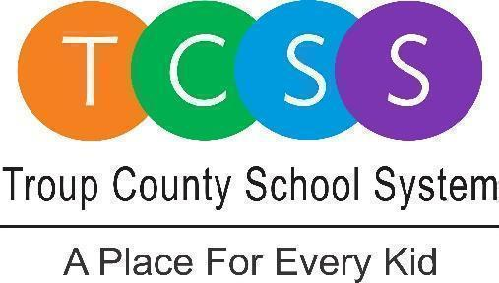
Irisha Goodman, Director of Public Relations
goodmani@troup.org / troup.org
100 North Davis Rd, Building C / LaGrange, Georgia 30241
Office: 706.812.7900 / Fax: 706-812-7904

Media Release
FOR IMMEDIATE RELEASE

LaGrange, GA., May 23, 2023 – The Troup County School System received a report from a parent that a paraprofessional at Clearview Elementary had inappropriate physical contact with a student in what is called the opportunities room at the school.

The district reported the incident to law enforcement and is cooperating with law enforcement’s investigation. The former employee was arrested Tuesday, May 23, 2023.

TCSS is not at liberty to discuss the situation any further as it is a personnel matter and to protect the identity of the student involved.

As always, the safety and well-being of our students is our first priority.

About Troup County School System

Troup County School System is an accredited educational system with over 12,200 students in grades K-12. TCSS does offer a free Pre-K program at each elementary school. The system is comprised of eleven elementary schools, three middle schools, three high schools, one college and career academy, and one alternative learning center. Students within the school system are taught a rigorous and relevant curriculum that helps them make college and career choices beyond graduation. The system 2022 graduation rate is 85.9 percent. To learn more about Troup County School System, visit troup.org and the Troup County School System Facebook page.
###

