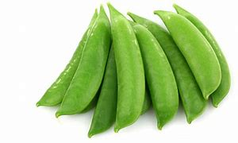 **Snap Peas**

**Also known as “Sugar Snap Peas”**

* Snap peas grow on vines that can grow up to 6 feet high!
* Snap peas are considered a “pod fruit” or “legume”.
* Snap peas are sweeter than their cousins the snow peas.
* They are high in Vitamin C, which helps you stay healthy!
* You can eat the whole snap pea pod - best eaten raw (or with your favorite dip).
* They can also be cooked as a side dish or used in stir fry.

**Want to Make a Snap Pea Pod?**

Paint a paper plate green (both sides). Fold in half. Staple ends to hold together. Make the peas. (Green play dough, crumpled green construction paper, green balloons, or whatever you can think of). See picture for ideas.



**Snap Pea Jokes**

Q: What do you call an angry snap pea? A: Grump-pea

Q: What did one snap pea say to the other snap pea on Valentine’s Day? A: “Peas be mine”

