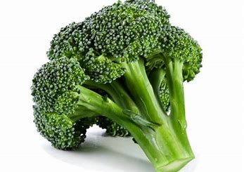Broccoli

* The name “broccoli” comes from the Latin word brachium, which means “branch,” or “arm.”
* Broccoli contains twice the vitamin C of an orange.



* Thomas Jefferson, our 3rd President, imported broccoli seeds from Italy and planted them in his own garden in 1767.
* In the United States broccoli is grown year round in California.
* The average person consumes over 4 pounds of broccoli a year.

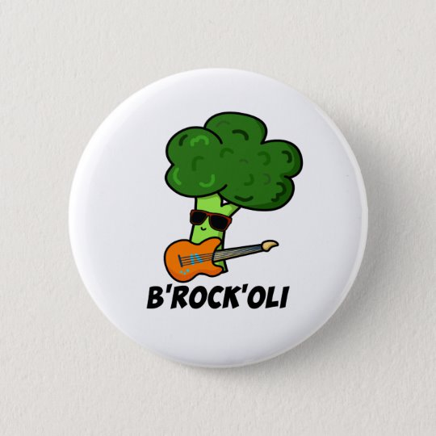 Broccoli Jokes

Q: What kind of music do vegetarians like to listen too?

A: Broc’ N’ Roll

[](about:blank)

