## 

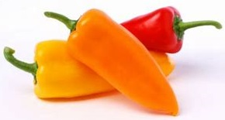 **Mini Sweet Peppers**

## Mini Sweet Peppers are related to the regular bell peppers (just smaller and not as round) and are available all year long.

* Mini Sweet Peppers come in different colors like yellow, orange and red.
* The best way to eat a Mini Sweet Pepper is to hold it by the stem and bite it just below the stem. You can eat the whole Sweet Pepper (seeds and all).

**Did You Know??**

Peppers are actually fruits, because they are produced from a flowering plant and contain seeds. However, most people still think of them as vegetables.

**Try this snack idea**: 

Cut sweet peppers in half (have an adult help). Clean out the seeds (if you want–they are edible).

1. Stuff with one of the following: Flavored or Plain Cream Cheese, Hummus, String Cheese, or your favorite filling.

1. Use like a chip with your favorite dip!

