Butler County Middle School
Site Base Policies

Table of Contents

Enhancing Achievement 2
Committees Policy 3-4
Curriculum 5
Staff Assignment 6
Student Assignment 7
School Schedule 8
School Space Use 9
Instructional Practices 10
Discipline and Classroom Management 11
Alignment with State Standards, Technology, and Program Appraisal 12
Consultation in Filling Certified/Classified Positions 13-14
Promotion 15
Extra-Curricular Eligibility 16
Staffing Models 17
Student Support Services 18
Professional Development 19
SBDM Teacher Election 20-21
School-Wide Discipline Policy 22
Literacy and Writing Policy 23-25
Parent Involvement 26
Extracurricular/Athletic Form 27-28
Wellness 29
Program Review 30-31

Butler County Middle School
Site Base Policy

Council Policy Type:
By-Laws (Council Operational Policies)
X Functional (School Operational Policies)

Policy Topic: Enhancing Achievement

Policy Statement:

The council will be responsible for the development of the school Comprehensive School Improvement Plan that serves as a reference guide for student achievement. The council will review and assist in analysis of data and determine if practices are contributing adequately to helping all our students meet state standards.

The council shall assist in ongoing monitoring and evaluation of the impact practices have in order to meet state standards.

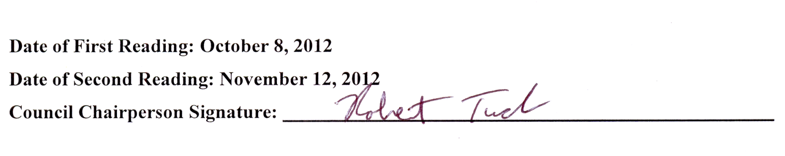

Butler County Middle School
Site Base Policy

Council Policy Type:
By-Laws (Council Operational Policies)
X Functional (School Operational Policies)

Policy Topic: Committees Policy

Policy Statement:

The school council shall establish the following four standing committee: Curriculum/ Assessment, School Culture, Professional Development/Technology, and Parent Involvement.

The school council may establish ad hoc committees to accept specific assignments at the discretion of the school council.

Curriculum/Assessment:

The committee will make recommendations with regard to the status of the school’s curriculum and instruction. It will also research and discuss appropriate curriculum and instruction issues, make recommendations to the school council, and complete assignments from the council related to curriculum and instruction.

This committee will make recommendations to the council regarding the annual assessment process and review the K-Prep and Explore test scores.

School Culture:

This committee will make recommendations to the council for establishing he school’s code of conduct. It will gather information and develop guidelines designed to keep our kids safe.

This committee will also examine school attendance issues and look for ways to improve our average daily attendance.

Professional Development/Technology:
The committee will make recommendations to the council for assisting the principal in the development of a professional development plan.

The committee will also examine and make recommendations on technology purchases and usage in the middle school including hardware and software.

Parent Involvement:

This committee will be charged with finding ways to increase the flow of communication between all stakeholders in the school community. The committee will also promote the involvement of parents/guardians in school activities and the involvement of parents/guardians on various councils and committees.

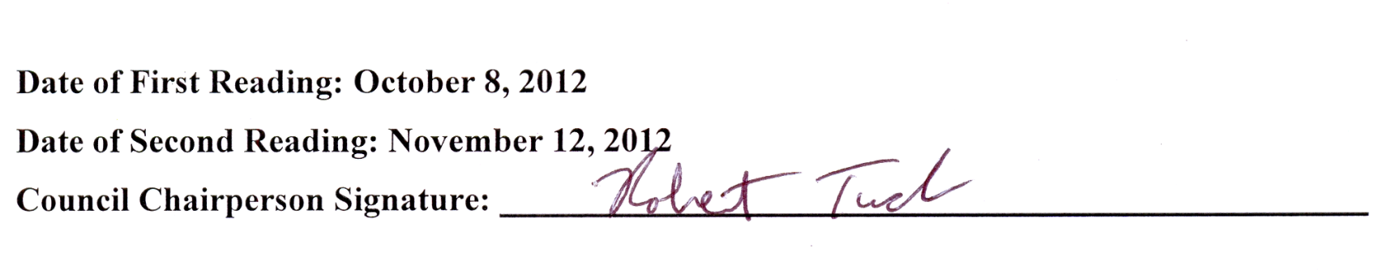

Butler County Middle School
Site Base Policy

Council Policy Type:
By-Laws (Council Operational Policies)
X Functional (School Operational Policies)

Policy Topic: Curriculum

Policy Statement:

The school council, in alignment with local school board and state standards, shall plan and implement a course of studies designed to meet students’ needs. The council shall adopt curriculum changes and new programs for implementation as needed.

All classroom instruction shall follow each content’s pacing guide and the school’s Comprehensive School Improvement Plan.

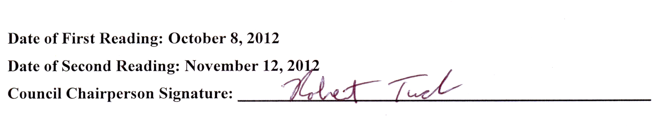

Butler County Middle School
Site Base Policy

Council Policy Type:
By-Laws (Council Operational Policies)
X Functional (School Operational Policies)

Policy Topic: Staff Assignment

Policy Statement:

By June 1 of each year, the principal shall prepare an instructional and non-instructional staff assignments plan for the following school year, and shall present the plan to the school council.

- This plan shall support the implementation of the Comprehensive School Improvement Plan.
- Staff members will be provided at least 45 minutes of planning time per day.
- Staff members will be assigned consistent with that person’s district job classifications and state certification.

A follow up plan that reflects amendments to the original plan shall be prepared by the principal and submitted to the school council by August 1.

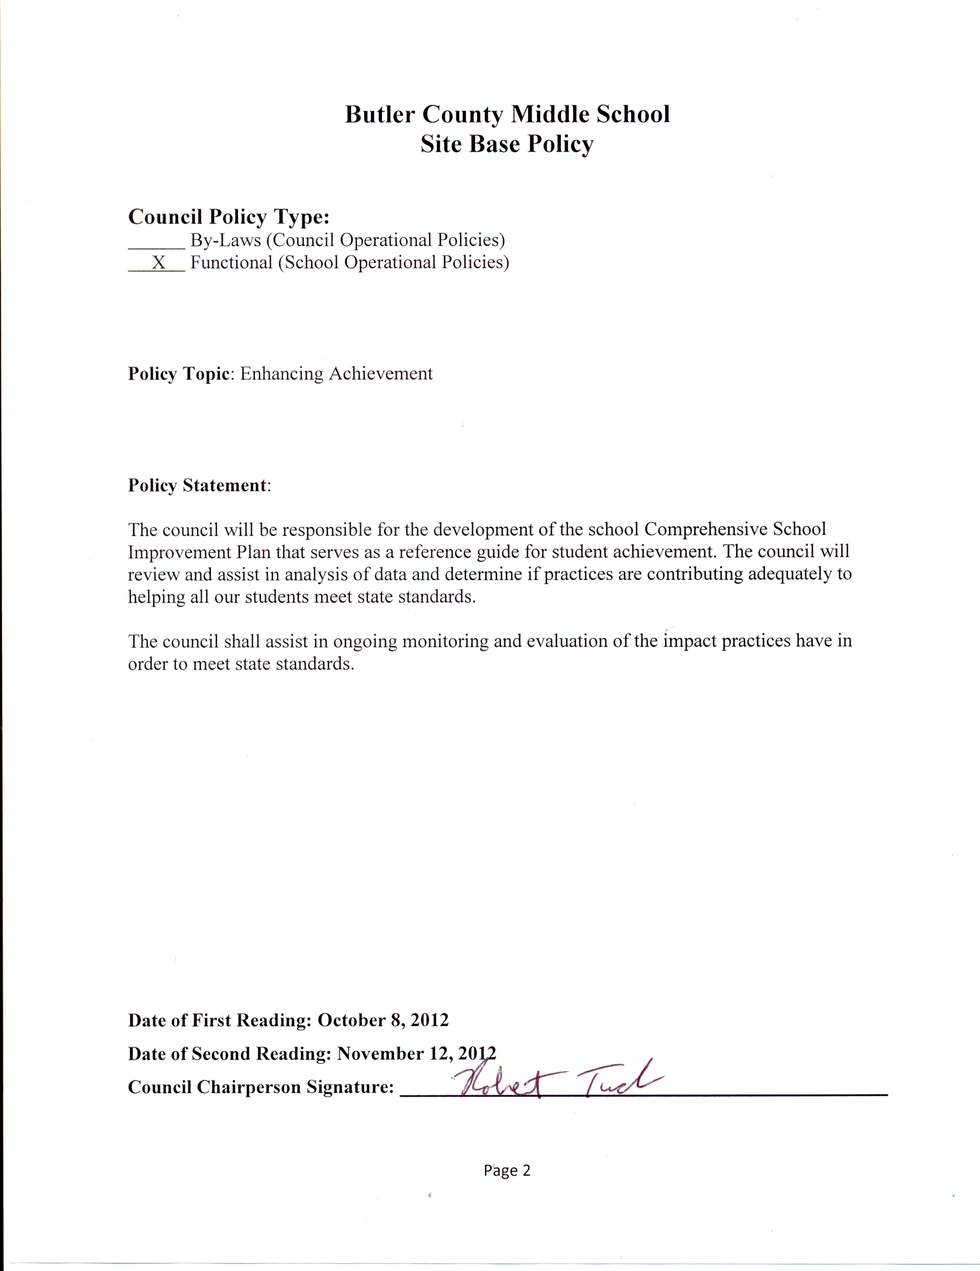
Butler County Middle School
Site Base Policy

Council Type:
By-Laws (Council Operational Policies)
X Functional (School Operational Policies)

Policy Topic: Student Assignment

Policy Statement:

The principal and counselor will assign students to classes and programs within the school based on individual student needs which will include collaboration with grade level teachers for appropriate assignment.

Parents who wish to seek a change in the assignment of their child shall confer with the principal who shall have the authority to make the switch or not.

Butler County Middle School
Site Base Policy

Council Policy Type:
By-Laws (Council Operational Policies)
X Functional (School Operational Policies)

Policy Topic: School Schedule

Policy Statement:

After the staffing numbers for the school has been determined, the principal will prepare a schedule for the upcoming school year and be presented to council for approval by June 1.

Butler County Middle School
Site Base Policy

Council Policy Type:
By-Laws (Council Operational Policies)
X Functional (School Operational Policies)

Policy Topic: School Space Use

Policy Statement:
By June 1, the principal shall prepare a school space use plan and present the plan to the school council. The principal shall implement the plan subsequent to the presentation to the council for approval.

Butler County Middle School
Site Base Policy

Council Policy Type:
By-Laws (Council Operational Policies)
X Functional (School Operational Policies)

Policy Topic: Instructional Practices

Policy Statement:

The school principal and faculty will determine instructional practices, including technology. Based on program appraisal specific improvement areas will be included in the school consolidated plan. They will be reviewed yearly by the council and revised as needed.

Butler County Middle School
Site Base Policy

Council Policy Type:
By-Laws (Council Operational Policies)
X Functional (School Operational Policies)

Policy Topic: Discipline and Classroom Management

Policy Statement:

The council shall determine discipline and classroom management, in alignment with local board and state guidelines.

Portions of the CHAMPS program and the STOP.WALK.TALK program are being implemented and reviewed annually by the School Culture Committee as the program of choice. The specific expectations of CHAMPS are listed in the student handbook and given to each student.

Butler County Middle School
Site Base Policy

Council Policy Type:
By-Laws (Council Operational Policies)
X Functional (School Operational Policies)

Policy Topic: Alignment with State Standards, Technology, and Program Appraisal

Policy Statement:

The school shall direct staff to conduct to a thorough review of the school’s K-Prep scores and shall use information from that review to develop the school’s Comprehensive School Improvement Plan.

The council shall consider recommendations from the technology committee to address needs in the Comprehensive School Improvement Plan.

To appraise the quality of our programs, the council shall review the progress of the Comprehensive School Improvement Plan quarterly. In addition, the review of test scores each year will help us to identify priority needs for future attention.

Butler County Middle School
Site Base Policy

Council Policy Type:
By-Laws (Council Operational Policies)
X Functional (School Operational Policies)

Policy Topic: Consultation in Filling Certified/Classified Positions

Policy Statement:

Our definition of consultation is as follows: acting in good faith, the principal will “seek the advice of” and “deliberate together” with the school council prior to the selection decision.

The principal shall inform the superintendent of any resignation of school employee assigned to his/her school. The superintendent shall determine the position as vacant.

Once a certified position has been identified as vacant the superintendent/designee will provide a slate of candidates for the certified position. The principal will review applications and references prior to interviewing. An ad hoc committee consisting of the principal, a parent, and a certified staff member shall interview appropriate applicants. If available a SBDM member will serve on the committee.

After the interviews are completed, the council will meet in closed session and shall:
-Hear the committee’s report
-Allow each council member to offer advice to the principal
-Allow general discussion among the council members about the applicants
-Provide any additional input requested by the principal

All interviews and selection of classified employees shall be completed by the principal. The principal may form an ad hoc committee to assist with the selection of a classified employee.

In the event of an emergency, the council will be consulted with but a quorum will not be necessary. Emergency shall be defined as the need to employ at a time when the council members cannot meet as a quorum to assist with the interviews of candidates or when immediate commitment to a candidate is needed in order to assure employment of candidate. The principal shall make every effort to consult with the council concerning the employment of certified school employees.

After the meeting with the council, the principal shall select the person he/she believes will contribute most to the success of the school’s students and notify the superintendent of his/her choice. The superintendent shall complete the hiring process.

Butler County Middle School
Site Base Policy

Council Policy Type:
By-Laws (Council Operational Policies)
X Functional (School Operational Policies)

Policy Topic: Promotion

Policy Statement:

Students who maintain in a minimum “C” average in all of their classes will be promoted to the next grade level at the end of the school. Students who have a “D” or “F” average in one or more classes may be considered for retention.

When a student does not meet the above criteria, the school administrator and the instructional staff will meet to determine the best placement for the student for the student for the next school year. Factors to be considered, but not limited to, would be: the age of the student, number of classes not meeting “C” expectation, basic skill mastery, performance in past grades levels, attendance, standardize test scores, and intervention attempted.

Retention will occur if the school administrator and the instructional staff believe it would be in the student’s best interest to repeat the curriculum material that has not been mastered.

Parents will be notified of the possibility of retention in January and March of each school year. Final notice will be given to parents of retention during the last month of school.

Butler County Middle School
Site Base Policy

Council Policy Type:
By-Laws (Council Operational Policies)
X Functional (School Operational Policies)

Policy Topic: Extra-Curricular Eligibility

Policy Statement:

Academic Progress during the School Year:

On a weekly basis, beginning with the Friday after Labor Day, a student must be passing (cumulatively for the credit period) in at least four hours of instruction as defined by Kentucky Board of Education regulations (of the six hours of instruction required) or the equivalent of four hours of instruction acceptable to graduation in order to be eligible to participate in athletics during the subsequent week (Monday through Sunday period) and through the next opportunity to examine grades in this manner. Absent any other determination, this weekly check of grades shall be conducted on each Friday of each grading period or on the last day of classes preceding that particular Friday if no classes are conducted on that particular Friday. No special tests or recitations are to be given for the purpose of making the student eligible.

Butler County Middle School
Site Base Policy

Council Policy Type:
By-Laws (Council Operational Policies)
X Functional (School Operational Policies)

Policy Topic: Staffing Models

Policy Statement:

After reviewing staffing allocations from the superintendent, the principal shall prepare staffing models that will be presented to the council at the March meeting. The council will select the one that they feel best meets the need of the coming school year.

Butler County Middle School
Site Base Policy

Council Policy Type:
By-Laws (Council Operational Policies)
X Functional (School Operational Policies)

Policy Topic: Student Support Services

Policy Statement:

The council shall determine what student support services are needed and that can be funded when considering staffing and budget for the coming school year.

Butler County Middle School
Site Base Policy

Council Policy Type:
By-Laws (Council Operational Policies)
X Functional (School Operational Policies)

Policy Topic: Professional Development

Policy Statement:

After reviewing the Comprehensive School Improvement Plan the Professional Development Committee shall develop a plan for the following year.

Butler County Middle School
Site Base Policy

Council Policy Type:
By-Laws (Council Operational Policies)
X Functional (School Operational Policies)

Policy Topic: SBDM Teacher Election

Policy Statement:

Teacher Members: Teachers conduct their elections as per KRS 160.345. Annual elections shall be conducted each May for the purpose of electing three teacher council members. Teachers must be elected by a simple majority (more than one half) of the number of faculty members. A ballot is valid if it casts a vote for at least one candidate. The teachers at Butler County Middle School unanimously approved the following procedures for electing their representatives to the council on January 11, 2006.

- Nomination: Each grade level will designate a willing representative to accept nominations and run the election. Written nominations for SBDM Council teacher representative shall be summited to one of these election officials by the officials’ announced deadline. Officials will verify each nominee’s willingness to accept his/her nomination and ascertain each nominee’s compliance with qualifications listed in Article III, Section B, subparagraph 1.

- Peroration of Ballot: At least two school days prior to the officials’ announced election day, the officials shall allow the faulty to view/correct a typewritten sample ballot which lists the candidates alphabetically by last name. Any corrections shall be made as soon as reasonably possible so that a correct sample ballot is still made available at least two school days prior to the election day.

- Elections: The election officials will conduct the voting process on the announced election day in the announced location in the building. Only those teachers present may vote. (Teachers arriving late will be given ballots in subsequent round(s).) Three–fourths of the faculty must be present in order to proceed with the election. Teachers will fill in ballots as they wish, voting for no more than three candidates on the first ballot. Election officials will count the ballots aloud in the presence of the faculty; they will tally and total the results of each round of voting. Any candidate receiving a majority vote will be elected. If at some point during a vote, none of the votes will be eliminated from the ballot and the faculty will begin a new round of voting among the remaining nominees. Faculty members may vote for only the number remaining vacant positions. This procedure will continue until a successful election of three SBDM Council teacher representatives to the subsequent term occurs.

- Term Limits: School council members can serve an unlimited number of terms as long as they continue to meet the eligibility requirements.

- Reporting Election Results: The election officials shall submit the names of the teacher representatives-elect to the principal so that he/she may give a full report of the newly elected council to the local news area.

Butler County Middle School
Site Base Policy

Council Policy Type:
By-Laws (Council Operational Policies)
X Functional (School Operational Policies)

Policy Topic: School-Wide Discipline Policy

Policy Statement:

In an effort to bring consistency and uniformity to the school’s discipline plan, a list of consequences for inappropriate behavior has been developed. The consequences become effective at 3 card intervals and increase in severity as the number of discipline cards increase. It is critical to contact parents at each 3 card interval. Each team will develop a mechanism for parental contact.

3 Cards Grade Level Team will have an option of contacting student and/or parent based on severity of cards.
6 Cards Teachers meet with students/parents notified by mail
9 Cards TIP Booth/parents notified by Principal or Asst. Principal
12 Cards Student place on a behavior sheet
15 Cards Student placed in In-School Suspension (ISS) for one full day
18 Cards 1 or 2 days of ISS
21 Cards Student suspended from school for 1 day
24 Cards Student Suspended from school for 1 day/Alternative School Considered (ALP)/ Multiple Days of ISS
27 Cards Multiple Days of Suspension/ALP Consideration/Multiple Days of ISS
30 Cards Multiple Days of Suspension/ALP Consideration/Multiple Days of ISS

It is important to note that serious violations of the discipline policy will result in the immediate consequences regardless of the number of cards. It is also important to note that all violations of the law will result in the Principal or designee notifying Law Enforcement Officials.
Butler County Middle School
Site Base Policy

Council Policy Type:
By-Laws (Council Operational Policies)
X Functional (School Operational Policies)

Policy Topic: Literacy and Writing Policy

Policy Statement:

Purpose: The purpose of this policy is to provide teachers, staff, and students with the
Instructional/Learning expectations for the daily school experience.

Definition: Successful instructional practices utilize a variety of learning experiences.
Daily instruction should be meaningful and engaging. Lessons should also include assessment that reflects the format of the Commonwealth Accountability Testing. Daily learning experiences should also include the following:
• Make prior connections and extend new learning.
• Include everyday applications.
• Personal involvement and ownership.
• Communication skills.
• Text - World learning.

Goals: Improve the responsiveness of instructional programs resulting in quality integration of literacy strategies and improved student performance in reading and writing across all disciplines

- Improve implementation of formal writing activities across the disciplines
- More regular integration of writing into content areas
- Intentional integration of effective reading strategies to support content learning
- lesson plans that regularly indicate integration of effective literacy strategies
C. Students need more opportunities to write in all content areas and to analyze, critique, and
interact with their own writing and with models of good writing.

Procedures: Each day BCMS strives to offer students the opportunity to:
• Read books or core content related materials independently, with a partner, or group.
• Think, discuss, and write in response to a prompt, in a journal, or formal writing assignment.
• Explore math, science, or cultural concepts and solve relevant problems.

Each day BCMS strives to offer students the following:
• At a minimum, 200 minutes of instruction directly related to core content of math, science, social studies, and language arts. In the related arts classes, students should experience 50 minutes of this content daily. Students will also have a study skills time. This time should be another means to explore and master an area of the core content utilizing a different instructional format. A student's individual educational plan, gifted plan, or identified area of growth, strength is the basis for placement.

Each week BCMS strives to offer our students the opportunity to use inferencing skills that pertain to each subject area:
* In math, inference questions come in the form of word problems or statistical analysis. The students must take the data they have available to them to determine an outcome. They have to determine which operation to use to solve problems based on the vocabulary used in the word problems. Activities for inferences should focus on the process of making an inference and developing strong reasoning skills to support the inferences they have made.
*In social studies, students will find answers not explicitly found in maps, charts, and other texts by using inference skills. Teachers will model through "think-alouds". Students will also draw from background knowledge and chart their reflections as they predict and judge/evaluate, as well as draw conclusions and make cause-effect connections about, what they read.
*In language arts, students will find answers explicitly in text by using inferencing and evidence. This will be modeled by teachers through "think alouds" using words and sensory images. Students will draw conclusions, make predictions, use background knowledge, chart information, and make critical or analytical judgments about what they read.
*In science, students will be afforded opportunities to practice inferring skills using a variety of texts and hands-on activities by
- drawing conclusions
- making reasonable predictions
- creating dynamic interpretations
- using their background knowledge to state information from the text to answer questions as they read
- gathering and analyzing data and drawing conclusions
- making connections between their conclusions and other beliefs and knowledge
- applying critical and analytical judgments to what they read and experience.

*In related arts, students will read from a variety of texts including works of art, dramatic plays, pieces of music and articles to enhance their critical thinking skills, inferencing skills and ability to relate to real world applications. Students will apply the content knowledge to various software applications, to our culture, history and present challenges and achievements, to understand what we are seeing and listening to, and make predictions to what will happen next when covering literary, technical and performance elements.
Each month BCMS strives to offer our students the opportunity to:
*Speak in front of a group.
*Complete one piece of writing.
*Observe and respond to classmates learning products.
*Respond to self-assessment of engagement tool.
*Open response questions and multiple choice questions will be a part of on-going classroom assessment.

Butler County Middle School
Site Base Policy

Council Policy Type:
By-Laws (Council Operational Policies)
X Functional (School Operational Policies)

Policy Topic: Parent Involvement

Policy Statement:

Purpose: To promote an effective partnership between and Butler County Middle School staff, students, parents, and other family members.

Definition: An effective partnership is defined in this policy as any activity that recognizes that a child's education is a responsibility shared by the school and the family. An effective partnership increases student achievement and helps students develop positive attitude about self and school.

Procedures: Butler County Middle School will:
1. Hold an annual parent meeting early in each school year to inform parents of the rights and responsibilities under the No Child Left Behind Act (NCLB).
2. Include parents and families as leaders and decision-makers in school issues and programs by inviting them to participate in Site Based Decision Making (SBDM) Council, SBDM Committees, PTA, Surveys, Volunteer Programs and other activities.
3. Promote two-way communication between school and families by using report cards, parent-teacher conferences, agendas/planners, website, social networking and Monday Messenger newsletters.
4. Provide services through the Youth Service Center; such as, home visits, collaborative programs, parent meetings, Adult Education to assist parents, families, and guardians in developing knowledge and skills to support children's learning.
5. Utilize the Youth Service Center, Adult Education and Family Literacy to provide access to and coordinate community and support services for children and families.
6. Identify and reduce barriers to parent/family involvement through surveys, open house meetings, translation of materials for ESL families, and blending of funds to maximize resources.
7. Provide professional development for teachers, staff and parents on ways to work together effectively.
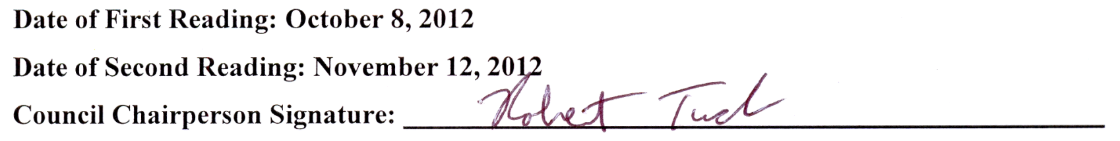
8. Post a copy of this plan on the school's website.
Butler County Middle School
Site Base Policy

Council Policy Type:
By-Laws (Council Operational Policies)
X Functional (School Operational Policies)

Policy Topic: Extracurricular/Athletic Form

Policy Statement:
Extracurricular/Athletic form must be completed by any new organization or team and be approved by site-base council before they start functioning.

Identify the goals of the organization
__________________________________________________________________________________________________________________________________________________________________________________________________________________________________________

Identify what financial means will be used to assist the organization in meeting the goals
__________________________________________________________________________________________________________________________________________________________________________________________________________________________________________

Describe the strategies, methods (in general) that will be used to assist the student members in reaching these goals (practice, conditioning, and tournaments)
__________________________________________________________________________________________________________________________________________________________________________________________________________________________________________

Identify who will provide the leadership for this organization
_____________________________________________________________________________

Describe the method of decision making to be used by the organization
__________________________________________________________________________________________________________________________________________________________________________________________________________________________________________

Butler County Middle School
Site Base Policy

Council Policy Type:
By-Laws (Council Operational Policies)
X Functional (School Operational Policies)

Policy Topic: Wellness Policy

Policy Statement:

The Butler County School District is committed to providing a school environment that enhances learning and development of lifelong wellness practices.

The Butler County Middle School’s Wellness Policy has been established based on the Standards and Indicators for School Nutrition and Wellness policies and School Health indexes including the following indicators:
- Physical activity will be integrated across curricula and throughout the school day.
- Each grade level will take students down to gym during study skills time for physical activity at least once a week.
- Teachers will work to incorporate physical activity into lessons.
- Appropriate accommodations shall be made for students with special needs, as required by law.
- A medical excuse will be necessary for any student not participating in physical activity.
- The Principal will have final say in participation.

Our school shall encourage healthy choices among students using the following methods:
- Our school shall implement the nutritional standards required by federal and state laws and regulations. Those rules apply to our food program and to other food and beverages available during the school day.
- Our Practical Living curriculum shall address Core Content, including health, consumerism, and physical education.
- Our curriculum and lesson plans shall reflect an integrated concern for wellness.

Date of First Reading: December 10, 2012

Date of Second Reading: January 7, 2013

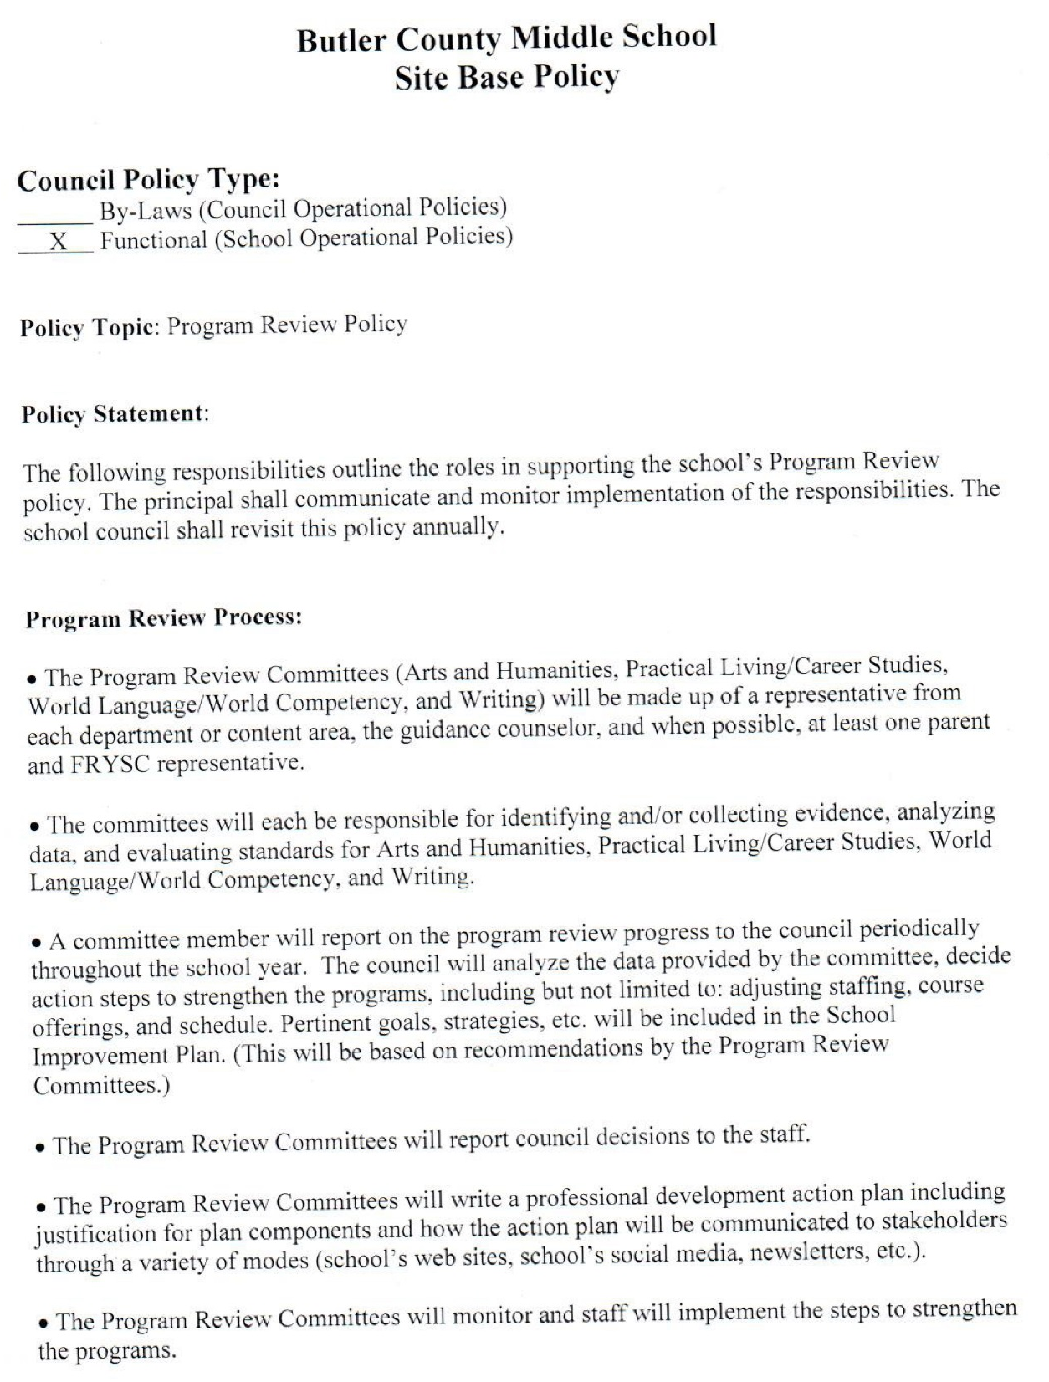
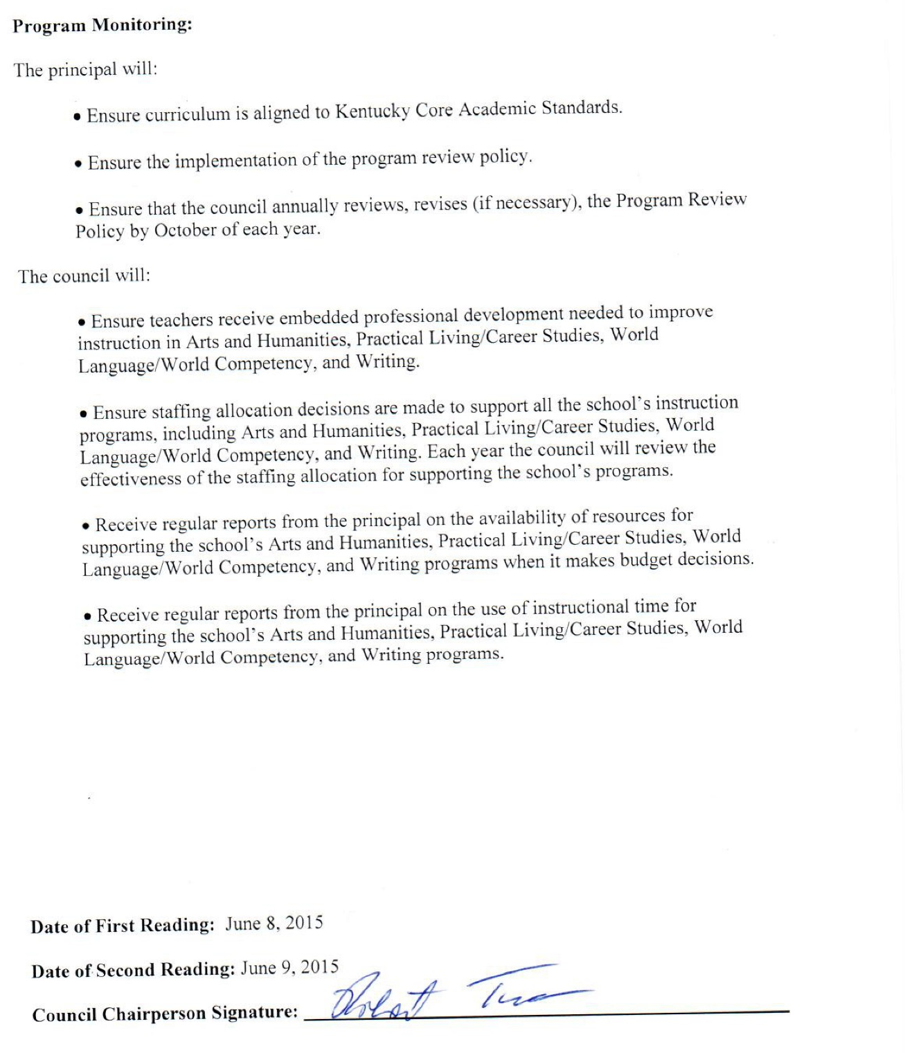

Butler County Middle School
Site Base Policies

Deleted Policies

Butler County Middle School
Site Base Policy – Deleted
October 8, 2012

Council Policy Type: Policy Number: 16
By-Laws (Council Operational Policies)
X Functional (School Operational Policies)

Policy Topic: Textbooks

Policy Statement:

The council shall establish a committee in November chaired by the Curriculum Resource Teacher and content area staff. That committee will review core content and determine which book and additional materials provided best meets the teaching of that specific core content.

The recommendation of the committee will be presented to the council at the April meeting for their approval.

Date of First Reading: June 12, 2006
Date of Second Reading: June 15, 2006
Council Chairperson Signature:

Butler County Middle School
Site Base Policy – Deleted
October 8, 2012

Council Policy Type: Policy Number: 17
By-Laws (Council Operational Policies)
X Functional (School Operational Policies)

Policy Topic: Instructional Materials

Policy Statement:

Teachers make request for instructional materials to the council. The council approves the purchase based on need and school budget.

Date of First Reading: June 12, 2006
Date of Second Reading: June 15, 2006
Council Chairperson Signature:

