**Millbury Public Schools**

**FY 2017 Proposed Budget**

**Financial Assumptions**

**Salary Calculations:**

Millbury Public Schools has two collective bargaining agreements.

The Millbury Teachers’ Association’s contract, which includes classroom teachers, special education teachers, guidance counselors, psychologists, librarians and nurses, expires on August 30, 2016. Contract negotiations for FY 2017 will begin in January 2016. In addition, eligible staff will move one step in their salary schedule column.

The Service Employees International Union (SEIU) Local 888 contract, which includes custodians, groundskeepers, maintenance staff, secretaries, clerks, and cafeteria workers, expires on June 30, 2017. This contract calls for a 1% cost of living increase for FY 2017. There are no step increases.

All other personnel are nonunion and are budgeted for a 1.5% increase. Personnel with individual contracts have been budgeted for increases as stipulated in their contracts. The budget has accounted for six (6) known retirements and five (5) resignations over the last eighteen months. It has also allowed for three (3) full-year leaves of absence to return for FY 2017.

**Financial Assumptions (continued)**

Tuition Reimbursement is allocated to cover the costs per the Millbury Teachers’ Association agreement. A review of the historical data helped determine the budgeted amount.

**Transportation:**

The contract with our primary home to school regular bus contractor has a 5.1% increase for FY 2017. The contract with our transportation provider, AA Transportation, expires June 30, 2017. This contract covers eleven (11) regular buses, two (2) mini-buses, one (1) wheelchair bus and other transportation like field trips and athletic events.

We have budgeted for a 3% increase in our special education and homeless transportation costs through our agreement with the Assabet Valley Collaborative (AVC) and Van Pool. This agreement is currently being negotiated for next year. We also anticipate fewer out-of-district transportation routes due to a reduction in total placements.

**Special Education Tuitions:**

There are 22 special education tuition placements in the budget, down from 26 in FY 2016. This decrease is the result of two students aging out of the formal programs and services provided by the District and two students moving out of Millbury. The Commonwealth’s Circuit Breaker Reimbursement Program funds $308,026 of the special education tuitions costs.

The budget has accounted for a 3% expected increase in special education tuitions. Private day school and residential school pricing in Massachusetts is regulated by the Commonwealth. Collaborative tuition pricing is set by the Collaborative Boards. The Millbury Public Schools maintains membership in the Assabet Valley Collaborative and the Southern Worcester County Education Collaborative. In both cases, there is a member discount for tuitions. Due to a reduction of special education placements, Millbury has reduced its out-of-district tuitions budget by $152,129.

**Financial Assumptions (continued)**

**Utilities:**

There are five factors used to determine utility costs:

1. Estimate of usage based upon past history, climate and trends.
2. Electricity and natural gas supply rates based upon Town of Millbury contracts are fixed. The electricity contract expires in January 2017 and the natural gas contract expires in September 2016.
3. No. 2 heating fuel supply rate is estimated for FY 2017. That contract is bid each year through the Town Manager’s office. Market rates are currently at a nine year low.
4. Distribution or Basis Rates which fluctuate and are expected to increase based upon rates set by from NGrid and NStar.
5. Electricity rebates we receive for Solar Credits from agreements with Hanover (which reduces Shaw’s invoice) and First Wind (which reduces the Elmwood Street School and Millbury Jr./Sr. High School invoice). The Hanover solar farm is located in Leicester and the First Wind solar farm is located in Millbury. The agreements save us about 30% off our electricity supply cost of 7.79 cents per kwh.

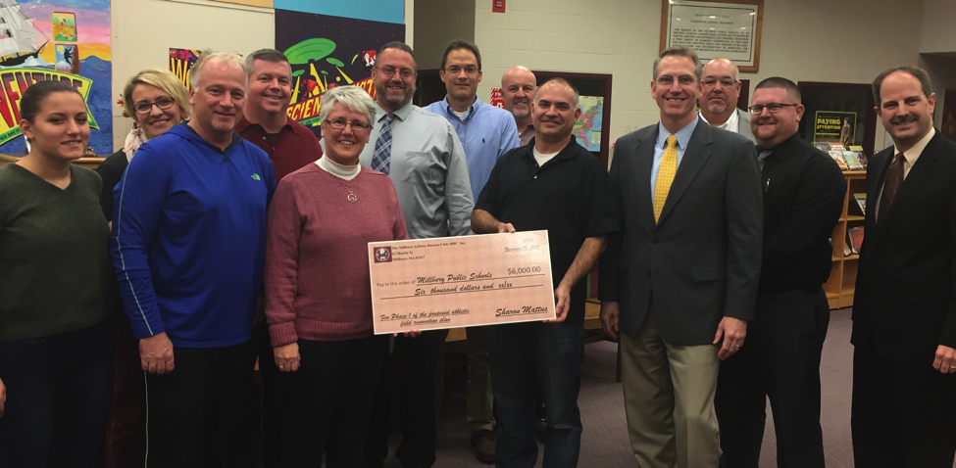Millbury Jr./Sr. High School and Elmwood Street School is heated and cooled by natural gas. R.E. Shaw Elementary School and the District Central Office is heated with No. 2 heating fuel.

The Millbury School Committee receives a gift of $6,000 from the Athletic Booster Club

to help fund survey work for the athletic field renovation project.

**Financial Assumptions (continued)**

**Utilities (continued):**



The Town of Millbury was designated a Commonwealth of Massachusetts Green Community in 2011. The Town used a benchmark year of 2009 in order to reduce our energy consumption usage by 20% in five years. Through FY 2015 the town has reduced its energy consumption by 10%. As you can see on the chart included below, the Millbury Public Schools has reduced its electric consumption by 19% since 2009 by installing energy conservation measures and making cultural changes in the way we use our resources. The District’s energy consumption is comprised of electricity, natural gas, heating fuel and motor vehicle fuel. The Town’s Energy Advisory Committee meets regularly in order to find ways to conserve energy and apply for grant funding.

**Financial Assumptions (continued)**

**Other:**

Unemployment Compensation is based upon an estimate from previous years’ history. As per the Indirect Cost agreement with the Town of Millbury, we budget for any new unemployment claims.

The District has fully funded its kindergarten program. We anticipate the Commonwealth’s kindergarten grant to be in jeopardy during the next budget cycle. Therefore, the District’s operating budget now assumes full financial responsibility for $47,256 in instructional salaries formerly paid by the grant.

Julia Lucier, Grade 12

Millbury Jr./Sr. High School

There is $170,000 budgeted in the *Instructional Technology Equipment – Systemwide* line item. This is a budget increase of $30,000. We will have obligations for one quarterly payment left to pay on three leases totaling $9,400. The balance of this account will be for technology equipment leases or purchases based upon our technology capital needs, which includes a telephone system upgrade.

There is $7,850 allocated in the *Replacement of Motor Vehicles* line item for the purchase of a new commercial lawn mower for the grounds department. The final lease payment to Ford Motor Credit for one of the red maintenance pick-trucks was made during FY 2016. The district now owns that pick-up truck.

The Windle Field budget reflects an increase of $5,000, which is allocated for the purchase of replacement bleachers.

Lydsey Lapierre, Grade 8

Millbury Jr./Sr. High School