|  |
| --- |
|  |
| NOVEMBER 2022 Newsletter |
|  |

Troup County Schools Health Services

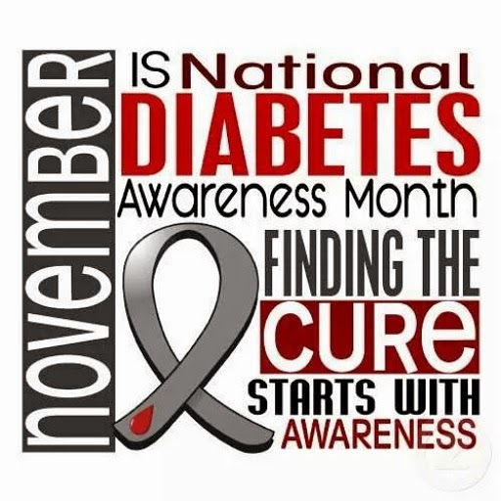

# In November we also observe:

## Epilepsy Month

## National Gratitude Month

## National Adoption Month

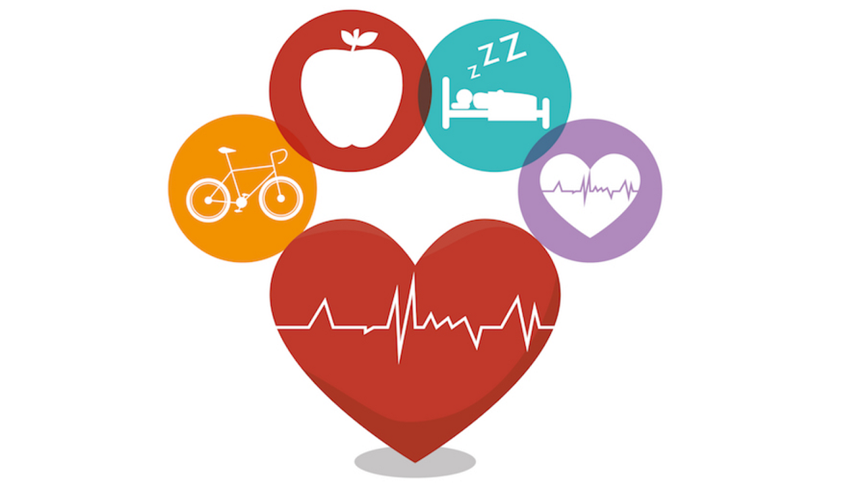

|  |
| --- |
|  |
| Diabetes Resources:  1. Diabetes.org 2. cdc.gov/diabetes 3. niddk.nih.gov/diabetes |

**Christy King BSN, RN Health Services Coordinator**

|  |
| --- |
|  |
| **NATIONAL DIABETES MONTH**  November is National Diabetes Month, a time when communities across the country team up to bring attention to diabetes. This year’s focus is on managing diabetes by building your health care team.  Here are some tips to help manage diabetes and manage your health care team.   * **You are the center of your care.** Learn as much as you can about diabetes. * **Manage diabetes as early as possible.** Take steps to improve your health. * **Build your diabetes health care team.**A team of health care professionals can tailor your care for your specific needs. * **Prepare for visits with your providers.** Before your appointment, write down questions, review your diabetes self-care plan and record blood sugar results. * **Start with small changes to create healthy habits.** * **Make physical activity and healthy eating part of your daily routine.**   **National Epilepsy Awareness Month**  More than three million people in the U.S. -- and over 65 million people worldwide -- live with epilepsy. People with epilepsy have seizures -- unexpected electrical "storms" in the brain.  Seizures impact their lives in many ways including creating barriers to employment and education and facing a sense of discrimination and isolation from their peers who donʼt understand what happens when they see a seizure occur.  **"Not everyone who has a seizure has epilepsy."**  Is this epilepsy?  **Epilepsy** is a neurological disease. A person with epilepsy is at higher risk for having recurrent (more) seizures. Sometimes people use the words “seizure disorder” to describe epilepsy. Some key facts include   * A diagnosis of epilepsy does not define the cause or the outlook. * Epilepsy is a spectrum disorder. There are many different [types of seizures](https://www.epilepsy.com/learn/types-seizures) and [types of epilepsy syndromes](https://www.epilepsy.com/learn/types-epilepsy-syndromes).   For more information on epilepsy visit: https://www.epilepsy.com/what-is-epilepsy/understanding-seizures |
|  |



|  |
| --- |
|  |
| School Nurses **Cynthia Walston RN (HES)**  **Candace Crawford LPN (FFE)**  **Norma Fannin LPN (BWE)**  **Jennifer Hammock LPN (LCE)**  **Teri Ogles LPN (HCE)**  **Maxine Copeland RN (CES)**  **Sherrie Smith LPN (CVES)**  **Margaret Franklin RN (HHE)**  **Chastain Pitts LPN (EKES)**  **Dedra Siggers LPN (LCMS)**  **Bernice Strozier RN (CMS)**  **Ivy Burton LPN (GNMS)**  **Pennie Hill RN (CHS)**  **Amy Crites RN (LHS)**  **Loretta Allen RN (THS)**  **Tiffany Harris LPN (RE)**  **Kaye Hodge RN (WPE)** |