Activities to Develop our Sense of Touch (Tactile)
The tactile sense detects light touch, deep pressure, texture, temperature, vibration, and pain. This includes both the skin covering your body and the skin lining the inside of your mouth. Oral tactile issues can contribute to picky eating and feeding difficulties.

Toddlers and Preschoolers
Food and drink. Let your child drink plain seltzer or carbonated mineral water to experience bubbles in her mouth (you can flavor it with a little juice or with lemon, lime, etc.).
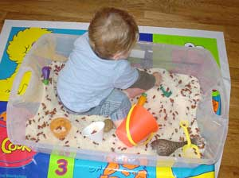
Messy play with textures. Have her play with foamy soap or shaving cream, and add sand for extra texture. Have her fingerpaint, play with glitter glue, mix cookie dough and cake batter, and so on. Let your child use the playground sandbox or create your own at home, filling a bin with dry beans and rice or other materials and small toys. Cover and store the bin for future use.
Use child-friendly modeling material such as Play-Doh, Model Magic, and Sculpey (the classic Play-Doh Fun Factory provides excellent proprioceptive input as well). Never force a child who is unwilling to touch “yucky” substances. Let him use a paintbrush, stick, or even a toy for cautious exploration.
Dress up. Dress up in fun costumes to get used to the feel of unfamiliar clothing,

School-age kids
Food and drink. Provide your child with frozen foods (popsicles, frozen fruit or vegetables) and mixed temperature foods (hot fudge sundae, hot taco with cold toppings, etc.).
Get in touch with nature. Encourage him to walk barefoot in the grass (avoiding pesticide applications), sand, or dirt. Have him garden and repot indoor plants.
Play dress-ups. Encourage play with make-up, face painting, and costumes, putting on a play or making a mini movie with a video camera.

Teenagers and Adults
Tactile hobbies. Sculpt, sew, weave, crochet or knit. Create a scrapbook (which involves lots of pasting and working with different textures). Use sandpaper to smooth a woodworking project. Make things out of clay, and try using a potter’s wheel.

