Proprioception Activities
Proprioceptive input (sensations from joints, muscles and connective tissues that lead to body awareness) can be obtained by lifting, pushing, and pulling heavy objects, including one’s own weight. A child can also stimulate the proprioceptive sense by engaging in activities that push joints together like pushing something heavy or pull joints apart like hanging from monkey bars.

Toddlers and Preschoolers
Make a “burrito” or “sandwich.” Firmly press on your child’s arms legs and back with pillows or make a “burrito” by rolling her up in a blanket.
Push and pull. She can push her own stroller, and a stronger child can push a stroller or cart filled with weighted objects such as groceries.
Carry that weight. Your child can wear a backpack or fanny pack filled with toys (not too heavy!).
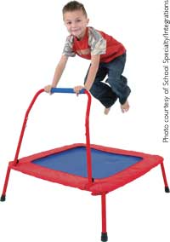

School-age Kids
Jump! Have your child jump on a mini-trampoline or rebounder or play hopscotch.
Push and pull. Have him vacuum, carry books from one room to another, help wash windows or a tabletop, and transfer wet laundry from the washing machine to the dryer.

Teenagers and Adults
Heavy lifting. Without straining, teens and adults can shovel snow or lift free weights.
Push, pull, and carry. Rake leaves, push heavy objects like firewood in a wheelbarrow, do push-ups against the wall, wear a heavy knapsack (not too heavy!) or pull a luggage cart-style backpack, or mow the lawn with a push mower.
Reassuring pressure. Get a firm massage, use a weighted vest or lap pad from a therapy catalog, or place light weights in the pockets of a fishing, athletic or regular type of vest. (Please see Raising a Sensory Smart Child for weighted wearable recommendations and precautions).

