Smell/Olfactory Activities
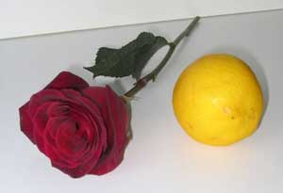
Olfactory input (sense of smell) comes through the nose and goes straight to the most primitive, emotional part of the brain. So if your child is upset by something being stinky, it’s no wonder. Certain odors can stimulate, calm, or send him into sensory overload.
Smell stuff! Explore scents with your child to find ones that work best to meet your goal (to soothe him or to wake him up). Everyone has different preferences, but vanilla and rose scents are generally calming. Peppermint and citrus are usually alerting. Let’s say your child needs help staying calm and loves vanilla. You can use high-quality vanilla soap and bath oils at bath time, vanilla candles or essential oils in an aromatherapy machine at bedtime, and vanilla body lotion.
Caution: Avoid lavender products for boys as several recent studies show a link with breast development in boys. It’s probably best to avoid using these products for girls as well.
Scent break. If your child is overtired at the shopping mall and you know scents help, have her smell her favorite scent or stop into a store that sells candles and soaps.
Scent play. Play a smelling game with your child. Have her close her eyes or wear a blindfold and try to identify smells such as citrus fruit, flowers, spices such as cinnamon, and so on.

