The
Oconee Federal Savings and Loan Association

Truman Blasingame
Fellowship

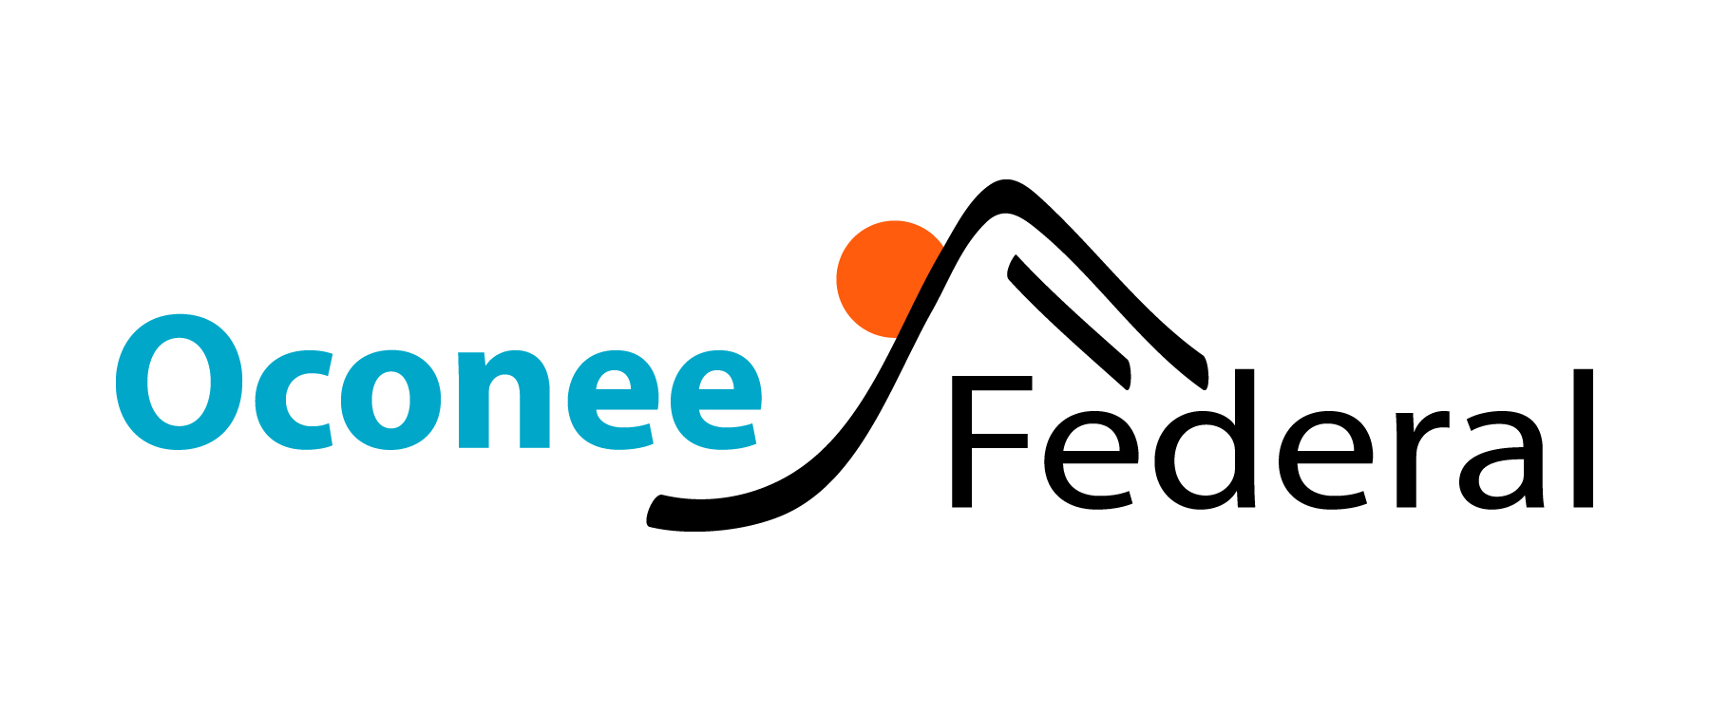

The Oconee Federal Savings and Loan Association
Truman Blasingame Fellowship

Oconee Federal Savings and Loan Association is the continuation and outgrowth of the Seneca Building and Loan Association, which was chartered by the state of South Carolina in February 1924.

In 1958, we changed our name to Oconee Savings and Loan Association when our first branch office was opened in Walhalla, SC. In 1992, our Association was issued a federal charter, at which time we changed the name to Oconee Federal Savings and Loan Association.

In 2011, the association completed a mutual-to-stock conversion, creating Oconee Federal Financial Corp. and Oconee Federal, MHC. Oconee Federal Financial Corp. is federally chartered corporation that was formed to be the mid-tier stock holding company for Oconee Federal Savings and Loan Association. Oconee Federal, MHC is a federally-chartered mutual holding company formed to be the mutual holding company of Oconee Federal Financial Corp. Oconee Federal Savings and Loan Association is a wholly-owned subsidiary of Oconee Federal Financial Corp.

In 2014, the Association entered a merger agreement with Stephens Federal Bank, a Toccoa, Georgia based mutual savings bank in business since 1933. The acquisition added Stephens Federal’s three offices in Toccoa and Clayton, GA, to our four existing branches. Our main office location is in Seneca, SC and most recently, we opened our eighth branch in Clemson, SC in January 2020.

We are pleased to award the Truman Blasingame Fellowship. The Fellowship is granted each year to a graduate of Stephens County High School who chooses to continue his or her education through attendance at a college, university or technical school.

W. Truman Blasingame served as the Managing Officer of Stephens Federal from 1956 until his retirement in 1990. He continued to be active in church and community, and showed a high degree of interest in the success of the young people of Northeast Georgia until his death in 2009.

The award is granted each year to that student who, in the opinion of teachers and administrators, has demonstrated a need for financial assistance in order to continue their education, and who has further demonstrated a commitment to their academic progress and a commitment, through their service, to the well-being of their family, and community.

An award of $1,000 is given to a student in Stephens County. There is no requirement that the award recipient attend a particular college or technical school, nor is there a requirement that the recipient pursue any particular degree program. The student is expected to furnish to Oconee Federal evidence of acceptance to the college of choice prior to payment.

Should you have any questions concerning the selection process for the fellowship, please direct your questions to your school counselor. Should you have questions concerning the administration of the fellowship, you may call Katie Ledford, Vice President/Market Manager of Oconee Federal Savings & Loan at 706-886-2111 or e-mail at katie.ledford@oconeefederal.com.

Good luck to you as you make application for Oconee Federal Truman Blasingame Fellowship. We wish you much success as you graduate from high school and continue your education.

The Oconee Federal Savings and Loan Association
Truman Blasingame Fellowship
Application

Name:
Last First Middle Preferred

Address:
Street City State Zip

Home/Cell Phone Number:

Name of High School:

Parents or Guardian:

Father or Legal Guardian

Name:

Address:

Place of Employment:

Years Employed:

Mother or Legal Guardian

Name:

Address:

Place of Employment:

Years Employed:

List any siblings, other than you, supported by your parents or guardian

Name and Age: Name and Age:

Name and Age: Name and Age:

This Fellowship is based in part on need and financial consideration is a must. Please describe family finances, include number of dependents, financial obligations (such as medical bills, siblings in college, single parent income, etc.). Please also include average annual family income.

Please list the college/university or technical school you plan to attend (attach letter of acceptance, if already accepted) and the degree or major you plan to pursue

List the following: SAT Score:

Hope GPA Grade Avg (%) Class Rank #

Please list each club in which you are or have been a member in high school, for how long, any officer position held within that club, and personal achievements while a member.

List any other extra curricular activities while in high school, including the number of years of participation and any awards or honors awarded.

List any community activities you are involved or have been involved while in high school. Please include church and civic. Describe personal activities and achievements in your involvement within these activities.

Please list below your work experience including name of employer, type of work and length of time involved.

Name of Company Responsibility/Duties Length of Time

To better determine your financial needs for continuing your education, please list any source of financial assistance, including scholarships, awards and grants that you may be eligible for or will be receiving.

Signature of Applicant Date

As part of your application, you are required to prepare an essay not to exceed 500 words. This essay should include information about your family, your school, your community and the things which you have accomplished which make you worthy of consideration of this award.

You are also required to attach at least two letters of recommendation. One recommendation must be requested from a teacher who has taught you an academic class. The other recommendation must be obtained from a community leader, or your employer. These recommendations must include information regarding academic motivation, potential for growth, leadership skills, self reliance, emotional maturity, initiative and any other information that may be beneficial to consideration for this Fellowship.
Application Process for the
Oconee Federal Truman Blasingame Fellowship

- Open to graduating high school seniors from Stephens County who plan to enter either a college/university or technical school for fall semester following their graduation.

- Applications may be obtained from the school guidance counselor and should be returned by the deadline established by the counselor.

- Students must complete the entire application; attach an essay and at least 2 letters of recommendation.

- Applications which are not complete will not be considered.

- The school will review all applicants and select the nominee who will be presented to the Bank’s selection committee. A letter of recommendation from the high school should be submitted with the application.

- Deadline for submission to your school counselor is ____________.

- The Fellowship will be presented to the student at the school’s annual award/scholarship program.

