APPLICATION FOR EDUCATOR LICENSURE INFO

All applications must be submitted online through the Ohio Department of Education by creating a SAFE account. You will find instructions at this link: http://education.ohio.gov/Topics/Teaching/Educator-Licensure

Click “apply for a new license” to get to the SAFE account set up instructions. If you have difficulties with the online application please contact ODE toll free at 1-877-644-6338. The page should look like this:
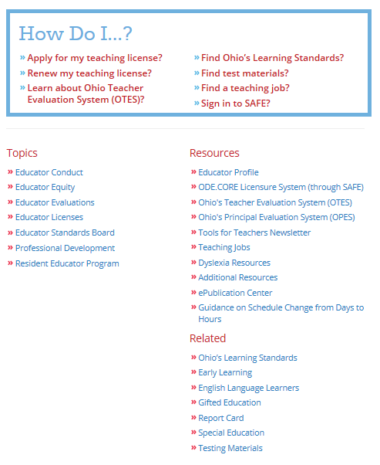

LPDC Contacts and Other Information can be found at the ESC website under Personnel Services: http://www.warrencountyesc.com

For GOVS LPDC eSigner and approval use this IRN#: 016453

Brian Barot, GOVS Licensure Contact
Email: brian.barot@warrencountyesc.com
Phone: 513-695-2900, x1312

SPECIAL NOTE FOR THOSE APPLYING FOR AN EDUCATIONAL AIDE PERMIT (Paraprofessional):
Educational aides (paraprofessionals) working for the GOVS are not required to apply for the ESEA
(Elementary and Secondary Education Act) endorsement. The endorsement requires an additional $20 one time fee
and an official college transcript verifying the required 48 semester.
Please use GOVS IRN# when selecting an eSigner: #000282

