2022-23 Encuesta de elegibilidad del programa del condado de Clinton

Para servir mejor a sus hijos, el Distrito Escolar del Condado de Clinton está ayudando al estado de Kentucky a identificar a los hijos de trabajadores agrícolas que pueden calificar para recibir servicios educativos adicionales. **Programa de educación para migrantes del condado de Clinton** proporciona una variedad de servicios educativos a las familias que trabajan en la agricultura. Este programa **es gratis** para todas las familias que son elegibles y puede incluir tutoría, viajes educativos, programas del verano, actividades para padres, referencias para emergencias y otros servicios como sea necesario. Un personal del programa se contactará con usted si se necesita más información. Si tiene alguna pregunta, llame al **606-688-0146**. **Toda la información se mantiene confidencial.**

Nombre del niño: ____________________________ Nivel: _________ Escuela: ____________________________

¿En los tres años pasados, ha vivido su familia en otro distrito escolar en Kentucky, en otro estado, o en otro país?

**Sí __________ (siga al #2)**

**No ________ (pare aquí)**

_________________________________________________________________________________________

1. ¿En los tres años pasados, ha trabajado alguien en su familia en cualquiera de los trabajos abajo **(sin incluir su** **propiedad)**, en una granja, en el campo, en un invernadero, en un vivero, o en una fábrica? Por favor ponga círculos alrededor de todos que se aplican:





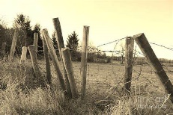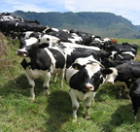



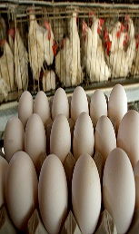

Huevos  
huevos

huevos

Ganados, ovejas, cerdos, vaquería

Tyson (planta de procesamiento de pollo)

cultivo de hortalizas

Trigo, maíz, frijoles

Esgrima

Pollos



Pasto seco











árboles y madera

Preparación de suelo

Tabaco

vivero / invernadero

**Si tiene uno o más círculos, siga al #3. Ninguno de estos _______ (pare aquí)**

_________________________________________________________________________________________

3. Nombre de los padres: ________________________________________________________________

Dirección: _________________________________________________________________________

Ciudad: _____________ Estado: _______ Código postal: _________ Teléfono: _________________

Mejor momento para contactarlo: ____ Mañana____ Tarde____Noche____ tiempo específico______

**None of these _______ (stop here) One or more (continue to #3)**

**None of these _______ (stop here) One or more (continue to #3)**

**None of these _______ (stop here) One or more (continue to #3)**

**None of these _______ (stop here) One or more (continue to #3)**

**None of these _______ (stop here) One or more (continue to #3)**

Por favor liste a todos los niños menos de 22 años en la casa:

|  |  |  |  |
| --- | --- | --- | --- |
| Nombre | Fecha de nacimiento | Nivel | Escuela |
|  |  |  |  |
|  |  |  |  |
|  |  |  |  |
|  |  |  |  |
|  |  |  |  |

2022-23 Clinton County Program Eligibility Survey

In order to better serve your children, the Clinton County School District is helping the state of Kentucky identify children of farm workers who may qualify to receive additional educational services. The **Clinton County MEP** provides a variety of educational services to families who work in agriculture, **regardless of their nationality** or legal status. This program is **free** to all eligible families and may include tutoring, educational field trips, summer programs, parent involvement activities, emergency needs and referrals to other services as needed. A program employee may contact you for further information if needed. If you have any questions please call **606-688-0146. All information is kept confidential.**

Child’s Name: ________________________________ Grade: ____ School: _________________________________

1. In the past three years, has your family lived in another Kentucky school district, another state, and/or another country?

**Yes ______ (continue to #2)**

**No _______ (stop here)**

**_________________________________________________________________________________________**

1. In the past three years, has anyone in your household had a job working with any of these products on a farm, in a field, in a greenhouse, in a nursery, or in a chicken processing plant (Tyson)?

Please circle all that apply.

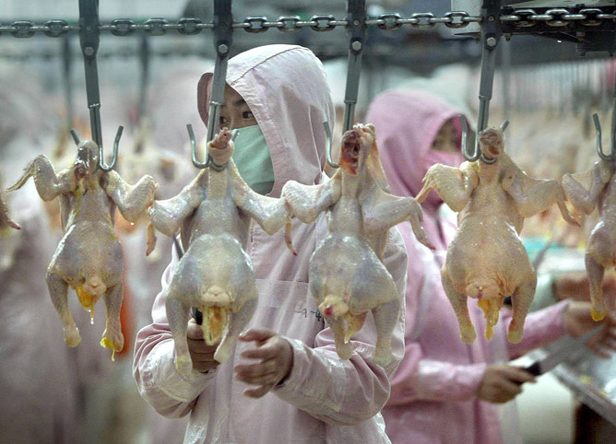

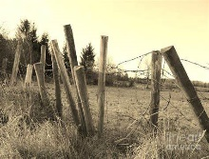



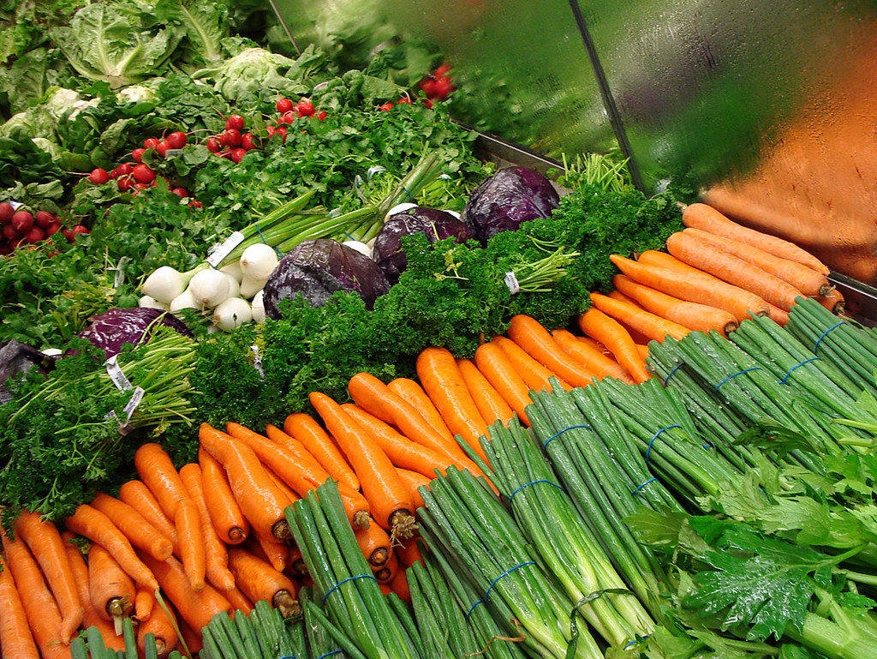

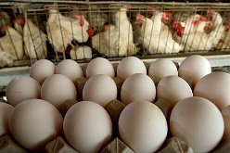

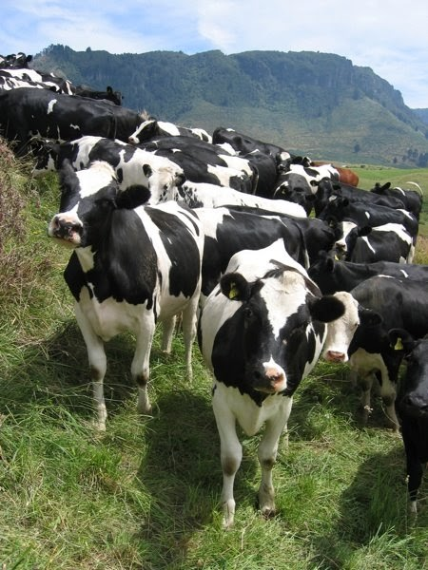



Fencing

Vegetable

Farming

Eggs

Crops (wheat, corn, soybeans, etc.)

Livestock (cattle, pigs, dairy, etc.).

Hay

Chickens

Trees and Timber

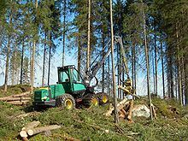

Nursery/ Greenhouse Flowers

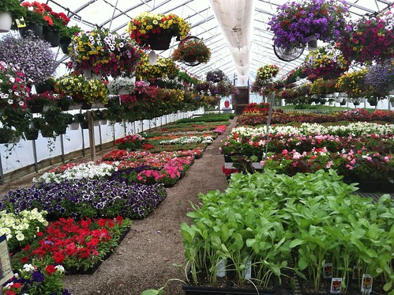

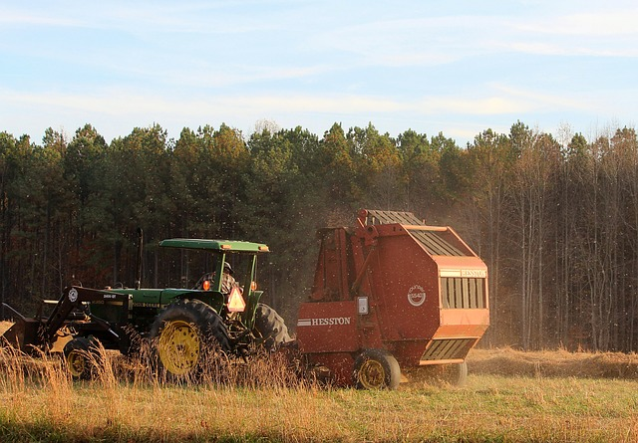

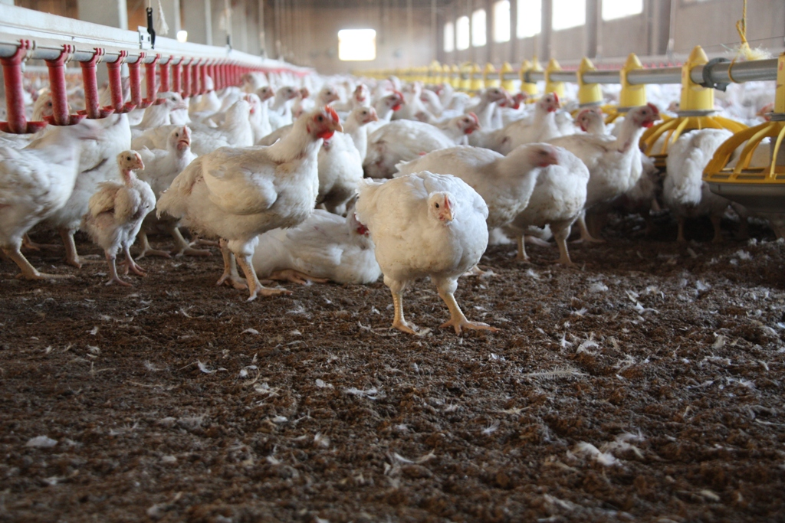

Tyson (Chicken Processing Plant)

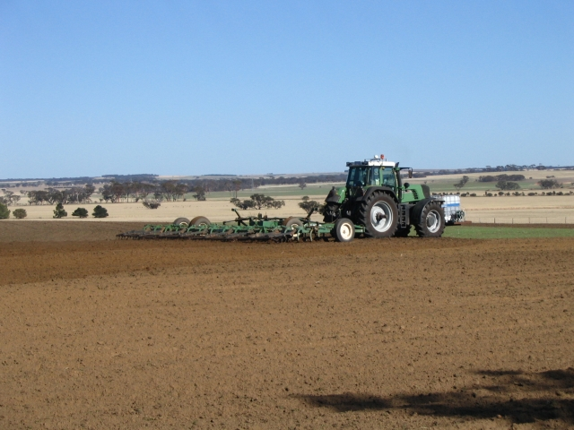

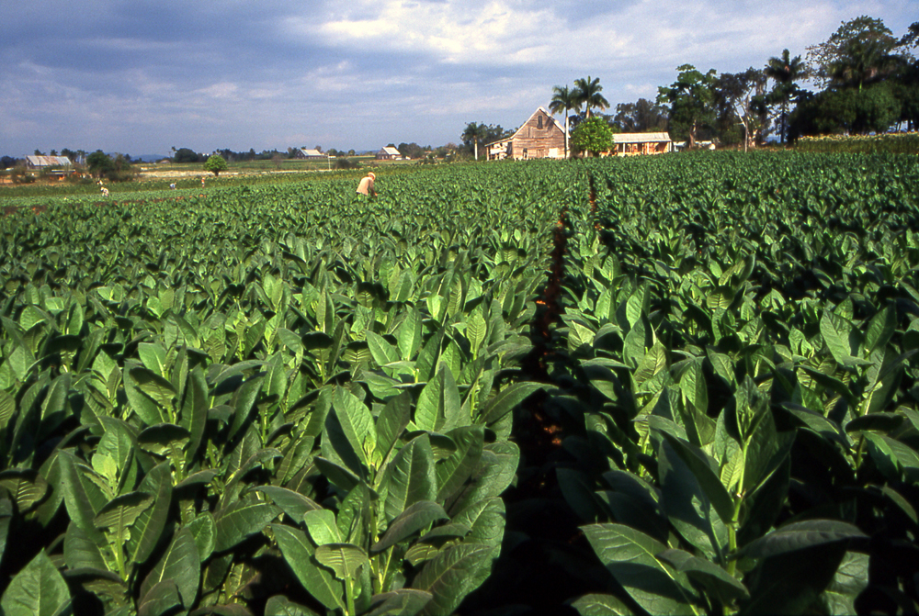

Tobacco

Soil Preparation

**If you circled one or more, continue to #3. None of these _______ (stop here)**

**_________________________________________________________________________________________**

3. Parents’ Names: _____________________________________________________________________

Address: ___________________________________________________________________________

City: _____________________ State: _______ Zip Code: _________ Telephone: ______________

Best time to contact you: ___Morning___Afternoon___Evening___Specific time__________

Please list all children in the household less than 22 years of age:

|  |  |  |  |
| --- | --- | --- | --- |
| Name | Date of Birth | Grade | School |
|  |  |  |  |
|  |  |  |  |
|  |  |  |  |
|  |  |  |  |
|  |  |  |  |
|  |  |  |  |
|  |  |  |  |
|  |  |  |  |
|  |  |  |  |
|  |  |  |  |
|  |  |  |  |
|  |  |  |  |

Program Eligibility Survey Instructions:

1. This form is to be completed by all students that enroll in Clinton County School this year.
2. This form needs to be included in student enrollment packets.
3. Print on colored paper if possible.
4. This is a two sided form (English on front side and Spanish on back side)
5. Please call 606-688-0146 and someone from the Migrant Education Office will pick up the surveys.

Thank you!