
Course Number and Title: Honors Civics and Government
Academic Credits: 1 credit
Course Delivery Format: In person (AIS)
Teacher: Mr. Jack Port
Teacher Summary:
This is my fifth-year teaching at Susquehanna Township High School. I previously taught social studies in Wilkes-Barre, PA. I graduated from Lycoming College with a Bachelor’s Degree in History and Misericordia University with a Master’s Degree Instructional Technology. I strongly believe that it is important to be an active, engaged, and informed citizen. I will encourage and challenge you to be the best you can be every day.
Teacher Room Number: 200
Teacher Phone: 717-657-5117
Teacher Email: jport@hannasd.org
Office Hours: By appointment only; please email to schedule an appointment.

Course Description:
This honors course is designed for the advanced student. Students enrolled in this course will investigate the constitutional underpinnings, formal structure, and politics of government in the United States at all levels. Emphasis will be placed on the federal government and its role in the international political system and comparative economic systems with an in-depth examination of the U.S. Congress, the Presidency, and the Supreme Court. Discussion of current political issues and a variety of experiences will supplement this program. Advanced reading and writing skills are emphasized.

Prerequisites:
Successful completion of Honors Modern World History or teacher recommendation

Required Texts and Materials:
Magruder’s American Government 2009 (e-book available) (class set)

Recommended Texts and Materials:
Various primary and secondary sources (teacher will distribute).
Composition Notebook.
Binder.

Course Outcomes:
- Student will be able to analyze the sources, purposes, functions of law, and how the rule of law protects individual rights and promotes the common good.

- Students will be introduced to the study of basis of American government and politics, particularly, the major institutions and processes.

- Students will be able to develop skills and knowledge so the student can analyze and evaluate political issues and public policies to be an informed and productive citizen.

- Students will be able to identify the role of citizenship and its related themes through course content & current events.

Units of Study/Pace of Course:
Unit | Major Topics | Standards Addressed | Approximate Length  of Unit | Assignments/  Assessments
1 | Foundations of American Government | History  Writing  Reading | 4 weeks | Civics assessment for growth Pre- Assessment  Unit quizzes and exams  Hobbes vs. Locke Primary readings
2 | The Constitution | History  Writing  Reading | 3 weeks | Unit quizzes and exams  Constitution Readings  Federalism and anti-Federalism
3 | Political Behavior: Government by the People | History  Writing  Reading | 5 weeks | Unit quizzes and exams  Ideological foundations of the two parties.  Third parties  Electoral College/Elections Process
4 | Legislative Branch | History  Writing  Reading | 4 weeks | Unit quizzes and exams  Letter to Congressperson  Mock Congress
5 | Executive Branch | History  Writing  Reading | 4 weeks | Unit quizzes and exams  Primary source readings
6 | Judiciary | History  Writing  Reading | 4 weeks | Unit quizzes and exams  Legal system basics  Mock Trial
7 | State and Local Government | History  Writing  Reading | 4 Weeks | Unit quizzes and exams  Why does PA have so many governments?  Civics Assessment for growth final

Procedures for Late Assignment:
Late work will be accepted but there will be a deduction of 10 points per day it is late. After 10 days the work will no longer be accepted for credit. Students have 5 days to make up any unit tests/quizzes.

Procedures for Redo Work:
Resubmitted work is not accepted except at the teacher’s discretion based on the situation.

Procedure for Extra Credit:
Per School Board Policy, Extra Credit is not offered.

Calculation of Final Grade:
CATEGORY | PERCENT (%) OF GRADE
Assessments | 70%
Classwork | 20%
Homework | 10%
Total: | 100%

Grading Scale:
- A - 90% - 100%
- B - 80% - 89%
- C - 70% - 79%
- D - 60% - 69%
- F - 0% - 59%

SOAR in the Classroom:
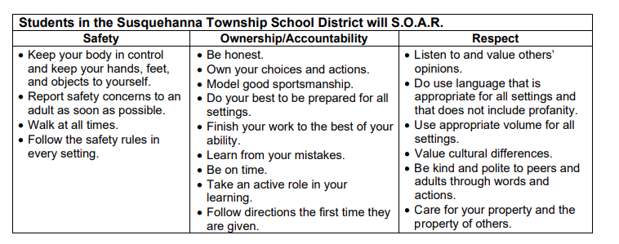

Class Attendance Policy:
Click HERE for the board approved attendance policy.

Cell Phone Policy:
Click HERE for the board approved electronic device policy.

Academic Integrity Policy:
Click HERE for the board approved academic integrity policy.

Pass Policy:
All students must use e-hall pass to sign out of class.

Academic Assistance Program (AAP):
Need additional assistance in the class? Come to AAP after school on Mondays, Tuesdays, and/or Thursdays from 2:37-4:30pm in the library. A certified teacher will be on staff to help with any work or questions you may have. Students may ride the 4:30pm late bus home from AAP.

Academic Integrity in a Social Sciences/Studies Classroom
The purpose of this class is to learn how to think for yourself and about the social sciences. Assignments in this class serve the purpose of practice, and/or assessment leading the student to mastery. Any assignment completed with the use of an on-line answer/writing program, by another student or person, or by you using the work of another person will receive a zero and a referral for lack of academic integrity. The teacher reserves the right to question and if necessary, nullify an assignment if the authenticity of the work is in question.
Students who “work together,” should provide support to each other, but they should not simply copy the work of another. All work should be unique to the student and his/her current level of learning. One should keep in mind that the ultimate goal is to learn and be able to think independently. Simply copying assignments or turning in the work of another person in order to gain credit does not promote learning. All work that is deemed to have been copied, or to have been the origin of the copied work is subject to a zero; thus, students who share their work for another student to copy will face consequences as well.
Furthermore, it is required that while working on assessments such as quizzes or tests, electronic devices remain out of sight in a teacher designated area. The presence of an electronic device at any point during the administration of an assessment will be a violation of the security of the quiz/exam and the authenticity of the student’s work, resulting in a zero.
Your grade is a reflection of your skill level and effort. Please take the time and make the effort to build your skill level. Cheating the system by trying to take short cuts will undermine your ability to build your skills and to be an independent and academically honest student.

The signature below indicates that you understand the above policy. (This will be done on forms this year.)

cut here

Honors Civics and Government
Student Name:
I have read and understand Mr. Port’s class expectations and information. Any further questions can be directed to Mr. Port at jport@hannasd.org.
Student: Date:
Parent/Guardian Date:

