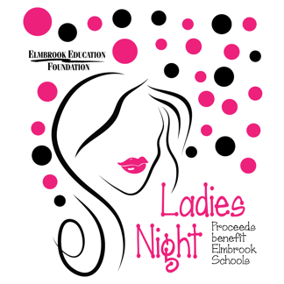

The Elmbrook Education Foundation (EEF) is proud to host the 19th Annual Ladies’ Night event on Wednesday, November 30, 2022, at The IMPROV at The Corners of Brookfield.

For those attending, this event kicks off the holiday shopping season! We offer a silent auction, raffle, swag bags, cash purse, gift card tree and more! This event sells out to capacity crowds of over 250 guests each year. CDC guidelines will be followed to ensure the safety of our guests and volunteers.

This year, funds raised will go towards Shared Theater and Fine Arts Production Equipment. Elmbrook’s Theater and Fine Arts programs are among the best in the state. The Elmbrook Education Foundation super-grant will provide funds to acquire wireless microphones, sound boards, and mobile lighting equipment that will be shared amongst all of our schools and used for musicals, plays, concerts, and school events. The Fine Arts staff and volunteers are grateful for this opportunity to spotlight the amazing opportunities afforded our students and the people who guide them!

We would love to have your support as a sponsor this year! Please see the sponsorship form enclosed. Thank you for your consideration!

To find out more about the Elmbrook Education Foundation and/or to stay up to date on future events/activities,
- Visit our website: https://www.elmbrookschools.org/elmbrook_education_foundation
- “Like” us on Facebook at www.facebook.com/EEFWI
- Follow us on Twitter @EMBK_Ed_Fndtion

We are a 501(c)3 organization, #39-6059490. If you have any questions, please do not hesitate to contact us at elmbrookeducationfoundation@gmail.com. Thank you for your consideration!

Sincerely,

Beth Dobrzynski Kelly Ebbole
Executive Director Ladies’ Night Chair
elmbrookeducationfoundation@gmail.com kebbole@exitrealtyxl.com
262-844-3742 262-725-5222

Donations should be sent to:
Elmbrook Education Foundation
c/o The School District of Elmbrook
3555 N. Calhoun Rd.
Brookfield, WI 53005

