
Course Number and Title: [2200] Civics and Government
Academic Credits: 1 credit
Course Delivery Format: In person (AIS)
Teacher: Mr. Joe Sell
Teacher Summary:
I began teaching at Susquehanna Township High School in 2017. I received my bachelor’s degree in history in 2004 and completed my Masters in Education in 2022. I have worked in education across the country. I live in Carlisle PA with my wife and three children and enjoy spending time outside whenever I can.

Teacher Room Number: 208
Teacher Phone: 717-657-5117
Teacher Email: jsell@hannasd.org
Office Hours: By appointment only; please email to schedule an appointment.

Course Description:
The course will investigate the constitutional underpinnings, formal structure, and politics of government in the United States at all levels. Emphasis will be placed on the federal government and its role in the international political system and comparative economic systems with an in-depth examination of the U.S. Congress, the Presidency, and the Supreme Court. Discussion of current political issues and a variety of experiences will supplement this program.

Prerequisites:
N/A
Required Texts and Materials:
Magruder’s American Government 2009

Recommended Texts and Materials:
Various primary and secondary sources.
Composition Notebook.
Binder.

Course Outcomes:
- Student will be able to analyze the sources, purposes, functions of law, and how the rule of law protects individual rights and promotes the common good.

- Students will be introduced to the study of basis of American government and politics, particularly, the major institutions and processes.

- Students will be able to develop skills and knowledge so the student can analyze and evaluate political issues and public policies to be an informed and productive citizen.

- Students will be able to identify the role of citizenship and its related themes through course content & current events.

Unit | Major Topics | Standards Addressed | Approximate Length  of Unit | Assignments/  Assessments (subject to change)
1 | Foundations of American Government | History  Writing  Reading | 4 weeks | Civics assessment for growth Pre- Assessment  Unit quizzes and exams  Hobbes vs. Lock Primary readings
2 | The Constitution | History  Writing  Reading | 3 weeks | Unit quizzes and exams  Constitution Readings  Federalism and anti-Federalism
3 | Political Behavior: Government by the People | History  Writing  Reading | 5 weeks | Unit quizzes and exams  Ideological foundations of the two parties.  Third parties  Electoral College
4 | Legislative Branch | History  Writing  Reading | 4 weeks | Unit quizzes and exams  Letter to Congressperson
5 | Executive Branch | History  Writing  Reading | 4 weeks | Unit quizzes and exams  Primary source readings
6 | Judiciary | History  Writing  Reading | 4 weeks | Unit quizzes and exams  Legal system basics
7 | State and Local Government | History  Writing  Reading | 4 Weeks | Unit quizzes and exams  Why does PA have so many governments?  Civics Assessment for growth final

Procedures for Late Assignment:
All work is due on date posted in MS Teams. Any work turned in after this is considered late.
Work turned in after due date will be assessed the following reduction in scores.
o Within one week of the due date: 25% reduction
o Within two weeks of the due date: 50% reduction

Procedures for Redo Work:
Resubmitted work is not accepted except at the teacher’s discretion based on situation.

Procedure for Extra Credit:
Extra credit will not be offered. The teacher may choose to include bonus opportunities depending on opportunities that arise throughout the year.

Absent Work:
It is your responsibility to find out what you missed during the time you were absent, you will have the same number of days to make up work as you were out (extended absences will be dealt with on a case by case basis). When possible, please inform the teacher that you will be out if it is a planned absence so that you can get your work ahead of time. I do understand that illnesses happen. Long-term projects / assignments are given well in advance and are due on the date due.

Calculation of Final Grade:
CATEGORY | PERCENT (%) OF GRADE
Assessments | 70%
Classwork/Homework | 30%
Total: | 100%

Grading Scale:
- A - 90% - 100%
- B - 80% - 89%
- C - 70% - 79%
- D - 60% - 69%
- F - 0% - 59%
SOAR in the Classroom:
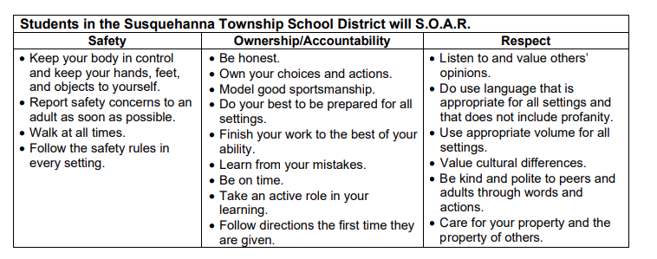

Class Attendance Policy:
Click HERE for the board approved attendance policy.

Cell Phone Policy:
Click HERE for the board approved electronic device policy.

Academic Integrity Policy:
Click HERE for the board approved academic integrity policy.

Pass Policy:
All students must use e-hall pass to sign out of class.

Academic Assistance Program (AAP):
Need additional assistance in the class? Come to AAP after school on Mondays, Tuesdays, and/or Thursdays from 2:37-4:30pm in the library. A certified teacher will be on staff to help with any work or questions you may have. Students may ride the 4:30pm late bus home from AAP.

---------------------------------------------------------------------------------------------------------------------------------------------------
Please Cut/Tear this bottom signature slip and return to Mr. Sell
Civics and Government
Student Name:
I have read and understand Mr. Port’s class expectations and information. Any further questions can be directed to Mr. Port at jsell@hannasd.org.
Student: Date:
Parent/Guardian Date:

