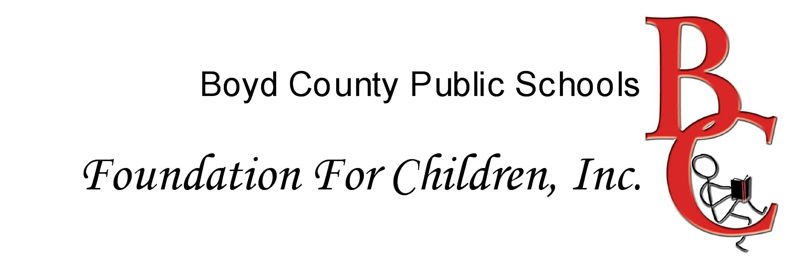
GRANT PROPOSAL APPLICATION Quick Facts
DEADLINE FOR GRANT APPLICATION SUBMISSION IS Friday, April 19th, 2013 by 4:00 p.m.

DO NOT USE EARLIER VERSIONS OF THIS APPLICATION!
- The questions on this application have been edited to include the highest expectations explained the initial review scoring rubric. The edits were designed to assist teachers in writing the best possible grant. The entire rubric is included for your reference at the end of this application.

- You may fax the application to the District Office, to the attention of Karen Curnutte. If you do fax it, please remember to send the original signature page in the courier mail or hand deliver it to the District Office by the above deadline.

- You may email your application to karen.curnutte@boyd.kyschools.us. If you do email it, please remember to send the original signature page in the courier mail or hand deliver it to the District Office by the above deadline.

- The typical maximum amount awarded for a grant project is $500.

- Applicants will NOT be allowed to resubmit a proposal in the exact format it was reviewed in prior years. Any proposal from prior years must be tweaked and revised before the Board of Directors will consider it again.

- Identical grant proposals from teachers from the same schools or classrooms will not be accepted.

- Those who receive a grant are required to submit an Outcomes Report Form. Recipients who do not submit a report will not be eligible for a grant next year. An Outcomes Report Form will be provided with your award notification. You may also find the form on the District Webpage under the drop down menu item “Resources” then “BC Foundation.”

- For a copy of this application in both MS Word and a printable pdf, please visit the District Webpage under the drop down menu item “Resources”, then “BC Foundation”, then hovering over the title button will cause a pop out menu to be visible. From there, you can navigate directly to this application. It is also available for download from the main BC Foundation page.

FOR OFFICE USE ONLY

Project Number: _ _ - _ _ - _ _ _
BCFFC Visit: ______________
ID #: ______________

Amount of Funds Approved | Month to Visit
Date Application Received | Date Funds Requested
 | Outcomes Report Received

Boyd County Public Schools Foundation For Children Grant Application

Date ___________________

_______________________________________ __________________________________
Applicant’s Name Co-applicant (if applicable)

_______________________________________ ___________________________________
Home Address: Street, City, State, Zip Home Address: Street, City, State, Zip

_______________________________________ ___________________________________
Home Telephone Number Home Telephone Number

_______________________________________ ___________________________________
Position or Grade(s) Taught Position or Grade(s) Taught

_____________________________________________
Name of School

_____________________________________________
School Telephone Number

_____________________________________________
Administrative Signature Date

Please list below any teachers other than the applicant (and co-applicant) who will be participating in the project.

Name, Address, Position or Grade(s) Taught

Name, Address, Position or Grade(s) Taught

Name, Address, Position or Grade(s) Taught

ID #: __________________ (For Office Use)

Please type or use black ink when filling out the application. Inks of other colors do not always copy clearly. Please do not write on the back of the application.
1. Title and one paragraph description of the project: (Provide a clear, student-focused concept of what the project intends to accomplish. The project, in abstract, will be well-thought out and organized.)

TITLE of project:

One paragraph description:

2. Total cost of the project: $ _________________ (The project cost is appropriate for the scope of the grant.)

Amount requested from BCFFC: $ _________________ (Typical amount awarded is $500)

List additional funding anticipated and/or received from other sources for this project:

$____________________________________________

$____________________________________________

ID #: __________________ (For Office Use)

3. A. What is the goal of this project? (The goal will be strong and clearly stated and include activities related to the Kentucky Core Academic Standards – cite the standard here – for the targeted students.)

3. B. Why do you think there is a need for this project? (Provide evidenced need for the project, which is justified by data or other factual means.)

3. C. How will students benefit from participating in this project? (Clearly relate the anticipated student benefit to the project activities and articulate by what measurable means the students will be assessed.)

ID #: __________________ (For Office Use)

4. Describe your project. Include materials you will need and the methods you will use. (Describe the materials and methods for this project making certain you are well-organized, student-focused and appropriately guided by the goals of this grant.)

5. What grade(s) will this project benefit? (Clearly state the targeted grades(s) for this project.)

6. Give a detailed chronological schedule of events. Include an approximate date when Foundation Board Members may visit this project. (Provide a realistic and well-organized timeline for the project which includes objectives, activities and dates.)

7. Approximately how many students will be participating in this project? (Provide a clear response outlining the number of students who will participate in this project.)

8. Will this project be continued in future years? (Will the materials be able to be reused and/or will the project be ongoing?)

9. How will you determine whether your objectives have been achieved and whether your project has been successful? (Provide a clear and reasonable descriptor of how progress toward outcomes will be measured and assessed.)

ID #: __________________ (For Office Use)

10. List in detail all planned expenditures of BCFFC funds. (The total amount should match the amount of funds requested from BCFFC.) (Provide a detailed and accurate list of expenditures for the project. The expenditures will be appropriate and reasonable for this grant project.)

Item Amount
 | $
Total | $

(Attach another sheet if additional space is needed. Do not use the back of this sheet.)

11. IMPORTANT!! Write a one- or two-sentence summation of your project. This will be used for news releases and for the BCFFC Annual Report.

12. What month would you like the Foundation Board Members to visit/observe your project?

Initial Review Scoring Rubric for BCFFC Grants 2013-2014

Applicant: ________________________________________________________

Category | Exceeds Standards | Meets Standards | Approaching Standards | Below Standards
Cover Page |  | Applicant has provided complete and accurate information in all required sections of the cover page. | Applicant has provided sufficient information on the cover page. | The cover page is incomplete or incorrect.
1.  Title & One Paragraph Summary | The title and one-paragraph summary provide a clear, student-focused concept of what the project intends to accomplish. The project, in abstract, seems well-thought and organized. | The title and one-paragraph summary provide a concept of what the project intends to accomplish. | The title and one-paragraph summary provide a concept of what the project intends to accomplish; however, some points are unclear or inappropriate for the scope of this grant. | The title and one-paragraph summary do not provide a concept of what the project intends to accomplish; or the concept is incomplete or inappropriate for the scope of this grant.
2.  Project Cost |  | The project cost is appropriate for the scope of this grant. |  | The project cost is not appropriate for the scope of this grant.
3.A.  Project Goal | The project goal is strong and clearly stated and includes educationally appropriate activities for targeted students. | The project goal includes educationally appropriate activities for targeted students. | The project goal needs to be more clearly defined but does include educationally appropriate activities for targeted students. | The project goal is not stated and is does not include educationally appropriate activities for targeted students.
3.B.  Need for the Project | The applicant provides evidenced need for the project, which is justified by data or other factual means. | The applicant provides statement of need for the project which is justified by general assumption. | The applicant provides evidenced need for the project but more information is required to justify the need. | The applicant failed to provide evidenced need for the project.
3.C.  Student Benefits | The applicant clearly relates anticipated student benefit to project activities and articulates how the benefits will be assessed. | The applicant relates anticipated student benefit to project activities. | The applicant relates anticipated student benefit but linkage to project activities is not related. | The applicant does not relate student benefit to project activities.
4. Project Description | The materials and methods for this project are well-organized, student-focused and appropriate for this grant. | The materials and methods for this project are student-focused and appropriate for this grant. | The materials and methods for this project are appropriate for this grant; however, organization and student-focus may be lacking. | The materials and methods for this project are inappropriate for this grant.
5.  Grade(s) Targeted in this Project |  | The applicant clearly states the targeted grade(s) for this project. |  | The applicant does not state the targeted grade(s) for the project.
6.  Timeline | The applicant provides a realistic and well-organized timeline for the project which includes objectives, activities and dates. | The applicant provides a workable timeline for the project which includes objectives, activities and dates. | The applicant provides a workable timeline for the project; however, detail is lacking on objectives, activities and dates. | The timeline proposed by the applicant is unrealistic or inappropriate.
7.  Participants |  | The applicant provides a clear response outlining the number of students who will participate in this project. |  | The applicant does not provide a clear response outlining the number of students who will participate in the project.
8.  Project Period |  | The project as proposed will be ongoing. |  | The project will be concluded with the academic year.
9.  Project Assessment | The applicant provides a clear reasonable descriptor of how progress toward outcomes will be measured and assessed. | The applicant provides a descriptor of how progress toward outcomes will be measured and assessed. | The applicant is not clear on how outcomes will be measured and assessed. | No statement of outcomes measure or assessment is provided.
10.  Project Expenditures | The applicant provides a detailed and accurate list of expenditures for the project. The expenditures are appropriate and reasonable for this grant project. | The applicant provides a list of expenditures for the project. | The applicant provides a list of expenditures for the project; however, some items may not be reasonable for this grant project. | The applicant provides no list of expenditures.
11.  Brief Summary |  | The applicant provides a one-to-two sentence summary of the project. |  | The applicant does not provide a one-to-two sentence summary of the project.
12.  Board Visit |  | The applicant states what month a Board member may observe / visit the project. |  | The applicant does not state what month a Board member may observe / visit the project.
Color Key Yellow - Administrative answers (not as weighty when scoring the application)
Blue - Explain these carefully and in detail. These questions are the “meat” of your application and carry the most weight when scoring.

