
Academic Talent Search (ATS)
Test Sign-Up Form

Mailing Address: 6000 J Street • Mail Stop 6098 • Sacramento, CA 95819
Office Location: 7667 Folsom Blvd, Suite 2040 • Sacramento, CA 95826
Phone: (916) 278-7032 • Fax: (916) 278-5930 • Email: ats@csus.edu
Website: www.csus.edu/experience/anchor-university/academic-talent-search
 Like us on Facebook for up-to-date info and announcements! www.facebook.com/academictalentsearch
Dear Parent,  Give your child a preview of the college experience with Academic Talent Search (ATS)!  Congratulations! Your school is offering your student the opportunity to attend Sacramento State this summer as part of ATS’ 39th annual program. ATS allows current 4th-9th graders to experience a real college campus in action while taking classes in their favorite subjects! After ATS, your student can tell their friends what “college” is like – students apply for courses that interest them, take classes held in actual university classrooms and labs, and explore the Sacramento State campus!  Just like with real colleges, students take a standardized qualification exam, the School and College Ability Test (SCAT), before they apply for ATS. The good news is that your school has agreed to provide the SCAT on-site so you don’t need to make special plans for testing. There is no risk in taking this exam – it is not pass/fail and will have no effect on your student’s grades. ALL students who take the test qualify to attend ATS classes at Sacramento State. For more information about the test, including sample questions, see the back of this document.  Your ATS School Representative (usually the person who gave you this form) can tell you when the test will be offered at your school. To sign up, complete the back of this sheet and return it to your School Representative at least one week prior to the testing date. If your school is offering online test registration, you can sign up for testing on the ATS website (go to csus.edu and search for “ATS”). The $20 testing fee can be paid online through the ATS website or your student can bring the fee with them on the day of the test (fees do not have to be submitted to the school before the exam). This fee covers scoring the exam and mailing test results to your home. If you cannot afford the testing fee, ask your School Representative about a Fee Waiver.  If you have any questions, please call the ATS office (916-278-7032), send us an email (ats@csus.edu), or visit the ATS website for more information. We look forward to seeing you this summer at Sacramento State!  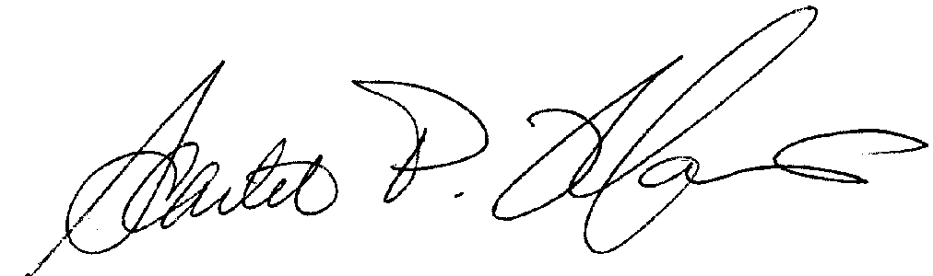  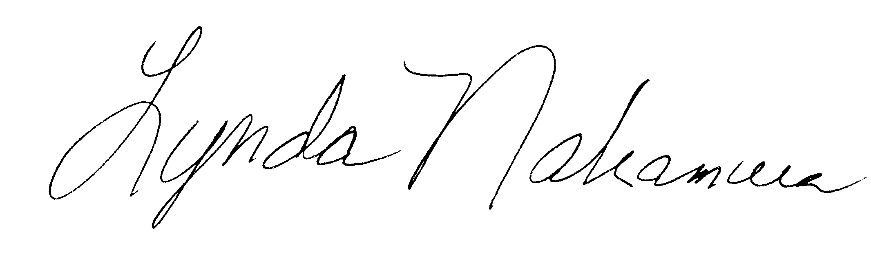  Scarlet P. Maurin Lynda Nakamura  Director Program Manager |  |  | Quick Facts  ATS…  Is designed for current 4th – 9th graders who want to get a glimpse of college by taking classes created just for them on a university campus.  Classes promote creativity and critical thinking – students can dive deeper into subjects that interest them and discover new topics not always available in regular school. See the Information Sheet for Students and Parents for some of our planned classes.  Engages students academically over the summer as they meet new friends from across the region who share their enthusiasm and interest in learning. Being treated like “college students” allows students to increase self-confidence and independence.  Testing Options  - Take the test at your school  - Take the test at Sacramento State on one of three Saturdays  -February 8, 2020  -February 29, 2020  -March 14, 2020  - Take the test at the ATS Office
❖ Parents/guardians: complete the back of this form 

Is your school offering online test registration? Skip the forms and sign up on the ATS website!

- Return this form to your ATS School Representative (usually the person who gave you this form) at least one week before testing.

- Payment options for the $20 testing fee:
- Payments can be submitted electronically through the ATS website.
- Your student can bring cash, check, or money order (payable to ATS) to school ON the day of the test.
  - Please note: Returned checks are subject to penalty fees per University Enterprises, Inc.
- If you cannot afford the processing fee, ask your School Representative about a Testing Fee Waiver.
 | Questions from Students  Why should I take this test?  The School & College Ability Test (SCAT) can offer valuable experience in taking a college admission-type exam and it will automatically qualify you for ATS. Test results help identify special academic talents to be further developed. The test is designed for older students, so you are not expected to know all of the answers or prepare for the test in any way!  If I have taken the test before, do I have to take it again?  If you are currently in grade 6 or above and last tested as a 4th or 5th grader, you will need to test again to take the “advanced” level exam. Since classes are filled top-score down, ATS strongly encourages all students to test every year to give the best chance of being admitted to their preferred courses.  If I take the SCAT, do I have to go to ATS?  Testing does not obligate you to participate – it just gives the option to apply for ATS classes at Sacramento State. We hope to see you this summer! | About the School and College Ability Test  The School and College Ability Test (or SCAT) takes no more than 1 hour and 15 minutes – this includes instructions and two 20-minute sections (verbal and quantitative). Students take the multiple-choice test appropriate for their grade: current 4th and 5th graders take the “intermediate” level, and current 6th–9th graders take the “advanced” level. Taking the test automatically qualifies you for ATS. The test is not “pass” or “fail” as it measures your academic abilities not specific knowledge.  • Verbal Section  The verbal section tests your knowledge of the meaning of words and your ability to identify relationships between pairs of words. You will be asked to find the pair of words that go together in the same way as the first two words.  Example gym : exercise ::  a) cafeteria : eat c) car : sit  b) mall : sell d) auditorium : clap  Solution  To solve analogy questions, put the primary pair of words into a sentence which explains their relationship (“You go to a gym to exercise.”). Next, substitute the answer choices into your sentence until you create a sentence that makes sense. The correct answer is A: “Gym” is related to “exercise” as “cafeteria” is related to “eat”.  • Quantitative Section  The quantitative section tests how well you work with numbers. Each question has two parts (Column A and Column B). You must determine if the value presented in Column A is greater than the value presented in Column B, if the parts are equal, or if there is not enough information to decide.  Example Column A Column B  Value of 3 nickels Value of 2 dimes  and 1 dime and 1 nickel  A if the part in Column A is greater  B if the part in Column B is greater  C if the two parts are equal  D if not enough information is given for you to decide  Solution  The example is asking you to add. Since a nickel is 5 cents and a dime is 10 cents, in Column A, 5+5+5+10 is equal to 25. This is the same answer as 10+10+5 in Column B. Therefore, the answer to the question is C, the two parts are equal.
_ _ _ _ _ _ _ _ _ _ _ _ _ _ _ _ _ _ _ _ _ _ _ _ _ _ _ _ _ _ _ _ _ _ _ _ _ _ _ _ _ _ _ _ _ _ _ _ _ _ _ _ _ _ _ _ _ _ _ _ _ _ _ _ _
ATS Test Sign-Up Form for 4th through 9th graders
Parent(s): If not signing up online, please return this completed form at least ONE week before the test to secure your student’s seat.
*A Message from your ATS Representative
Parent Name Parent Signature
Current School Current Grade as of Jan. 1, 2020 (circle) 4th 5th 6th 7th 8th 9th
Student Student Student
Last Name First Name Middle Initial

In
Mailing
Address Apt#
City State Zip
Primary Phone ( ) Primary Email

