Lakota Local School District – LLSD-2022-0225
Attachment #5

Historical Data - School Year: 2021/2022
Kit Description | Quantity Ordered
Kindergarten Kit | 1223
1st Grade Kit #1 | 1086
1st Grade Kit #2 | 223
2nd Grade Kit #1 | 1288
2nd Grade Kit #2 | 78
3rd Grade Kit #1 | 1285
3rd Grade Kit #2 | 189
4th Grade Kit #1 | 249
4th Grade Kit #2 | 1135
5th Grade Kit #1 | 204
5th Grade Kit #2 | 1120
6th Grade Kit #1 | 0
6th Grade Kit #2 | 1317
7th & 8th Grade Kit | 2781
Grand Total | 12,178

Kindergarten FY22 Kit Contents
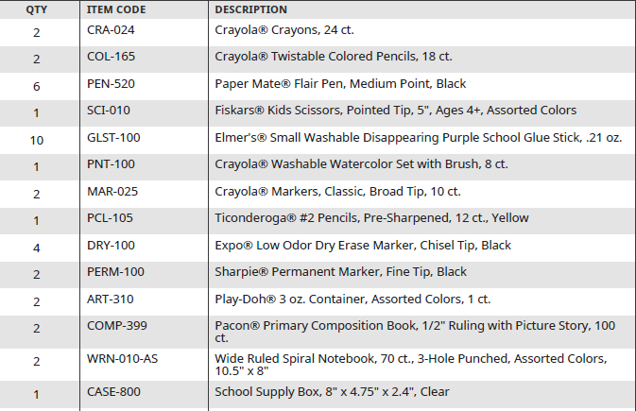

Lakota Local School District – LLSD-2022-0225
Attachment #5

1st Grade FY22 Kit Contents – Kit #1 ½ Page Comp Notebooks
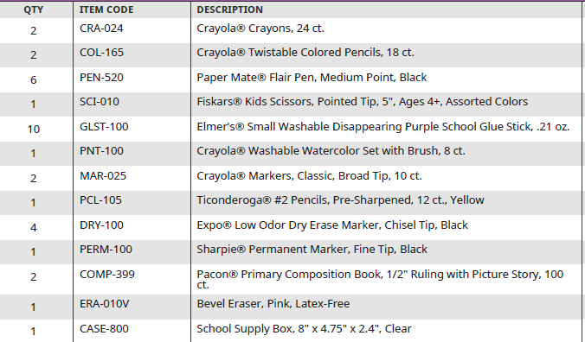

1st Grade FY22 Kit Contents – Kit #2 Wide Ruled Spiral Notebooks
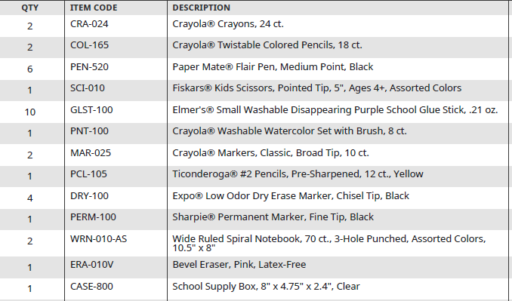

Lakota Local School District – LLSD-2022-0225
Attachment #5

2nd Grade FY22 Kit Contents – Kit #1 – Wide Ruled Comp Notebook
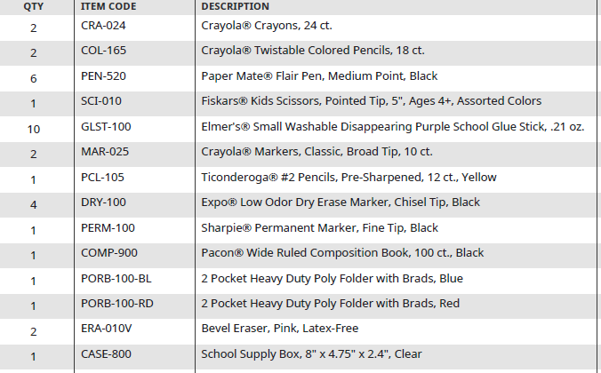

2nd Grade FY22 Kit Contents – Kit #2 Wide Ruled Spiral Notebooks
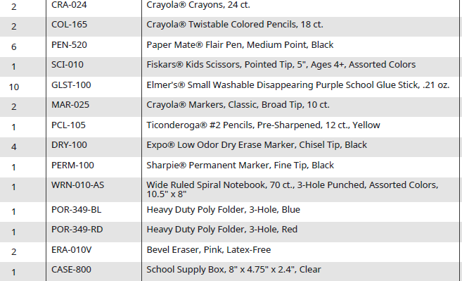

Lakota Local School District – LLSD-2022-0225
Attachment #5

3rd Grade FY22 Kit Contents – Kit #1- Composition Notebooks
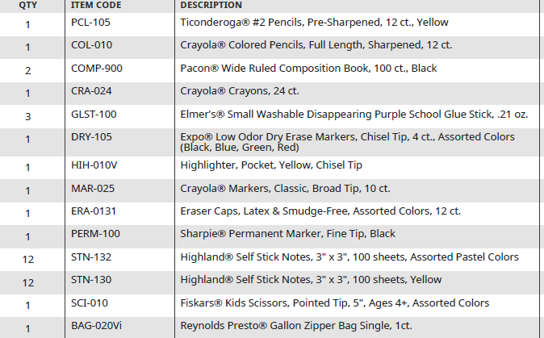

3rd Grade FY22 Kit Contents – Kit #2-Wide Ruled Spiral Notebooks
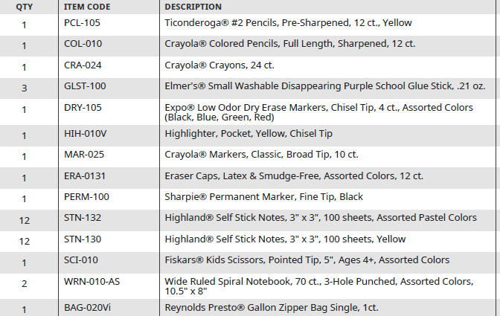

Lakota Local School District – LLSD-2022-0225
Attachment #5

4th Grade FY22 Kit Contents – Kit #1 – Wide Ruled Spiral Notebooks
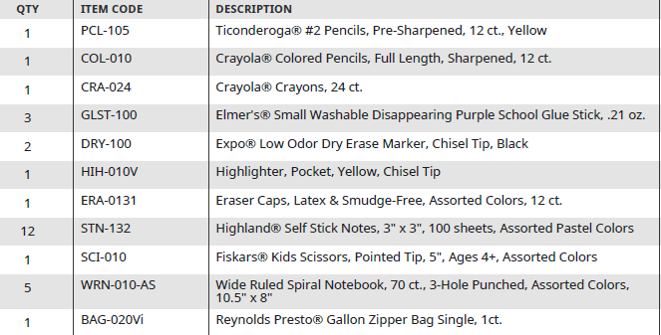

4th Grade FY22 Kit Contents – Kit #2 – Binders, Divider Tabs, Filler Paper
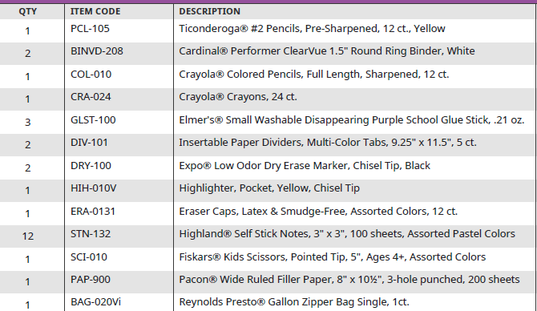

Lakota Local School District – LLSD-2022-0225
Attachment #5

5th Grade FY22 Kit Contents – Kit #1 – Wide Ruled Spiral Notebooks
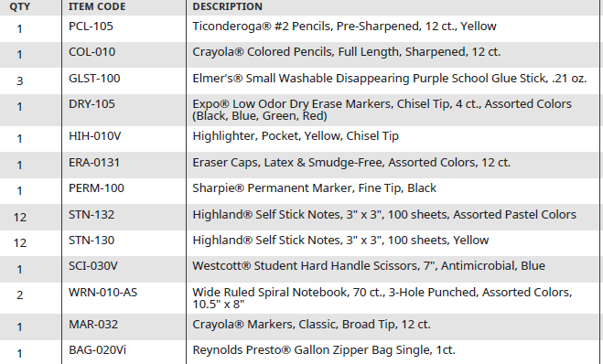

5th Grade FY22 Kit Contents – Kit #2 – Binders, Divider Tabs, Wide Ruled Filler Paper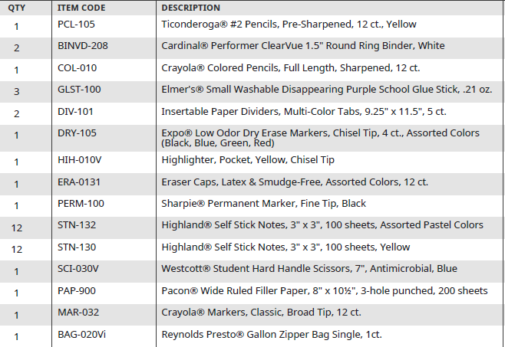

Lakota Local School District – LLSD-2022-0225
Attachment #5

6th Grade FY22 Kit Contents – Kit #1 – College Ruled Spiral Notebooks
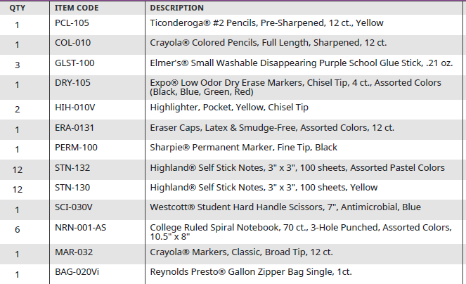

6th Grade FY22 Kit Contents – Kit #2 – Binders, Divider Tabs, College Ruled Filler Paper
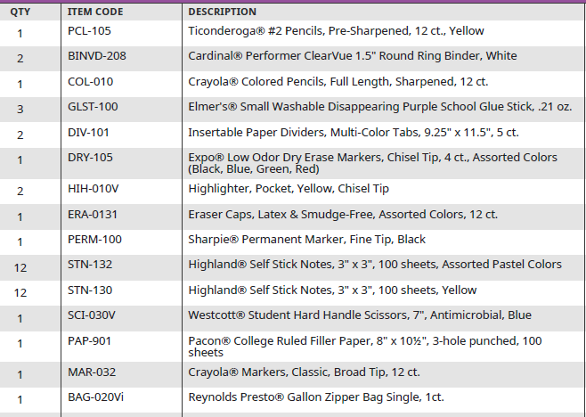
Lakota Local School District – LLSD-2022-0225
Attachment #5

7th & 8th Grade FY22 Kit Contents

