RFQ # LSD-2022-0225
ATTACHMENT # 4
Packaging Examples for Classroom Kits
Each box will be color coded and marked by the school and grade level, as outlined in RFQ LLSD-2022-0225 Section 4 “scope of work” .
Grades K-2 ONLY
Item Dimensions: 13 ¼”L x 9 7/8”D x 3”H
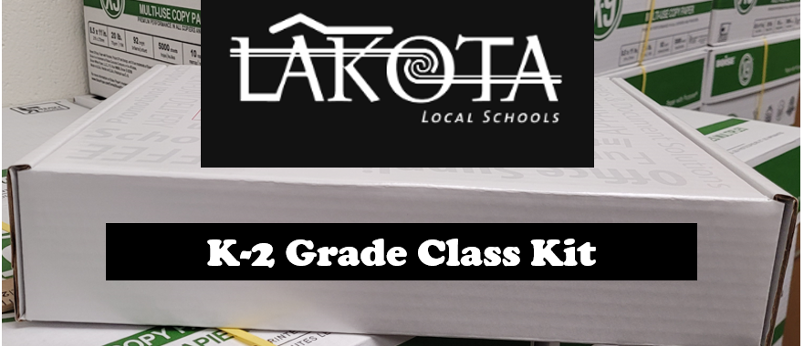

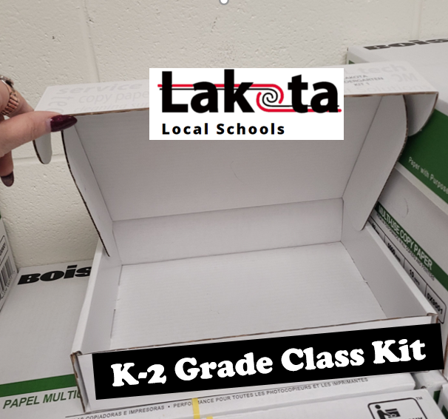
RFQ # LSD-2022-0225
ATTACHMENT 4 (cont’d)
Packaging Examples for Classroom Kits
Each box will be color coded and marked by the school and grade level, as outlined in RFQ LLSD-2022-0225 Section 4 “scope of work” .
Grades 3-8 ONLY
Dimensions: Size to be determined by supplier to fit all kit contents listed on offer sheets (Attachment #1), see sample below.

