Lakota Local School District – Request for Quote
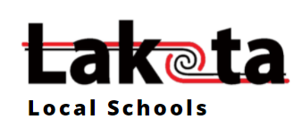
TITLE: CLASSROOM SUPPLY KIT REQUEST FOR QUOTE
RFQ # LLSD-2022-0225
Date Issued: Thursday, February 10, 2022
QUOTES DUE: Friday, February 25, 2022 3:00 PM EST
By signing this document, I am agreeing, on behalf of my company, to the specifications in this Request for Quote (RFQ). I am accepting, without exception or amendment, the terms and conditions listed herein, expect for such changes as the District’s terms and conditions will be considered non-responsible. Any purchase order or subsequent Agreement issued as a result of this RFQ will be subject to these terms and conditions. This cover page must be signed in ink. Unsigned responses will be disqualified.
COMPANY NAME:

FEDERAL TAX I.D. #:

BY (AUTHORIZED SIGNATURE):
REPRESENTATIVE’S NAME:

DATE:

TITLE:
CITY:

STATE:

ZIP CODE:

TELEPHONE NUMBER:

E-MAIL ADDRESS:

Quotes submitted via email will receive a confirmation of receipt from the Lakota Business Office. If no receipt received within 24 hours of submission, please inquire. Late quotes will NOT be accepted after the designated deadline.

POINT OF CONTACT: Veronica Gayotin, District Purchasing Manager, Email: veronica@lakotaonline.com
Lakota Local School District has a requirement to furnish school supplies for the 2022/2023 school year for grades K-8. The vendor will be required to furnish the supplies, package and deliver to each individual school as specified in the solicitation schedule.
SECTION A – OVERVIEW
- SOLICITATION SCHEDULE
Solicitation: Posted February 10, 2022
Questions: Questions about the RFQ must be emailed to Veronica@Lakotaonline.com no later than February 15, 2022. An email reply will be sent acknowledging receipt.
Addendum: Will post Q/A’s on Lakota’s website.
Amendments: Will post on Lakota’s website.
Submissions: Quotes are due by 3 p.m., Eastern Standard Time, on Friday, February 25th, 2022. Quotes will ONLY be received via email to: Veronica@Lakotaonline.com by specified deadline. An email reply will be sent within 24 hours acknowledging receipt.
Award by Date: Estimated by March 14, 2022
Delivery Date: K-8 (Kindergarten – 8th grade buildings): July 18-22, 2022 (this is not flexible)
- PRICING
All pricing must be submitted on the Offer Sheet included in this RFQ as Attachment 1 & 2. Attachment 1 represents the “core” kit contents. Attachment 2 represents the “supplemental” kit items.
Core Kit Items: These items will need to be quoted based on “Quantity in Initial Box”, even though the pack size is 36 (example below) the kit quantity is 6 each which is included in the total kit cost.
# of Items in Kit | Item # | Description | Brand | Qty in Initial Box | UOM
1 | 1530184 | PaperMate Flair Felt Tip Pens, Medium Point, Black pack of 36 | PaperMate | 6 | EA
Supplemental Kit Items: These items will be ordered at the building level and will vary based on building preference. Exact order quantities are unknown of these items, if necessary reference historical data provided in Attachment #5. Provide quote for each individual item based on the order quantity.
Supplemental Kit Example, Flair Felt Tip Pens, Medium Point, Blue, sold in a 12 PK, the amount that we want pricing on is one each. See example below:
 | Grade | Item # | Description | Brand | Order Quantity | UOM
1 | 2nd | 079488 | Flair Felt Tip Pens, Medium Point, Blue, 12 PK | PaperMate | 1 | EA

- BASIS FOR AWARD
It is the intention to award business to the responsive, responsible vendor offering the best overall value, which includes price, service and quality of product. However, Lakota Local School District reserves the right to determine the number of Agreements awarded against the RFQ. The RFQ can be awarded to one vendor or can be split between multiple vendors based on grade level groupings (K-2), (3-6) & (7-8) or by “core” items and/or “supplemental” items.
- SCOPE OF WORK
Classroom supply kits of specific school supplies for grades K-8 to be pre-packaged by the awarded bidder in a like type box (Reference Attachment 4) , color coded and marked by the school and grade for which they are intended, packed onto pallets for each building with delivery to each building July 18-22, 2022.
The vendor’s logo can be included on the individual school supply boxes (but not required). We are requiring the vendor to assemble the kits. There is no flexibility in the delivery dates beyond the window specified. Individual purchase orders will indicate the ship to location.
If the quote is awarded all to one vendor, we would want the “supplemental” items packaged in a separate bag and included in the kit with the “core” items. If the supplemental portion of the RFQ is awarded to a separate vendor we would require that the items be individually bagged and labeled with the grade level and school for which it is intended. The label would be on the shipping box and also on each individual bag.
Ship to locations can be found on our website (as indicated below): https://lakotaonline.com/about_us/school_addresses___phone_numbers and Attachment 3.
Shipping & Delivery (Building Access): The vendor will be granted access to the respective facilities with unobstructed access to deliver contents by the pallet. As outlined in Section B – Terms & Conditions, General Provisions, section “Packaging, Delivery Requirements & Claims”, second paragraph indicates “Transport deliveries must include tailgate services (driver must move pallets to the end of the trailer) and unload in the school building, as designated by a Lakota employee. Lakota Local School District DOES NOT HAVE DOCK CAPABILITIES AT ANY OF OUR LOCATIONS/FACILITIES. Deliveries will need to be scheduled in advance between 7:00 a.m. and 2:00 p.m.
The vendor is NOT required to break down skids once inside the school building.
Estimated quantities of kits per individual grade is as follows:
K – 1270 , 1st – 1263, 2nd – 1274  Total 3,807 | 3rd - 1288, 4th – 1380, 5th – 1318 6th – 1236  Total 5,222 | 7th – 1315, 8th – 1373  Total 2,606 | GRAND TOTAL:  11,635

Estimated kit quantities broken down by estimated students per grade level:
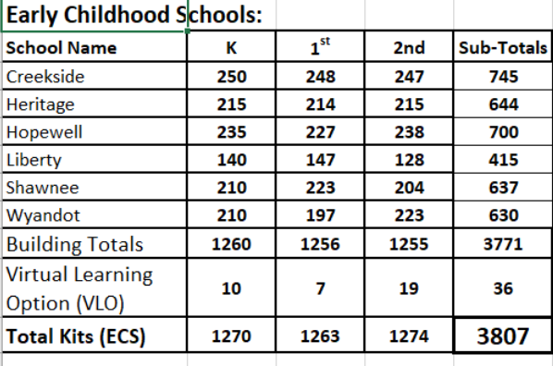
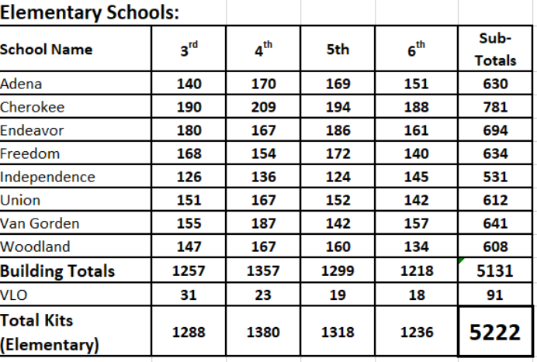
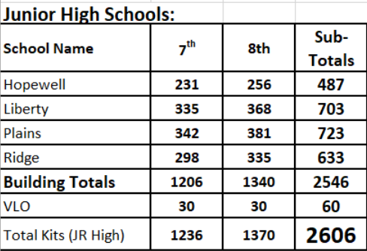

- APPROVED EQUALS
Attachment 1 identifies the “core” items and Attachment 2 identifies “supplemental” kit contents by grade level and list products by brands. We request the best quality items at the best price available. If quoting other than specified, indicate brand name, part number and or link for product specification sheet.
The vendor can submit “Attachment 1 & 2” the Excel “Offer Sheet” with all requested brand and another “Offer Sheet” with alternate items. The vendor can also submit one “Offer 1 Sheet” with a combination of requested brands.
If an alternate item is being offered, we ask that you provide a sample of the item(s) by the RFQ deadline of February 25, 2022. The samples can be mailed collectively to Lakota Local Schools, Attn: Purchasing Dept., 5572 Princeton Rd., Liberty Township, OH 45011, reference quote # RFQ # LLSD-2022-0225.
6A. PROJECT DESCRIPTION AND REQUIREMENTS – RESPONSE REQUIRED
We are providing estimated quantities, based on our current projected enrollment numbers. A simple proposal is all that is required. On a separate document submit your response to the following information as part of your proposal.
- Describe your overall approach to fulfilling such a large order to ensure the delivery times are met.
- Suggest the most efficient method of packaging each individual kit to reduce costs and ensure safe arrival for distribution and utilization by the students. Provide image of kit contents box.
- Provide a photo of one sample kit IS required as part of your submittal to illustrate how each kit will look. Include labeling in the photo. A physical sample is NOT required; however, samples are required for alternate items.
- Each individual kit must be labeled with the grade level and school for which it is intended, provide an image of the label you intend to use.
- Inspection of kits will be completed no later than August 31, 2022. Any damages, defections, shortages, and missing items will be reported to vendor by close of business on this date. Describe your policy and process for the fulfillment of missing/shorted items and replacement for damaged/defective items. What it the expected number of days to correct any issues for these kits?
- List all quotes and alternate items on the designated form “Attachment 1” – RFQ FY23 CLASSROOM KIT CONTENT OFFERS SHEET and “Attachment 2” RFQ FY23 SUPPLEMENTAL ITEMS. For alternate items listed in “Attachment 1 & 2”, samples of all alternate items must be shipped and received at the Lakota Central Office, Attn: Business Operations, Lakota Local Schools, 5572 Princeton Rd., Liberty Township, OH 45011 by the RFQ deadline date of Friday, February 25, 2022 at 3:00 PM EST.
- Vendor must document the steps they will use for EqualLevel integration and confirm they can meet the expected “go live” date and that the Vendor has the technical support to ensure the success of the online ordering program.
- Describe the process for re-ordering additional kits throughout the school year. Explain what the required lead-time is for delivery, method of shipment, if there is an order minimum, and if the order can be shipped direct to the building. Provide detailed information if there are any additional shipping/upcharges related to “later in the year” orders.
- Include a copy of a current W-9.
6B. PROJECT DESCRIPTION AND REQUIREMENTS – RESPONSE NOT REQUIRED
- Each shipping pallet will contain only the kits for one school; do not mix schools on one pallet
- Each PO should have tracking information and emailed to the building contact.
- EqualLevel “Go Store” or punch-out must be “live” no later than March, 31 2022, including all “core” kit and “supplemental” SKU’s uploaded.
6C. INFORMATION TECHNOLOGY
EqualLevel Integration Process
- For new vendors to EqualLevel, once the bid has been awarded, Lakota will submit the proper invite to begin the integration process. The vendor’s SKU’s will need to be uploaded into the EqualLevel platform.
- Reference the link for EqualLevel Supplier Resources specifically for creating an EqualLevel “Go Store”: https://documentation.equallevel.com/kb/display/suppliers/Supplier+Resources
At a high level, on boarding a new GO supplier would require:
- Buyer invites the new supplier to join the marketplace (via the Network)
- Supplier completes the e-commerce capability survey
- For a GO candidate supplier, EQL Supplier Enablement team provides info on GO training session. GO training is provided twice a week.
- Supplier attends a GO training, upon completion, GO store access provided
- Supplier imports their initial catalog
- EQL enablement team makes the connection between the marketplace and the supplier’s GO store
- Buyer and the supplier coordinates on testing

- ATTACHMENTS
- Attachment 1 – Supply requirements (core items ONLY) Offer sheet
- Attachment 2 – Supply requirements (supplemental items ONLY) Offer sheet
- Attachment 3 – Total kit estimates per grade level & Ship to address information
- Attachment 4 – Sample of box type
- Attachment 5 – Historical Data (2021/22) includes kit contents and order quantities)
- Attachment 6 – Customer Reference Questionnaire

- REFERENCES
Submit the “Customer Reference Questionnaire” form to at least three (3) major regional customers (preferably school districts) within the region, similar in size and scope to Lakota Local School District that you have done business within the past 36 months. The customer will need to complete and email feedback directly to the purchasing manager, Veronica@Lakotaonline.com due by Monday, February 25, 2022 at 3:00 p.m. EST.
On a separate document submit the name of the three major regional customers that you have requested to complete the “Customer Reference Questionnaire”. Also, provide the “Customer Reference Questionnaire” to one (1) local school district or major regional customer that has discontinued services within the past 36 months.
INCLUDE:
- District or Company Name, Contact Name and Title, City and State
- Telephone Number, Email Address, Years you have Serviced Customer

SECTION B – TERMS & CONDITIONS
- The Lakota Local School District reserves the right to cancel this order if not filled within the quoted time, as specified
- The conditions of this order are not to be modified by any verbal understanding
- Acceptance of this order includes all terms, prices, delivery instructions, specifications and conditions stated
- No payment will be made for materials ordered without proper Lakota Local Schools purchase order authorization
- Invoices and packages must bear the assigned Lakota Purchase Order number
- Email all invoices to: Accountspayable@Lakotaonline.com
GENERAL PROVISIONS
EMPLOYER-EMPLOYEE RELATIONSHIP The Vendor is not an employee of the District and is not covered by District Workers’ Compensation, group life, accident or health insurance, and other benefits associated with an employer-employee relationship.

A. GENERAL PROVISIONS

HOLD AND SAVE HARMLESS The Vendor agrees to indemnify, save harmless, and defend the District from and against any and all claims, demands, actions, debts, liabilities, and attorney’s fees arising out of, claimed on account of, or in any manner predicated on loss of or damage to the property of, and injuries to or death of any and all persons whatsoever, in any manner caused or contributed to by the Vendor, his or her agents, servants, or employees. Vendor further agrees to indemnify and save harmless the District from and on account of damages of any kind, which the District may suffer as the result of the acts of any Vendor’s agents, servants, or employees.

NONEXCLUSIVE AGREEMENT The Vendor expressly understands and agrees that this Agreement does not grant the Vendor any exclusive privileges or rights and District may Agreement with other vendor(s) for the procurement of comparable goods and services. The District makes no commitment for any minimum or maximum amount of purchases of goods or services hereunder except as otherwise set forth in this Agreement.

CHANGES The District Purchasing Manager, at any time, by written order, may make changes in or additions to the goods and services to be requested by this Agreement, issue additional instructions, require modified or additional work or services and goods within the general scope of the Agreement. If any of said changes cause any increase or decrease in the cost of, or in the time required for, performance of this Agreement, an equitable adjustment will be made in the Agreement price or term of performance, or both, and the Agreement will be modified in writing accordingly. Any claim by the Vendor for adjustment under this clause must be asserted within thirty calendar days from the date of receipt by the Vendor of the notification of changes provided, however, that the District Purchasing Manager, if he or she decides that the facts justify such action, may receive and act on any such claim asserted at any time prior to final payment under this Agreement. Failure to agree to any adjustment will be a dispute concerning a question of fact within the meaning of the clause of this Agreement titled "Disputes." However, nothing in this clause excuses the Vendor from proceeding with the Agreement as changed, and it is limited to proceeding with its appeal pursuant to the provision titled "Disputes."
PACKING, DELIVERY REQUIREMENTS & CLAIMS:
Packages must be plainly marked with shipper’s name and Purchase Order Number; charges are not allowed for boxing or crating unless previously agreed upon in writing. All materials must be shipped F.O.B. Destination with all transportation charges prepaid, unless otherwise specified in the RFQ. The Lakota Local School District will pay no freight or expense charges, unless noted in RFQ. The delivery must actually be affected within the time slated on the Purchase Order. Lakota Local School District, reserves the right to cancel this order and purchase elsewhere if the Vendor fails to meet the delivery date specified in the RFQ.
Each pallet delivered is required to have a PO# on the shipping label of the shrink-wrapped skid and a Bill of Lading should accompany each delivery.
Deliveries shall be made between 7:00 a.m. and 2:00 p.m. Monday – Friday unless otherwise stated. Transport deliveries must include tailgate services (driver must move pallets to the end of the trailer) and unload in the school building, as designated by a Lakota employee. Lakota Local School District DOES NOT HAVE DOCK CAPABILITIES AT ANY OF THE LOCATIONS/FACILITIES.
In case of default by the Vendor (or third party carrier), the Lakota Local School District, may procure the articles or services covered by this order from other sources and hold the Vendor responsible for any additional cost occasioned thereby. Vendor will be responsible for making any and all claims against carriers for missing or damaged items.
GOVERNING LAW This agreement and any matter or dispute arising out of or related to the subject matter of the agreement, shall be governed, construed, and enforced in accordance with the Laws of the State of Ohio without regard to its conflict of laws rules.
TERMINATION FOR CONVENIENCE The District may terminate performance of this Agreement in whole, or in part if the District determines that a termination is in the District’s interest with written notice. The Vendor, after receipt of a Notice of Termination, shall stop work on the cancellation date specified in the Notice. The District will conduct an audit of the Vendor’s costs to determine reasonable costs expended to date of cancellation, or the District may determine the vendors cost based on the schedule of values or exact cost of any work performed. The vendor will not be reimbursed for any anticipated profit.
TERMINATION FOR CAUSE If either party is in default under this Agreement, it shall have an
opportunity to cure the default within 10 days after it is given written notice of default by the other party, specifying the nature of the default. If the default is not cured within 10 days after notice of default has been given; the non-defaulting party shall have the right, in addition to all other remedies at law or equity, to immediately terminate this Agreement. Failure to complain of any action, non-action or default under this Agreement shall not constitute a waiver of any of the parties’ rights hereunder.

The District may terminate this Agreement, or any part hereof, for cause in the event of any default by the Vendor, or if the Vendor fails to comply with any Agreement terms and conditions, or fails to provide the District, upon request, with adequate assurances of future performance. In the event of termination for cause, the District shall not be liable to the Vendor for any amount for supplies or services not accepted, and the Vendor shall be liable to the District for any and all rights and remedies provided by law. If it is determined that terminated this Agreement for default, such termination shall be deemed a termination for convenience.

FORCE MAJEURE District may delay delivery, performance or acceptance occasioned by causes beyond its control. Vendor shall hold such goods or delay performance at the direction of the District and shall deliver goods or perform services when the cause affecting the delay has been removed. The District shall be responsible only for Vendor’s direct additional costs in holding the goods or delaying performance of this Agreement at District’s request. Causes beyond District’s control shall include government action or failure of the government to act where such action is required, strike or labor disputes, fire or unusually severe weather.

MATERIAL SAFETY DATA SHEET Where applicable, the Vendor agrees to furnish the Lakota Local School District, with a current Material Safety Data Sheet (MSDS) on or before delivery of each and every hazardous chemical or substance purchased.
PRODUCT WARRANTY
Vendor expressly warrants that all goods or services furnished under this Agreement shall conform to all specifications and appropriate standards, will be new, merchantable and fit for use and for the particular purpose describe herein, and will be free from defects in material or workmanship. Vendor warrants that all such goods or services will conform to any statements made on the containers or labels or advertisements for such goods, or services, and that any goods will be adequately contained, packaged, marked and labeled. Vendor warrants that all goods or services furnished hereunder will be merchantable and will be safe and appropriate for the purpose for which goods or services of that kind are normally used. If Vendor knows or has reason to know the particular purpose for which the District intends to use the goods or services, Vendor warrants that such goods or services will be fit for such particular purpose. Vendor warrants that goods or services furnished will conform in all respects to samples, inspection, test, acceptance or use of the goods or services furnished hereunder shall not affect the Vendor’s obligation under this warranty and such warranties shall survive inspection, test, acceptance and use. Vendor’s warranty shall run to District, its successors, assigns and customers, and users of products sold by District. Vendor agrees to replace or correct defects of any goods or services not conforming to the foregoing warranty promptly without expense to District, when notified of such nonconformity by District, provided District elects to provide Vendor with the opportunity to do so. In the event of failure of Vendor to correct defects in or replace nonconforming goods or services promptly, District, after reasonable notice to Vendor, may make such corrections or replace such goods and services and charge Vendor for the cost incurred by District in doing so.

Vendor shall be a factory authorized distributor of the product. The warranty shall be the manufacturer’s standard warranty beginning from the date the product is placed into service or one (1) year free replacement from the date the product is put into service, whichever is greater.
PAYMENT TERMS, CONDITIONS & DISCOUNTS Payment for services performed by the Vendor, as set forth in this Agreement, will be made at the rates prescribed hereto, upon submission by the Vendor of proper invoices to the District designated herein and at the time provided for herein.
All invoices must reference a Lakota Purchase Order number. Payment will not be made until the entire order is received, reconciled and invoiced. Any discount or incentives should be documented in the summary of the quote.
In connection with any payment term discount offered, time will be computed from the date of receipt of supplies or services or from the date a correct invoice is received, whichever is the latter date.
If an award is made, payment for services shall be made upon receipt and approval of a proper invoice and after services have been rendered and inspected and accepted by the district. Payment terms are immediate upon receipt and approval of an acceptable invoice referencing the Lakota purchase order number. Itemized invoices shall include a descriptive narrative of service provided and reference the building name.

INVOICING
Email invoices to: accountspayable@lakotaonline.com. Vendor will be required to provide individual invoices for each of the individual building’s purchase order(s).

