Get reminders from
Arleth Elementary School
Sign up for our Remind account from your phone
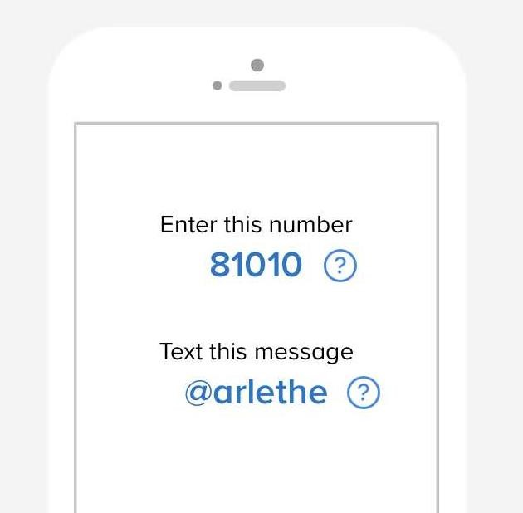

Follow us on Facebook @ Arleth Elementary School https://www.facebook.com/Arleth-Elementary-School-
528518943980697/timeline/?ref=aymt_homepage_panel

Follow us on Twitter @ ArlethPrincipal https://twitter.com/ArlethPrincipal

