District Improvement Plan 2021-2022
Summary Document for Parent & Stakeholder Input
July 29, 2021

The Georgia Department of Education’s strategic plan emphasizes transforming the agency into one that provides meaningful support to schools and districts. The agency has developed a common, continuous improvement framework to ensure that these efforts are aligned across all agency divisions, departments, and programs. Georgia’s Systems of Continuous Improvement focuses on the systems and structures (the “what”) that must be in place for sustained improvement in student outcomes. It also utilizes a problem-solving model (the “how”) to provide a clear process for identifying improvement needs, planning for improvement, and implementing, monitoring, and evaluating the improvement efforts.
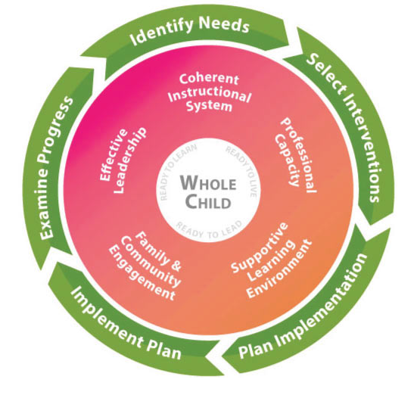
SYSTEMS TO IMPROVE
COHERENT INSTRUTIONAL SYSTEM- The major system of the complex school organization that articulates and guides the what and how of instruction
PROFFESIONAL CAPACITY-A major system of the complex school organization that develops a quality staff to reduce the variance of quality of instruction throughout the school
SUPPORTIVE LEARNING ENVIRONMENT- A major system of the complex school organization that ensures student’s participation and willingness to expend major effort on classroom learning.
FAMILY & COMMUNITY ENGAGEMENT- A major system of the complex school organization that develops quality links between local school professionals and the parents and community the school is intended to serve.
EFFECTIVE LEADERSHIP- A major system of the complex school organization that sets the direction for the school, ensures that the school’s staff is capable of meeting that direction, and makes sure the organization functions according to its mission.

Through a thorough needs assessment, our district developed the following goals for the 2021-2022 school term. These goals also match our system strategic plan. Each goal has action steps under each system of improvement to ensure the whole school organization is being addressed.

GOAL # 1 – Equity Gap 1
More individualized instruction will be implemented in order to meet the needs of all learners to have at least a 3% increase in the percentage of students earning proficient or higher scores on GMAS for the Spring of 2022.

ACTION STEPS
Coherent Instructional System
- Teachers will be provided instructional resources and strategies that will focus on student mastery of standards, including technology integration and assessing student needs.
- MAP data and GMAS scores will be used to provide individual instruction using a variety of evidence-based strategies
- Incorporate a variety of software options to enhance instruction and assessing of students.
- Provide an After School Program or Summer Remediation Program to address deficits identified through MAP assessments to provide enrichment opportunities for students.
- Teachers and students will have access to services through Georgia Youth Science and Technology Centers (GYSTC)
- Provide resources for STEM/STEAM, music, CTAE courses, environmental science, technology, art and physical education. School Connect will be used by our middle and high schools to provide modules to students on Supportive Learning Community, Developing Self-Awareness and Self Management, Building Relationships and Resolving Conflicts, and Preparing for College and the Workforce. Child Health software will be used to prevent child abuse, neglect, bullying and provide career exploration. All of these efforts are to prepare well-rounded students.
Effective Leadership
- Additional teachers will be provided to reduce class size and implement evidence-based strategies
Professional Capacity
- Continued professional development opportunities for teachers to create rigorous assessments at all grade levels
Family & Community Engagement
- MAP assessment reports as well as grade reports will be sent home periodically to inform parents of progress
- Parent Resource Center available to provide additional support for students and families
Supportive Learning Environment
- To ensure a supportive learning environment by maintaining order and safety for all staff members and students by implementing PBIS, offering resources to address mental and physical needs of all learners, and conduct drug awareness activities for students during Red Ribbon Week.
- Provide technology in classrooms to move to a 1:1 environ needed to enhance instruction for all students

GOAL # 2- Equity Gap 2
Provide at least four individualized evidenced-based professional learning to all staff by the end of the 2021-2022 school term
ACTION STEPS
Coherent Instructional System
- All staff members will participate in at least 2 evidenced based professional learning opportunities per semester
Effective Leadership
- Elementary school teams will attend GLISI base camp and summit to develop leadership & data analysis skills. Middle and High school teams will participate in 4T sponsored by GLISI and Southern Regional Education Board (SREB).
- Instructional coaches will be assigned to each school
- Professional Development meeting agendas, sign-in sheets, redelivery materials, etc will be maintained at each schools
Professional Capacity
- Provide a mentoring program for new building administrators and new teachers
Family & Community Engagement
- Teachers will complete one activity on building their capacity to engage with families from the list of resources provided by GADOE Family-School Partnership Program
Supportive Learning Environment
- Professional Learning on safety and emergency procedures will be conducted at each school.

GOAL #3
To address attendance issues and monitor students through MAP, MTSS, and Credit Recovery in order to improve graduation rates by 3% in accordance with the system Strategic Plan.

ACTION STEPS
Coherent Instructional System
- Implement an effective MTSS program to address student needs
- Provide Credit Recovery software for students that have the potential to graduate
Effective Leadership
- Provide MTSS Coordinator/Teacher in each school
- Monitor MAP, Lexile Scores, 9th grade failure reports and GMA results to target students that are at-risk for dropping out of school.
- Alternative Behavior Educator (ABE) and PBIS implementation, will be used to decrease the number of classroom removals due to behavior
Professional Capacity
- Professional learning will be provided to all staff on RTI strategies.
Family & Community Engagement
- Teachers will contact parents after a child has 3 unexcused absence.
- Conduct a School Attendance Awareness activity to share importance of attendance as well as protocols.
Supportive Learning Environment
- Implement an effective attendance protocol to influence attendance habits of families

GOAL #4
Support Parent Resource Room and provide meaningful opportunities for parental involvement at all schools to show a 3% increase in the number of offered events.
ACTION STEPS
Coherent Instructional System
- Maintain Parent Resource Room with supplies and provide a manager to make the room available to parents
Effective Leadership
- Administrators will work through their School Council, Family Connections, School Leadership Teams, and PTO to provide parent involvement activities specifically geared to the needs of parents.
Professional Capacity
- All staff will complete at least one activity to build their capacity to engage with parents and families.
Family & Community Engagement
- Using email, Emanuel Inspirations, school pointe app, KINVO, School & Home Connection Newsletter and social media to share learning opportunities with parents that would affect their child.
Supportive Learning Environment
- Annual Title I Parent Meeting and an annual survey will be conducted to address effectiveness of practices

If you have any questions or suggestions for input, please contact Dr. Gail Greenway by email at ggreenway@emanuel.k12.ga.us or 478-237-6674

