**Changing download actions**

You can change what action Firefox takes for defined content types. This will not affect media embedded in a web page - only links to the files themselves.

1. Click the menu button Fx57Menuand choose Preferences.
2. In the General panel, go to the **Applications** section.
3. Select the entry for the file type you want to change.

**Multiple entries for the same** [**file format or extension**](http://en.wikipedia.org/wiki/File_format)**?** Some file types can include more than one Internet Media type.

1. The Action column will give you a drop-down menu, with options on action to take, whenever you click that type of file.

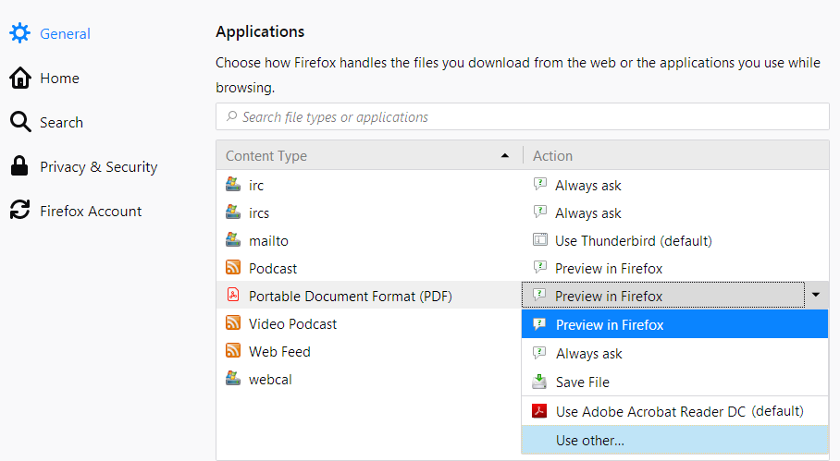

* + **Preview in Firefox**: Select this if you want Firefox to display the content. It's only applicable to a limited number of types, those that Firefox is able to decode such as Podcast, Video Podcast, Web Feed and Portable Document Format (PDF).
  + **Always ask**: This will prompt you to select what action you want Firefox to take when you click on that type of file. This can be useful if Firefox is automatically saving a file type or is always opening it with a certain program and you want to be asked what to do.
  + **Save File**: This will always save the file to your computer using the [Downloads window](https://support.mozilla.org/en-US/kb/where-find-and-manage-downloaded-files-firefox), whenever you click that type of file.
  + **Use ... :** Open the file with an application of your choosing.

1. Close the *about:preferences* page. Any changes you've made will automatically be saved.

**Adding download actions**

When you click on a link for a type of file that doesn't have a set content type and download action, Firefox will ask you how to handle the file:

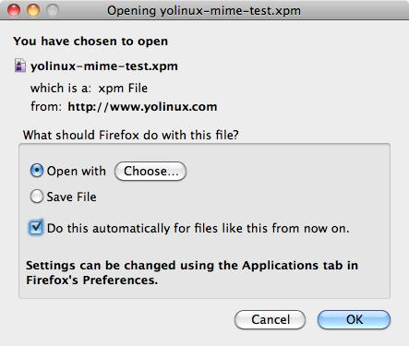

* **Open with**: Saves the file to a temporary folder and opens it in the default application for that file type. To select an application, click Choose....

**Warning:** Do not choose Firefox to always open a certain file type, as doing so can cause a problem where [Firefox repeatedly opens empty tabs or windows after you click on a link](https://support.mozilla.org/en-US/kb/firefox-repeatedly-opens-empty-tabs-or-windows).

* **Save file**: Saves the file to the download folder (specified in the **General** panel of Firefox [Preferences](https://support.mozilla.org/en-US/kb/firefox-options-preferences-and-settings)).
* **Do this automatically for files like this from now on**: Check mark this setting and then click OK to add a new entry to the Content Type list for that file type.

**Is *Do this automatically for files like this from now on* disabled?** This can happen if the website's server incorrectly specifies the Internet Media type of the file. It also can happen if the server assigns "Content-Disposition: attachment" to the file.

**Resetting download actions for all content types**

If you are having problems with how Firefox is handling file downloads that you can't resolve, or if you just want to start fresh, you can restore the default content types and actions by manually deleting the file that stores these settings.

This will remove all customized content type actions. You will have to make those changes over again after you take the following steps.

1. Open your profile folder:

From the Help menu, choose Troubleshooting Information. The Troubleshooting Information tab will open.

* + Under the **Application Basics** section, click on Show in Finder. A window will open that contains your profile folder.

**Note:** If you are unable to open or use Firefox, follow the instructions in [Finding your profile without opening Firefox](https://support.mozilla.org/en-US/kb/profiles-where-firefox-stores-user-data#w_finding-your-profile-without-opening-firefox).

1. Close Firefox.

Click the Firefox menu at the top of the screen, then click Quit Firefox.

1. Delete (or rename) the handlers.json file.
2. Restart Firefox.