Advent Resources for Schools and Parishes

December – Month of the Divine Infancy
3 | St. Francis Xavier
6 | St. Nicholas
7 | St. Ambrose
8 | Solemnity of the Immaculate Conception of the Blessed Virgin Mary
12 | Feast of Our Lady of Guadalupe
13 | St. Lucy
14 | St. John of the Cross
25 | Solemnity of the Nativity of the Lord
26 | Feast of St. Stephen
27 | Feast of St. John
28 | Feast of the Holy Innocents
30 | Feast of the Holy Family of Jesus, Mary and Joseph

The Season of Advent
Enjoy these two short videos as windows into the season of Advent at you begin preparations:

What is Advent? Bishop Barron:
The Spirituality of Advent

The online resources for Advent are abundant. Many websites and publishing houses offer excellent suggestions for living Advent in our homes, classrooms, schools and parishes. The following are just a sample of the banquet of choices available:

- Building Faith – Click here.
- Catholic Apostolate Center – Click here.
- Celebrate Las Posadas – Click here.
- Christmas Nativity Pageant Ideas, Tips and Scripts – Click here.
- Classroom Advent Suggestions – Click here and Click here.
- Creative Communications Advent Calendars – Click here.
- Loyola Press Advent Resources– Click here.
- Saint Lucy’s Feast Day for Beginners – Click here.
- Saint Nicholas Traditions – Click here.
- School-Wide Advent Wreath Prayer Service – Click here.
- The Jesse Tree – Click here.
- The Joyful Mysteries of the Rosary – Click here.
- The Liturgical Catechist- Advent – Click here.
- The Religion Teacher Advent Activities – Click here.

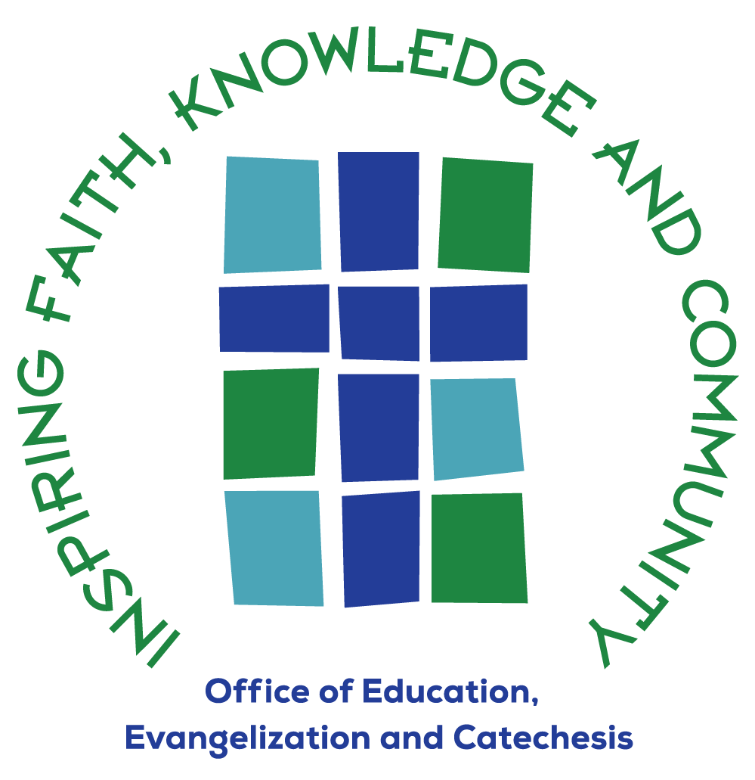
Lisa Orchen, M.Div.
Archdiocesan Director of Catechetical Initiatives
Office of Education, Evangelization & Catechesis
Archdiocese of Hartford
lisa.orchen@aohct.org

