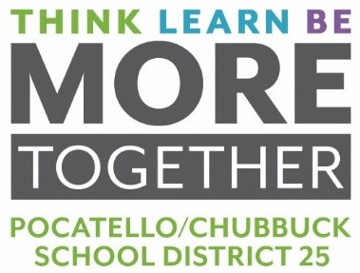
MEMORANDUM

To: Dr. Douglas Howell, Superintendent

From: Jonathan R. Balls, Director of Business Operations

Date: May 17, 2022

RE: BID FOR BREAD FOR 2022-2023 SCHOOL YEAR

On April 15, 2022, bids were opened for bread supply for the 2022-2023 school year. Bid specifications were sent to six (6) vendors. We received bids from four (4) vendors.

ITEM | Goldstar/TFS  Emmett, ID | Shamrock Foods  Meridian, ID | Bimbo Bakeries DBA: Sara Lee Pocatello, ID | Franz Bakery  Pocatello, ID
16,000 loaves, Bread, Sandwich | $32,800.00 | $52,006.50 | $22,080.00 | $19,840.00
32,000 Buns,  Hot Dog | $6,631.70 | $6,085.02 | $5,312.00 | $4,480.00
350,000 Buns, Hamburger | $62,086.50 | $70,970.61 | $55,300.00 | $49,000.00
Totals | $101,518.20 | $129,062.13 | $82,692.00 | $73,320.00

Board Action Requested: Motion to award Franz Bakery in the amount of $73,320 for the 2022-2023 school year.

