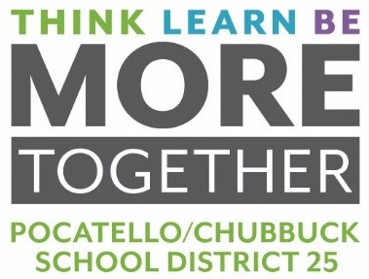
MEMORANDUM

To: Dr. Douglas Howell, Superintendent

From: Jonathan R. Balls, Director of Business Operations

Date: May 17, 2022

RE: BID FOR FRESH FRUIT AND VEGETABLES 2022-2023 SCHOOL YEAR

On April 15, 2022, bids were opened for Fresh Fruit and Vegetables food supply. This bid included specifications for 110 different fresh fruit and vegetables in a variety of quantities. Six (6) vendors were invited to bid. We received bids from three (3) vendors. Award recommendations are shown below:

FRUIT & VEGETABLES 2022-2023
Nicholas and Co., Salt Lake City, UT | $51,548.61
Charlies Produce, Boise, ID | $17,677.75
Grasmick Produce, Idaho Falls, ID | $9,367.50
Total Bid Award | $78,593.86

Board Action Requested: Motion to approve awarding the bid to Nicholas and Co. in the amount of $51,548.61, Charlies Produce in the amount of $17,677.75, and Grasmick Produce in the amount of $9,367.50 for a total bid award of $78,593.86. These bids are the lowest responsible bids that meet our specifications.

