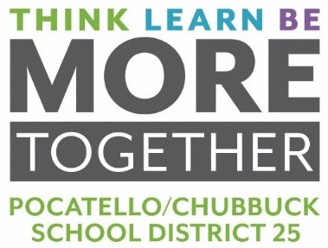
MEMORANDUM

To: Dr. Douglas Howell, Superintendent

From: Jonathan R. Balls, Director of Business Operations

Date: May 17, 2022

RE: BID FOR FOOD ITEMS 2022-2023 SCHOOL YEAR

On April 15, 2022, bids were opened for Food items. This bid included specifications for 345 different food items in a variety of quantities. Twenty-four (24) vendors were invited to bid. We received qualifying bids from twelve (12) vendors. There were four (4) vendors that submitted bids for which no items were awarded based on pricing and other considerations. Award recommendations are shown below:

FOOD ITEMS 2022-2023
Charlie’s Produce: Boise, ID | $169,118.50
Shamrock Foods: Meridian, ID | $110,605.50
Grasmick Produce: Idaho Falls, ID | $10,840.00
Nicholas & Co: SLC, UT | $629,431.65
Shamrock Foods: Meridian, ID | $110,605.50
Goldstar/Northwest Dist.: Emmett, ID | $490,421.07
Sysco USA: Boise, ID | $120,107.72
US Foods: Ogden, UT | $581,058.55
Total Award | $2,148,612.59

Board Action Requested: Motion to approve awarding the bid to the above list of vendors for a total bid award of $2,148,612.59. These bids are the lowest responsible bids that meet our specifications.

