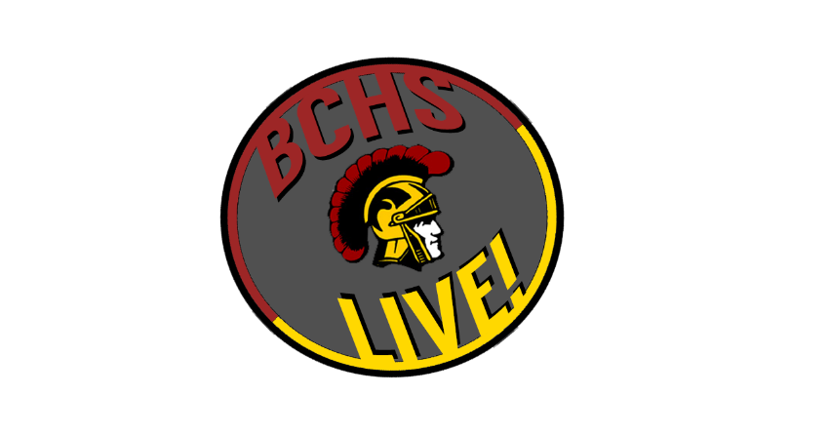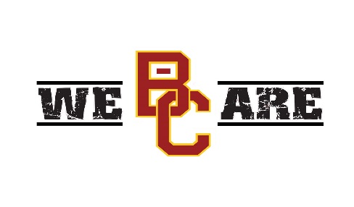

Advertiser Agreement

BCHS Live! Office:

511 Trojan Trail • Glasgow KY 42141, USA

Phone: (270)659-2875 • www.barren.kyschools.us/live

By signing this, you agree to sponsor BCHS Live! for the 2016-2017 boys’ and girls’ basketball season in the amount of $250. Your 15 second advertisement is guaranteed to show at least 5 times per event. Refunds are available under certain circumstances that will be determined by BCHS Live!. Your contract may be renewed annually.

Advertiser Signature Date

Marketing Correspondent Signature Date

District Video Coordinator Signature Date

Contract Page