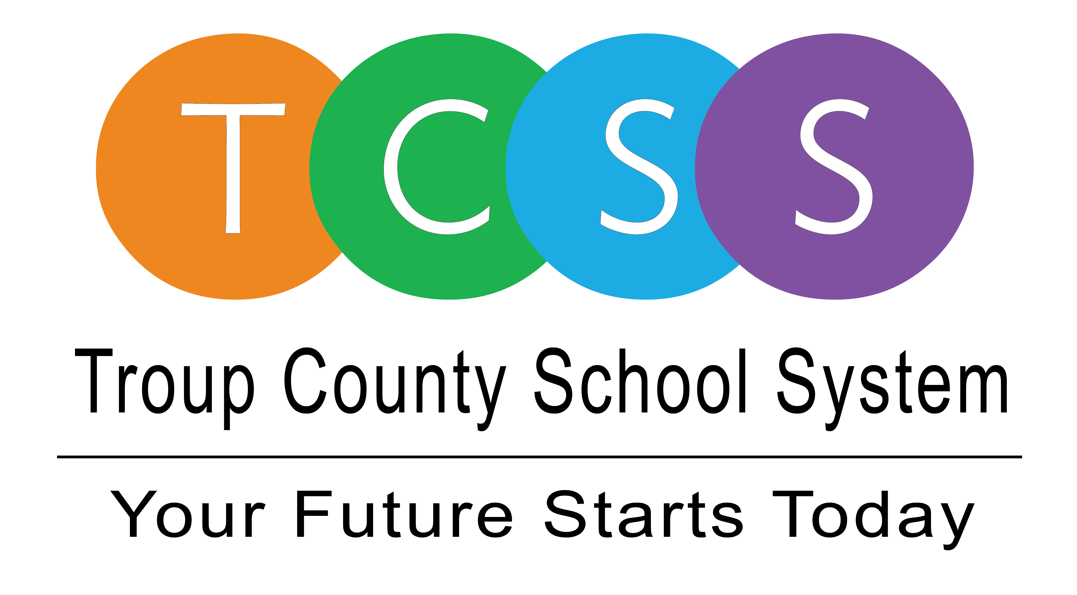
Yolanda Stephen, Director Public Relations
stephenyk@troup.org / troup.org
100 North Davis Rd, Building C / LaGrange, Georgia 30241
Office: 706.812.7900 / Fax: 706-812-7904

Story Release
FOR IMMEDIATE RELEASE

THINC Instructor First to Receive Master Career Academy Teacher Designation

LaGrange, Ga., September 25, 2020 – For almost 12 years, Aidan Blackwell has been an instructor in Troup County School System. For the last few years he has been teaching Advanced Placement Government, Advanced Placement US History, and Economics at THINC College & Career Academy (THINC). His students love his approach to teaching project-based assignments and he has been a past nominee for Teacher of the Year twice. Now, Blackwell just learned he is the first in the nation to earn the National Career Academy Coalition (NCAC) Master Career Academy Teacher certification.

Blackwell said, “Last year, THINC was certified as an NCAC Model School. At that same conference, the association leaders announced a new Master Teacher program and I was interested. It was an in depth process and I needed the support to complete the certification, so after speaking with my school and district leaders, I started the application process.”

He continued, “This certification helped me lead to improvement. I had to complete a SWOT Analysis, which forced me to look at the job I’ve done at THINC, while also looking at ways to improve the way I teach and enhance the student learning experience in my classroom. I hope with this acknowledgement I will be able to provide support for other teachers, as well.”

To become certified as a Master Teacher, applicants must show mastery in ten standards such as teaching philosophy, classroom environment, teacher leadership, student advocacy, partner collaboration, and student learning. The Auburn grad said, “For each standard, I had to provide evidence and artifacts that I mastered those elements. Those items were placed in a portfolio and submitted to industry professionals. I had to receive a minimum overall score to be certified.”

Blackwell is thankful for the opportunity and support of his current and past leaders, He noted that many programs he has been involved in helped bolster his project portfolio, “Without experiences such as the LIFT Externship, presenting at national conferences, Project Zero Classroom through Harvard, I would not have been able to complete the portfolio requirements. I have to give thanks to Dr. Chris Williams, Dr. Kathy Carlisle, Jennifer Pike, Gerald Wyatt, Dr. Penny Johnson, and Dr. Brian Shumate for their guidance and support throughout my career, and for this opportunity.”

About Troup County School System
Troup County School System is an accredited educational system with over 12,100 students in grades K-12. TCSS does offer a free Pre-K program at each elementary school. The system is comprised of eleven elementary schools, three middle schools, three high schools, one college and career academy, and one alternative learning center. Students within the school system are taught a rigorous and relevant curriculum that helps them make college and career choices beyond graduation and succeed in life. The system 2019 graduation rate is 86.6 percent. To learn more about Troup County School System, visit troup.org and the Troup County School System Facebook page.
###

