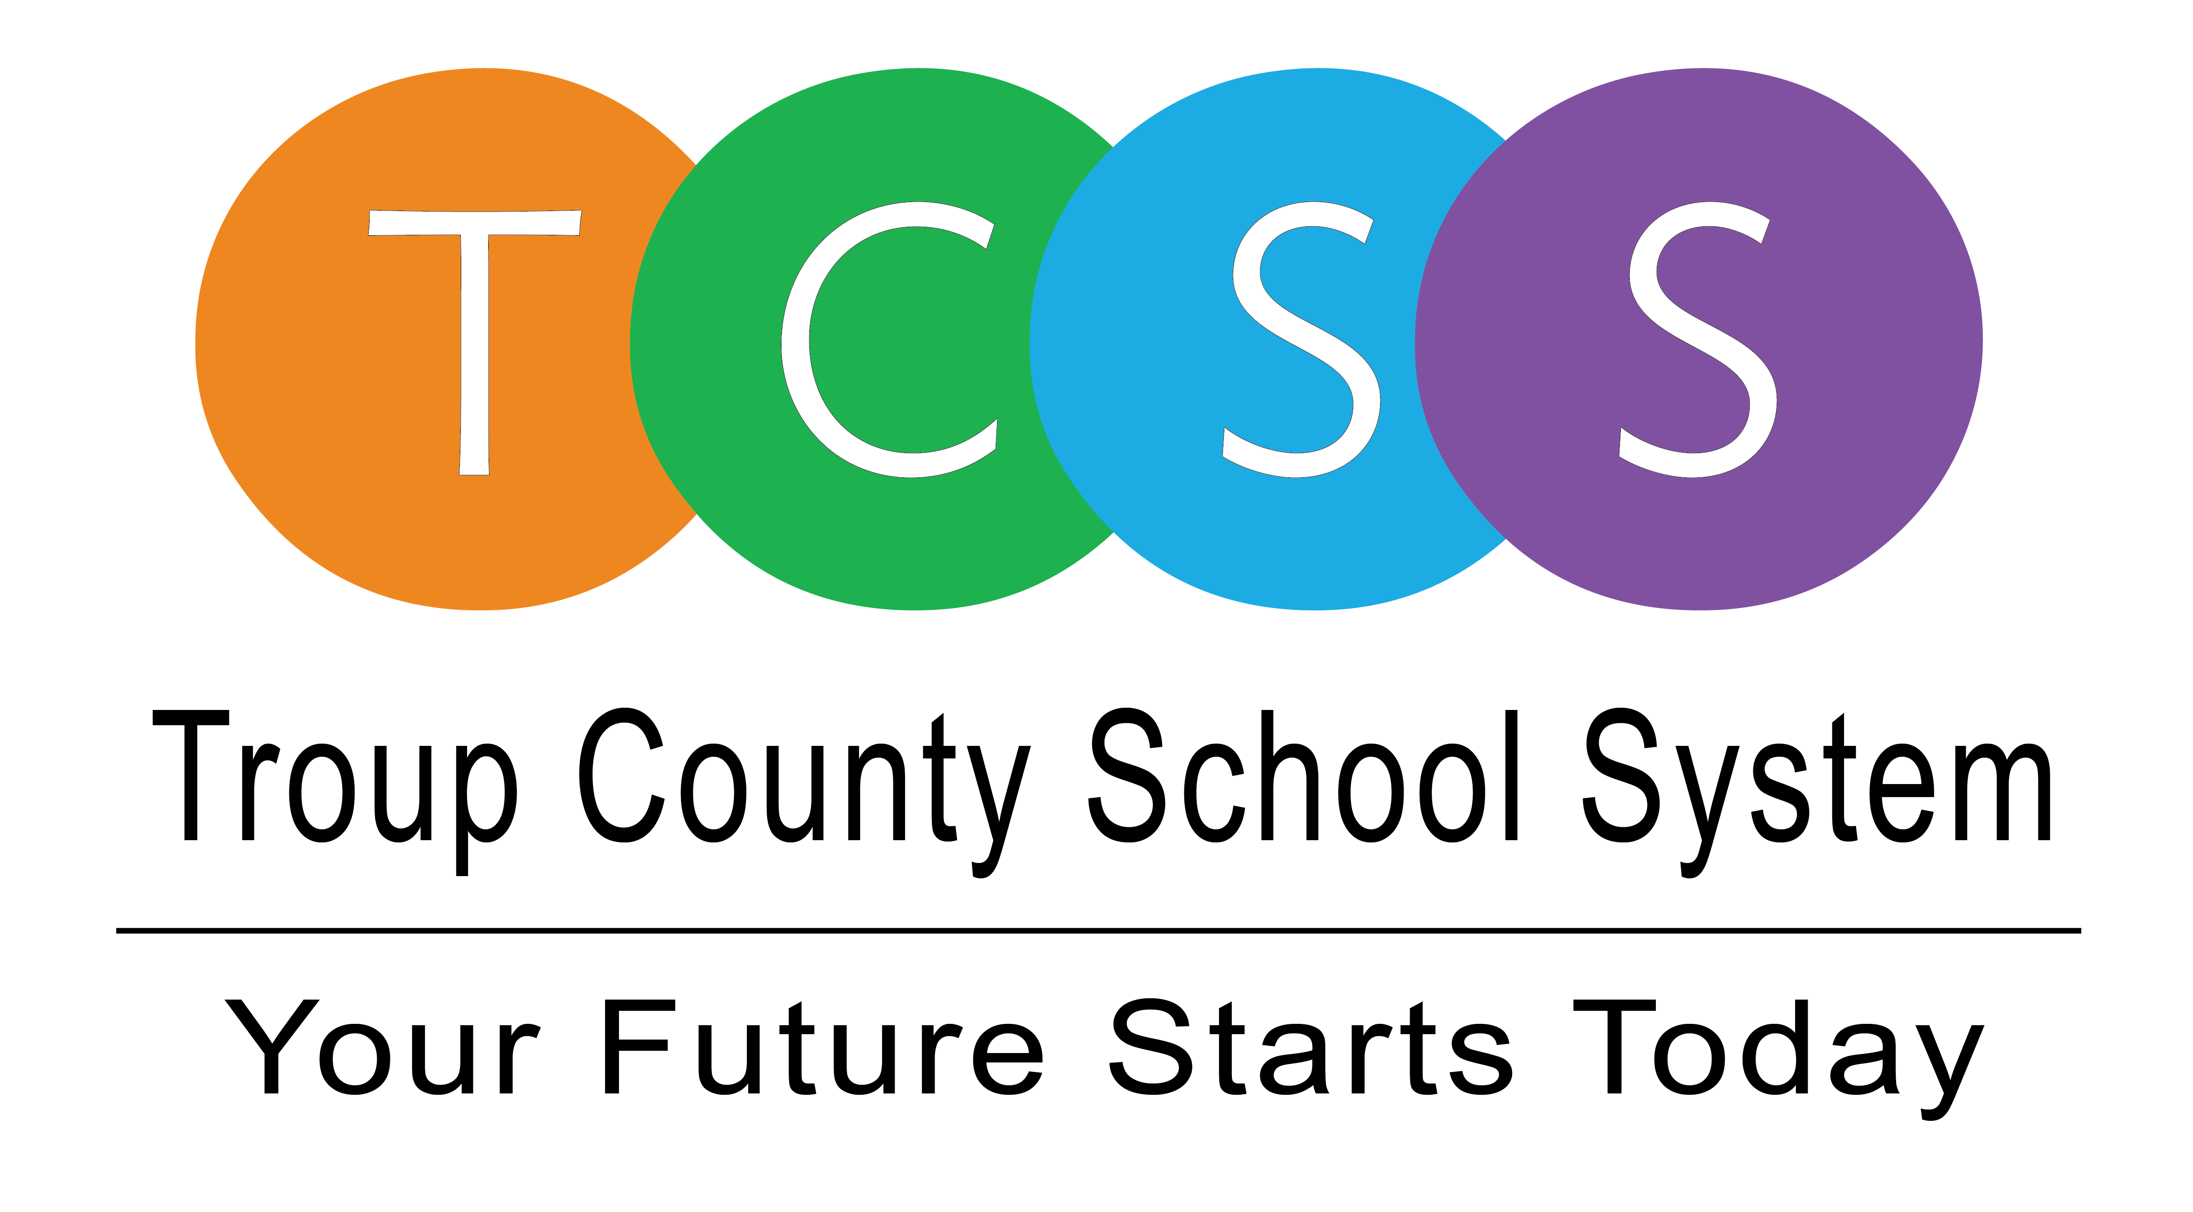
Yolanda Stephen, Director Public Relations
stephenyk@troup.org / troup.org
100 North Davis Rd, Building C / LaGrange, Georgia 30241
Office: 706.812.7900 / Fax: 706-812-7904

Story Release
FOR IMMEDIATE RELEASE

TCSS Board Approves Two Virtual Days for All Students
TCSS employees will report to work and students will remain home for learning

LaGrange, Ga., September 18, 2020 – Two upcoming Mondays have now been deemed virtual learning days according to a vote last night during the Troup County School System (TCSS) Board of Education September meeting.

The two days are:
- Monday, September 28, 2020
- Monday, November 2, 2020

Members of the Board voted to approve two virtual days for all students after the recommendation from Dr. Brian Shumate, TCSS Superintendent, came Monday night. He said, “We have heard from educators who simultaneously teach students in-person and virtually. Our teachers are still working through Canvas.”

“They’ve done a great job getting started, but there are still things to learn about the new system. These two days will allow them an opportunity to catch up on student assignments and lesson planning while also learning more about Canvas to better help students and parents,” Shumate stated.

Teachers will report to work as regularly scheduled and students will remain home for virtual learning. In addition:
- Teachers will assign work for students to complete at home.
- Teachers will participate in professional learning and lesson planning activities.
- Students will complete virtual learning assignments as instructed by the teacher.

About Troup County School System
Troup County School System is an accredited educational system with over 12,100 students in grades K-12. TCSS does offer a free Pre-K program at each elementary school. The system is comprised of eleven elementary schools, three middle schools, three high schools, one college and career academy, and one alternative learning center. Students within the school system are taught a rigorous and relevant curriculum that helps them make college and career choices beyond graduation and succeed in life. The system 2019 graduation rate is 86.6 percent. To learn more about Troup County School System, visit troup.org and the Troup County School System Facebook page.
###

